**CLOUD COMPUTING**

GAURI DEOKAR ROLL NO: 07



**CERTIFICATE**

This is to certify that Mr. / Miss/Mrs. **Gauri Deokar** with Seat No.**07** has

successfully completed the necessary course of experiments in the subject of **CLOUD COMPUTING** during the academic year **2020 – 2021** complying with the requirements of **RAMNIRANJAN JHUNJHUNWALA COLLEGE OF ARTS,**

**SCIENCE AND COMMERCE**, for the course of **M.Sc. (IT)** semester -I.

Internal Examiner Date: **6/3/2021**

#### Head of Department College Seal External Examiner

**Index**

|  |  |  |
| --- | --- | --- |
| **SR.NO** | **PRACTICAL TITLE** | **SIGNATURE** |
| 1 | Implement cluster on Windows |  |
| 2 | Developing application for Windows Azure |  |
| 3 | Implementing private cloud with Xen Server |  |
| 4 | Implement Search Engine Google App Engine(GAE) |  |
| 5 | Implement ESXi Server |  |
| 6 | Native Virtualization using Hyper-V |  |
| 7 | Implement Open Nebula |  |
| 8 | Implement IAAS using Eucalyptus |  |

# CLOUD COMPUTING

### PRACTICAL: 1 IMPLEMENTING CLUSTER ON WINDOWS

Install the **VMWare Workstation**. The **Home page** of VMWare Workstation looks like the picture below. To create a new Virtual Machine click on **“Create a New Virtual Machine”**.

In the **“New Virtual Machine Wizard”** select the **“Typical”** option. And click on

**“Next”** button.

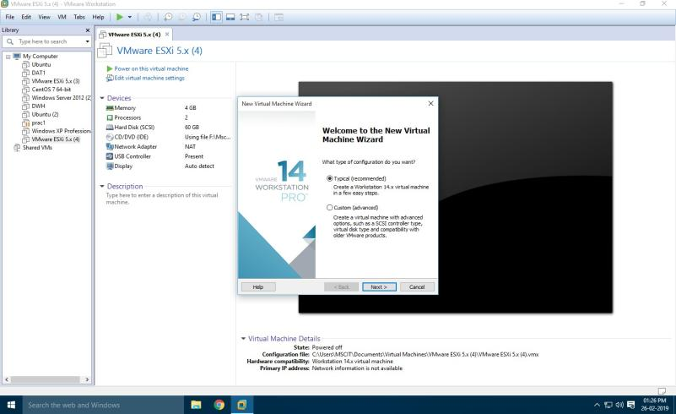

#### In the Next window, select the option **Install Disc** and click on **Browse** to select the windows server 2012 iso file and then click on **Next.**

In this window, select the name of **operating system** and its **version.**

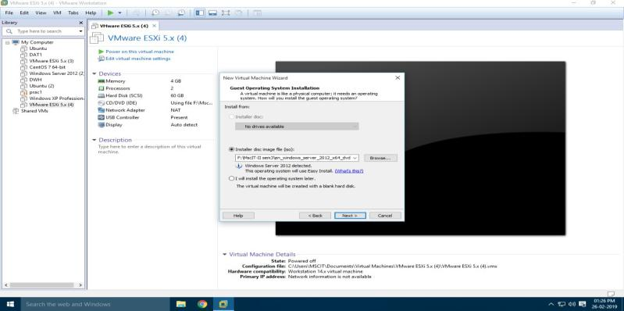

Click **“Next”,** And click on yes

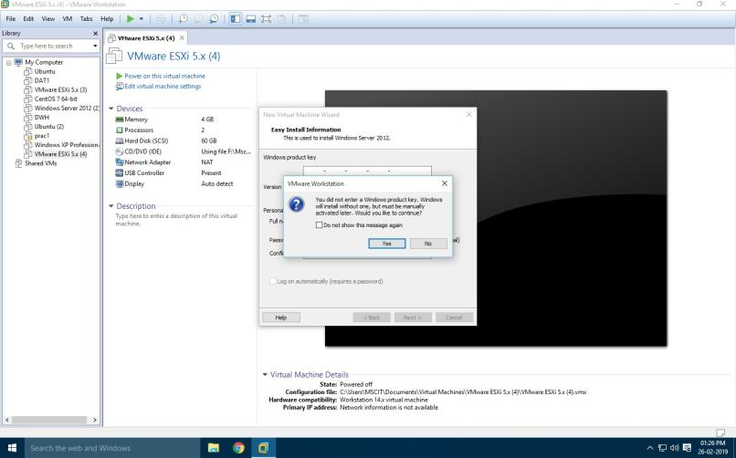

Choose **“Store virtual disk as a single file”** and Keep the memory size as **90GB**. Click on “**Next**”.

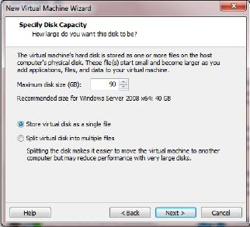

Click on “**Finish**” button.

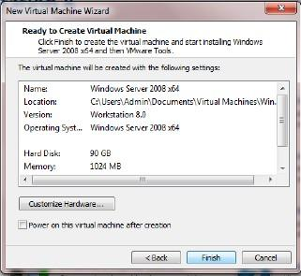

#### Click on **Memory** under Devices on the right side and make it to **2GB.**

Power on the virtual machine by clicking on “**Power on this virtual machine**”.

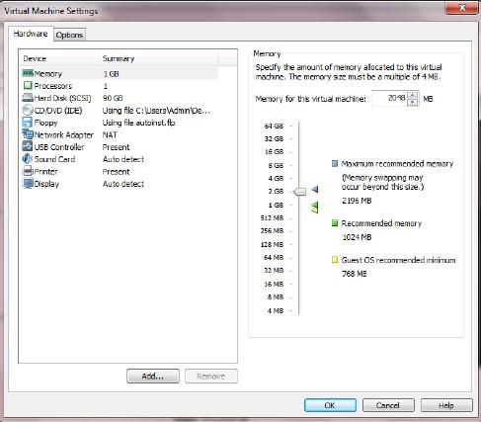

Copying of **System Files** will start.

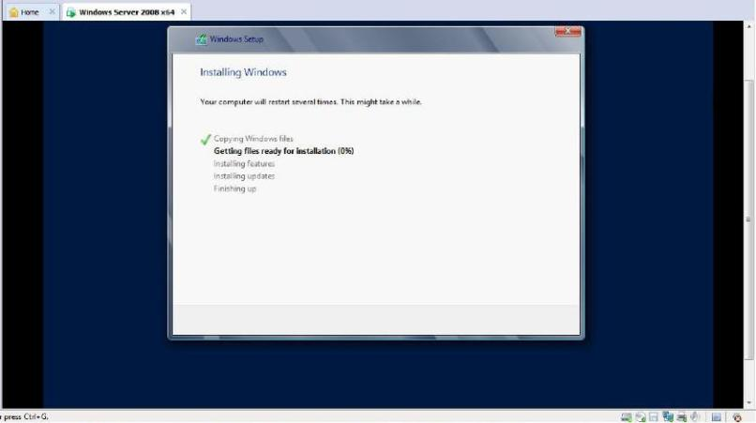

After copying files it will automatically start.

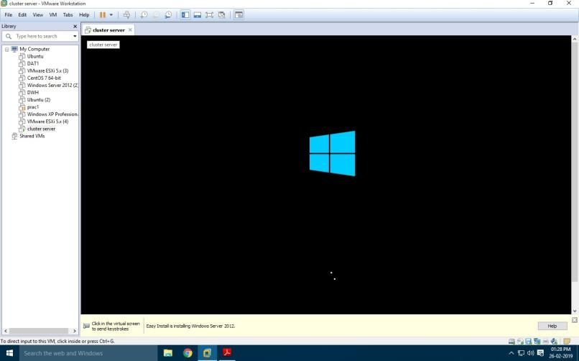

If installing on the Virtual Machine like VMWare then you need to click on the menu as show in the next screen.

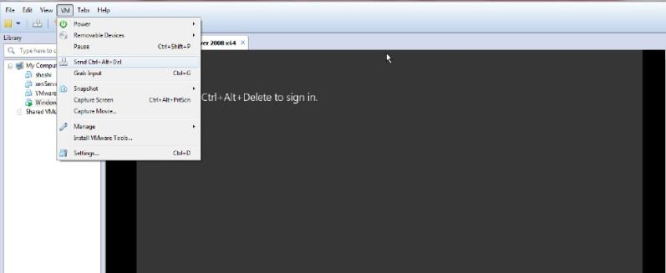

Enter the password and press “Enter” button on the keyboard

**Password:Admin12345**

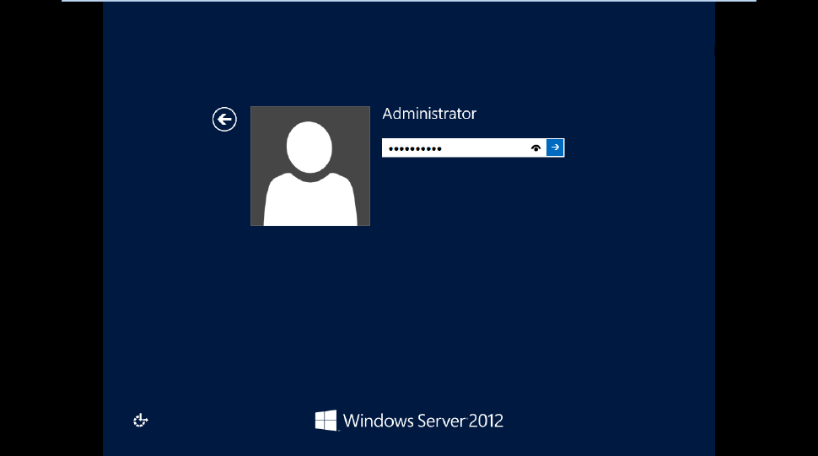

#### To make the current system a Domain Controller click on “Add Roles and

Features” under the “Manage” menu at the top of the screen and get the “Add Roles and Feature Wizard”.

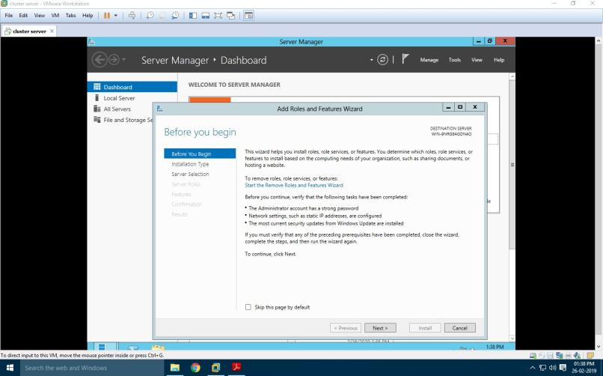

CC

#### C:\Users\HP\Desktop\CC 1ST PRAC\Screenshot (433).pngUnder “select installation Type” select “Role-based or feature-based installation” and click “Next” button.

Under “select destination Server” select “Select a server from the server pool” option and select the server as shown in the screen below and click “Next”

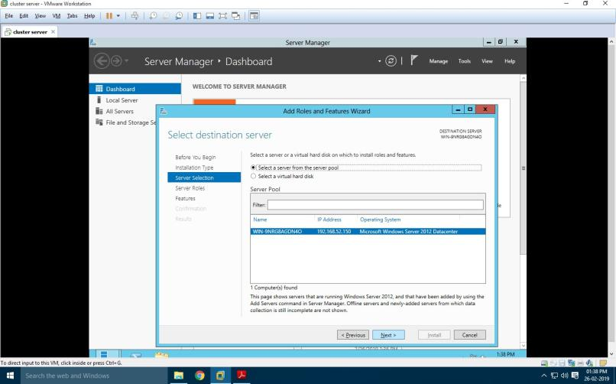

#### Click on “Active Directory Services”, “DNS” and “DNS” roles from the list of roles provided and click on “Add Features” button as shown in the screen. Add Features button will appear as you click on any of the roles.

After selecting the Role click “Next”.

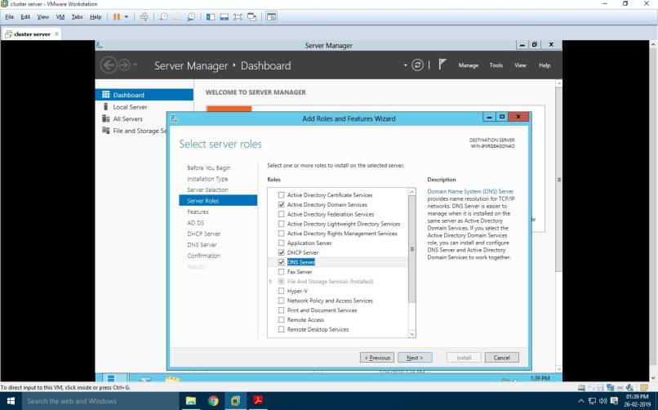

#### Under “Select Features” select “Failover Clustering” and “.NET Framework 3.5 Features” and click “Next”.

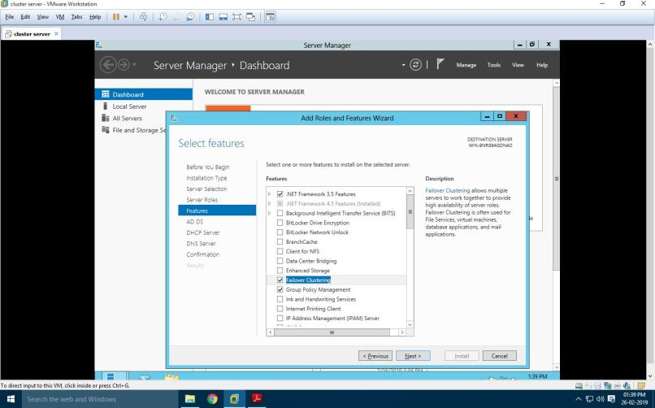

You will see the “Confirm Installation selections” then click on link “specify an alternate path”. As shown in below two screens.

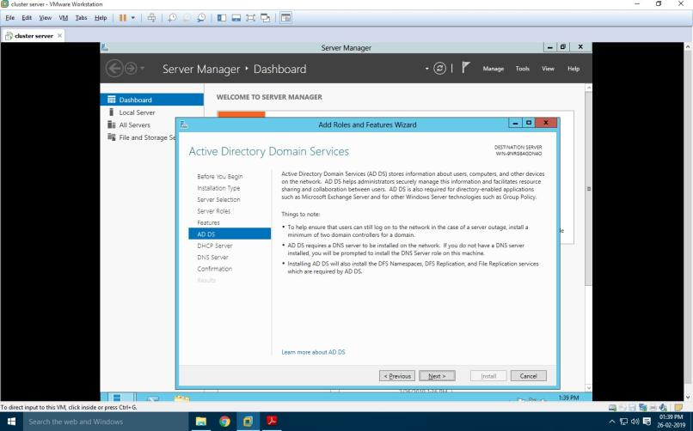

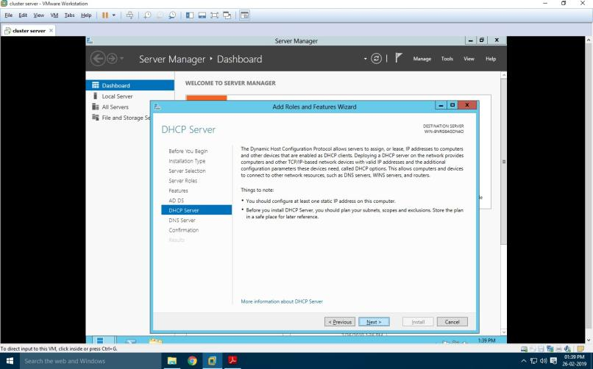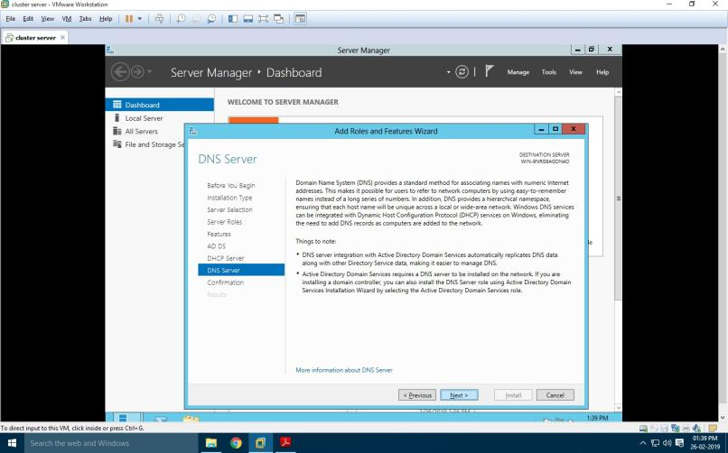

#### Now, For path specification Go to menu VM->use Iso image file of windows server 2012->Ok Then, Go to File Explorer->Computer -> select the DVD->VIEW FILE-> SOURCES->SXS:

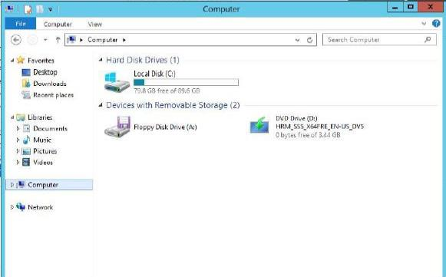

Paste the path Here,

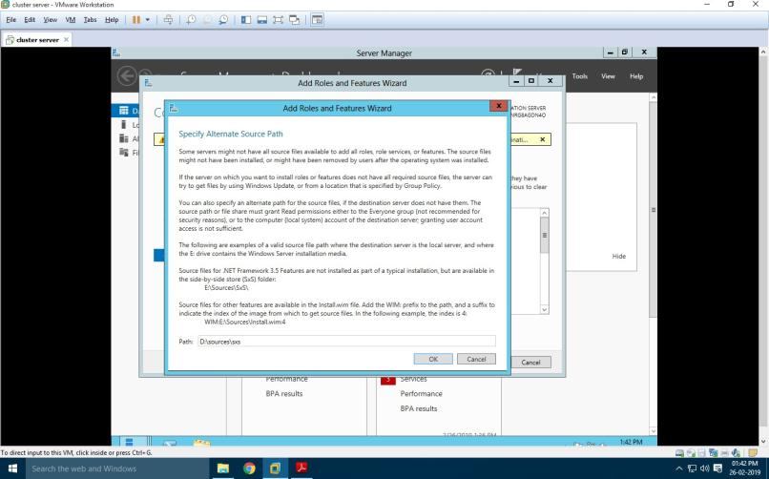

#### Now, Click on ok and Install button

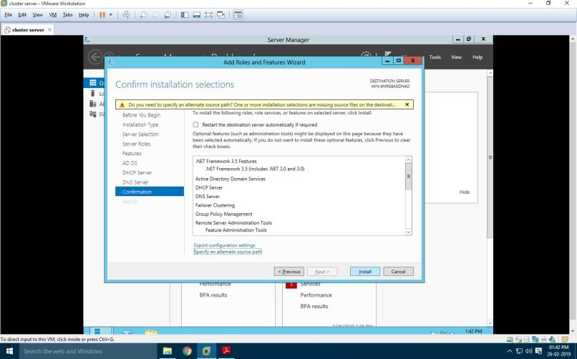

**PROMOTING AS DOMAIN CONTROLLER**

After installation Go to the “ADDS” shown on the left side in the server Manger Dashboard as shown in next screen and click on More, then Click on “Promote this server to a domain controller”.

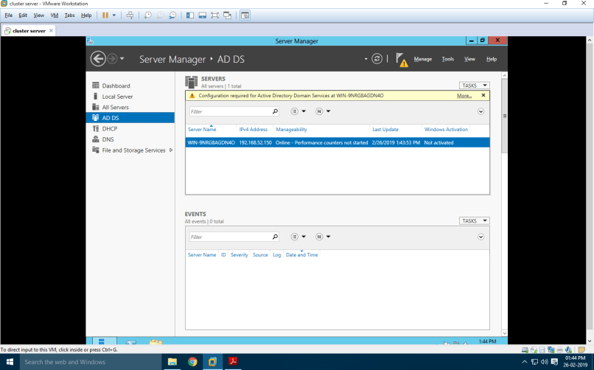

#### Choose “Add a new forest” option in the “Active Directory Domain services Configuration Wizard” window. Enter the Domain Name “rjcollege.com” as shown in the screen and click “Next”.

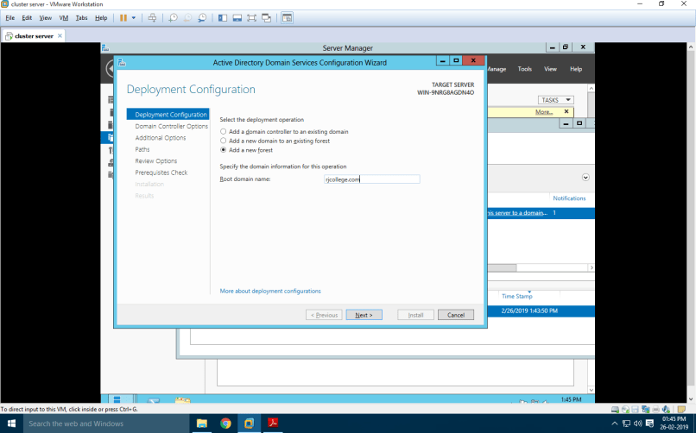

#### Under “Domain Controller Options” enter the alphanumeric password for the “Directory Services Restore Mode (DSRM) PASSWORD”. Preferably use the password given to the Administrators account.

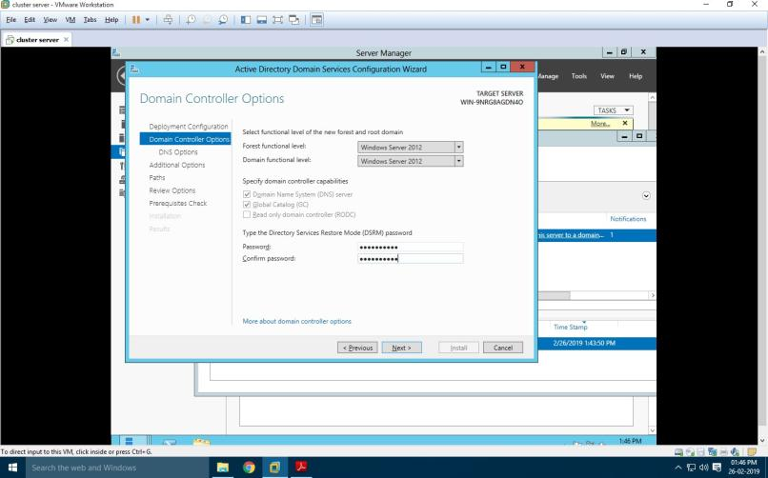

Click “Next”

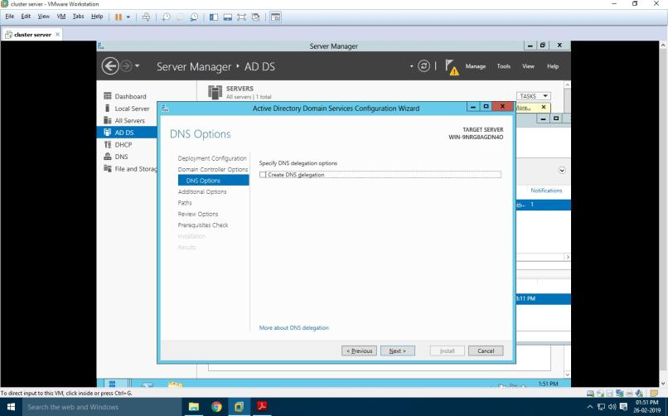

#### The NetBIOS Domain Name appears here automatically. Click “Next”.

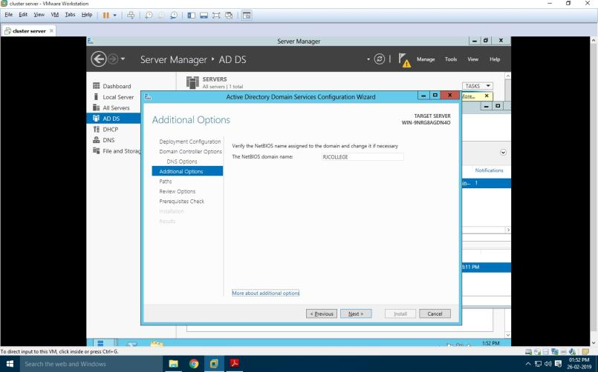

Click “Next”

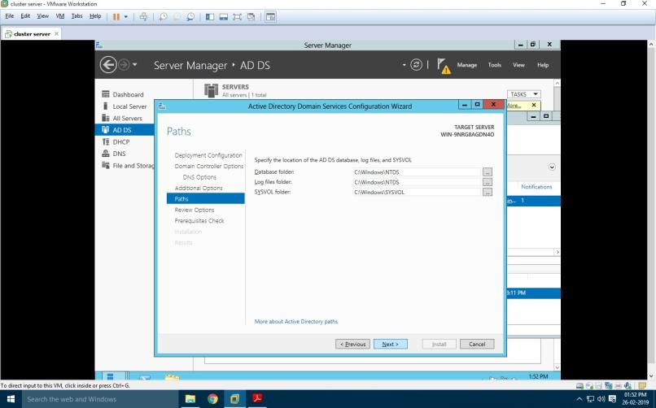

#### Under “Review Options” it shows us whatever we have selected for the Domain Controller.

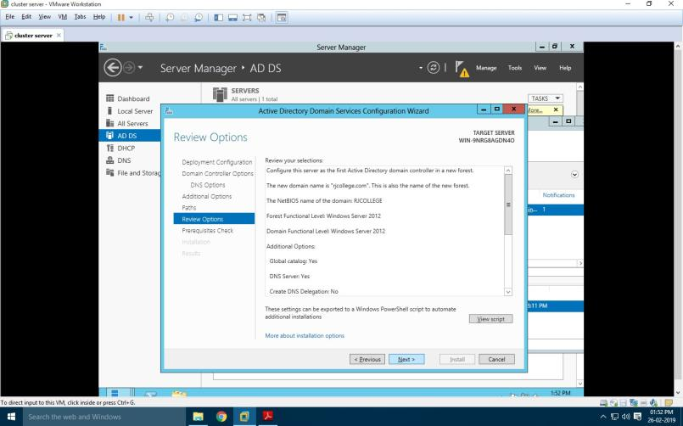

#### It checks for all the Prerequisites required to create a Domain Controller under “Prerequisites Check”. Click on “Install” button.

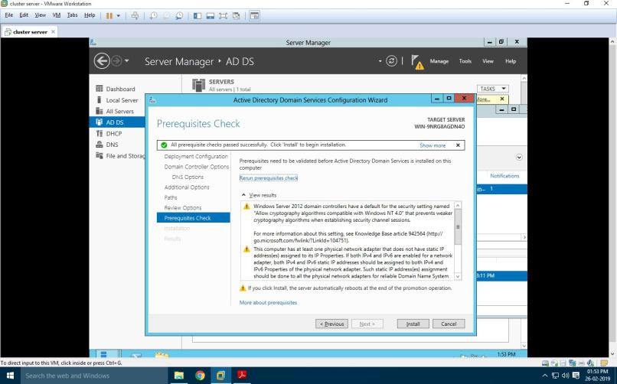

### CREATING FAILOVER CLUSTER

#### Click on the “Failover Cluster Manger” under the tools menu to get the following screen.

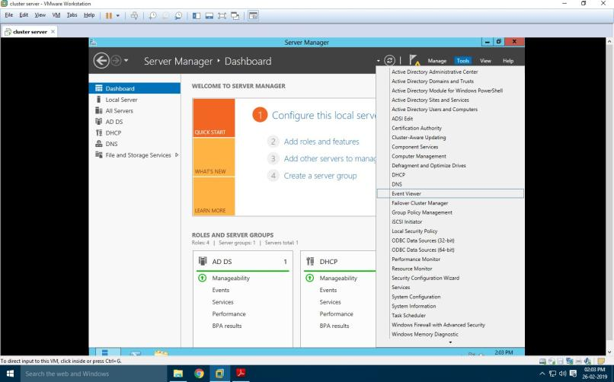

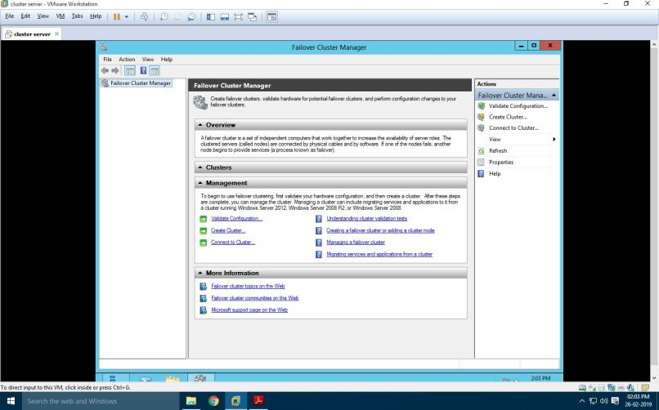

#### Click on “Validation Configuration” to open the “Validate a Configuration Wizard” by clicking on the “Validate Configuration” under the Management section at the bottom or right side of the screen. The nodes to be added must be validated prior to add in the cluster. Click “Next”.

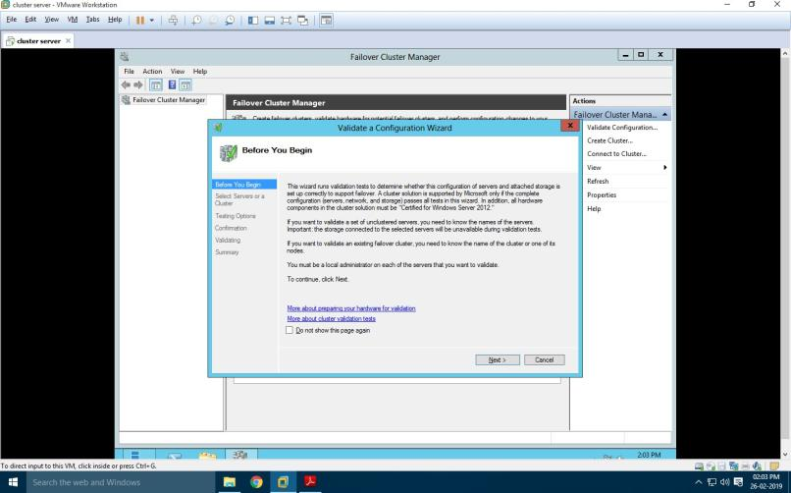

#### In this screen, click on Browse button and then Advanced for finding the domain node. As shown in below screens.

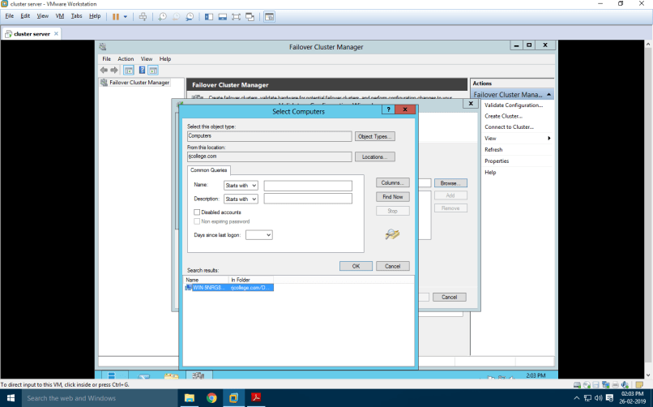

Click on **run all test**

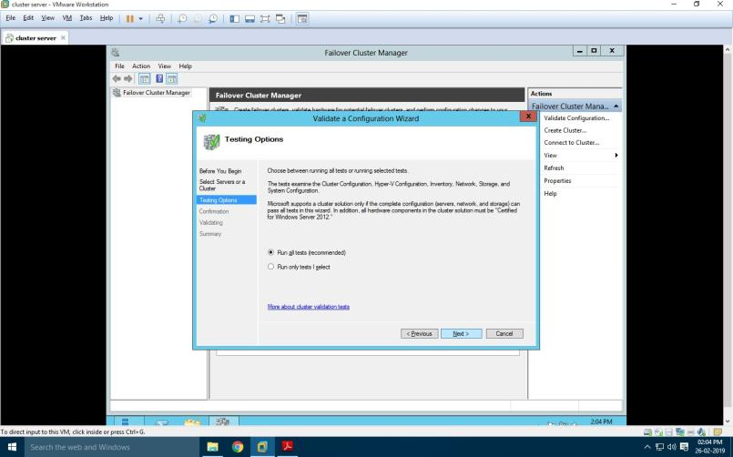

#### Choose “Run all the tests(recommended)” and click “Next” and then it will ask for the confirmation click “Next”. It will start all test validation.

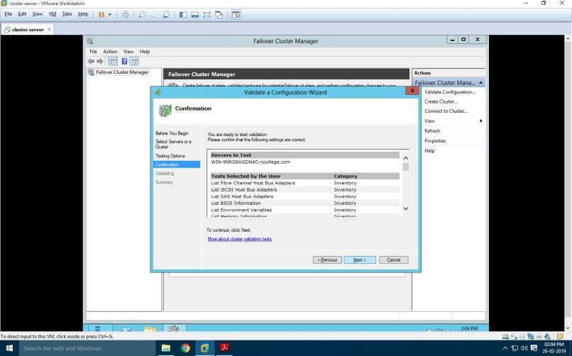

After completion it will display the summary report as shown below. If there are any errors can be seen here and you will not be allowed to create the cluster. As shown in the screen we can see that the nodes are validated. Click on finish.

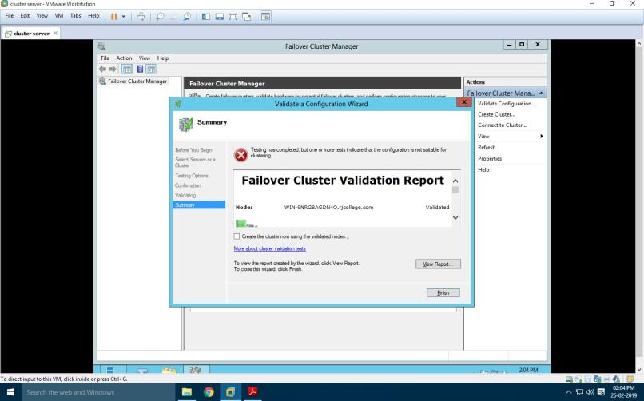

#### After validation completion you will create the “Create Cluster Wizard” click Next.

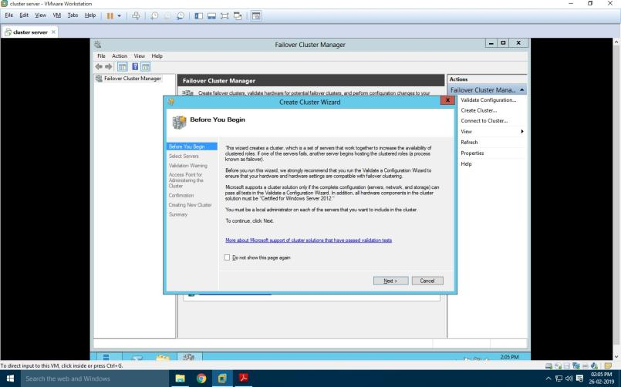

#### Specify the Cluster name. Cluster name here should be the NetBIOS name of the Domain Controller, so here it is RJC_Node. Click next

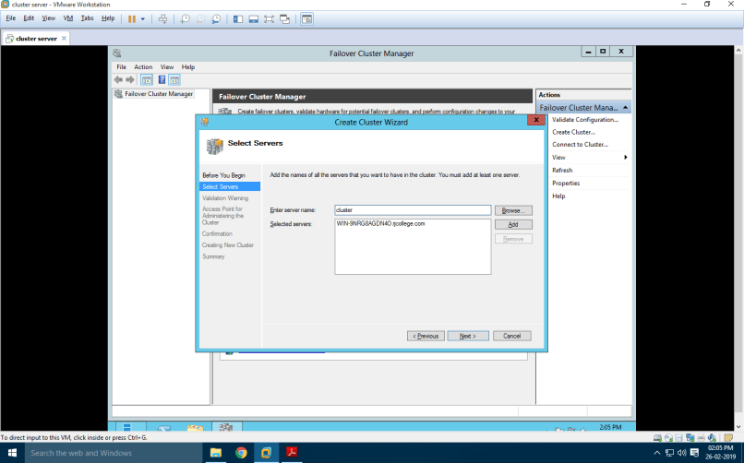

It will ask for the confirmation of cluster Creation. Click “Next”.

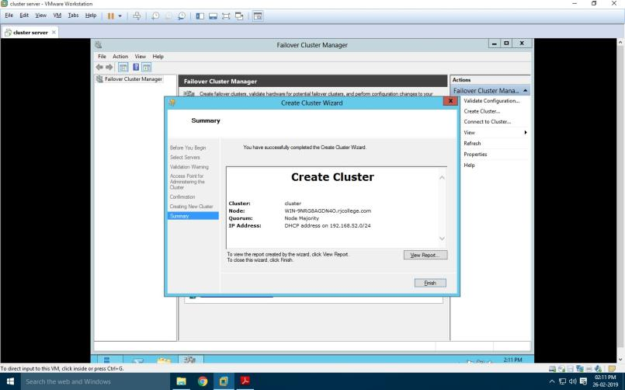

RAMNIRANJAN JHUNJHUNWALA COLLEGE OF ARTS, SCIENCE & COMMERCE, MSCIT / PART 1 /SEM II /CC

#### If the Cluster creation is successful you should see the following screen that shows a message “You have successfully completed the Create Cluster Wizard”

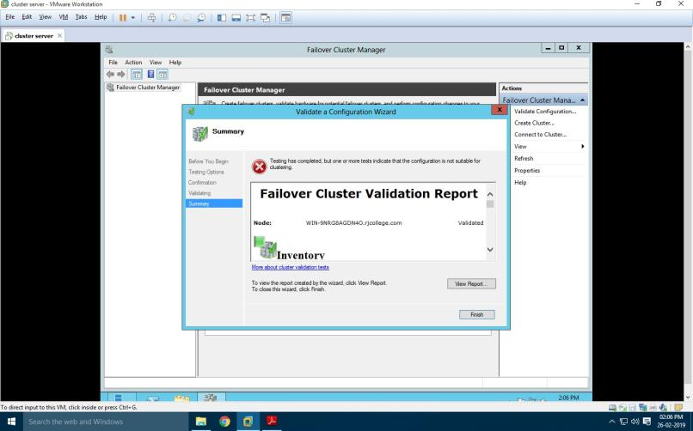

After cluster gets created you can see the cluster on the left side as shown in the screen below.

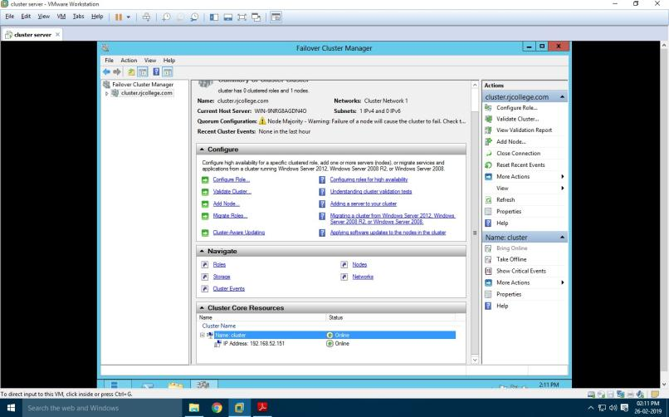

**PRACTICAL: 2 DEVELOPING APPLICATION FOR WINDOWS AZURE**

#### To develop an application for Windows Azure on Visual Studio install the

**“Microsoft Azure SDK for .NET (VS 2010) – 2.8.2.1”**

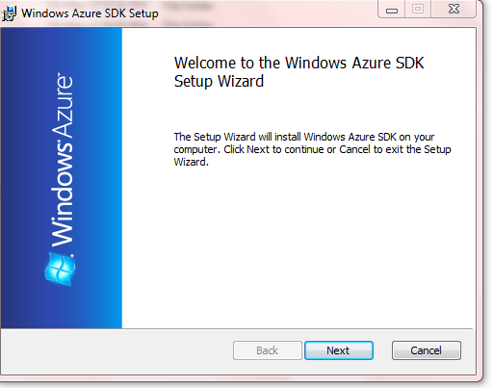

#### Accept the license and Click on Next.

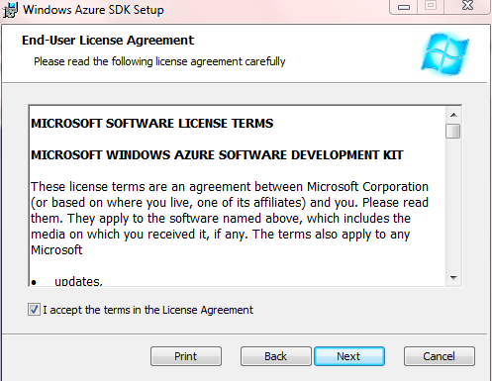

Click on Finish

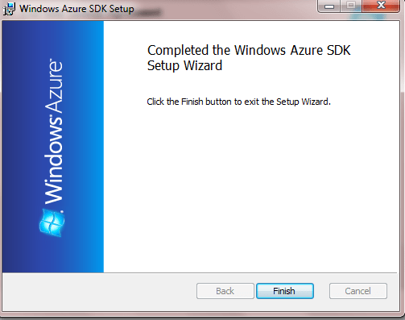

## Step2:

#### Turn windows Features ON or OFF:

Go to Control panel and click on programs.

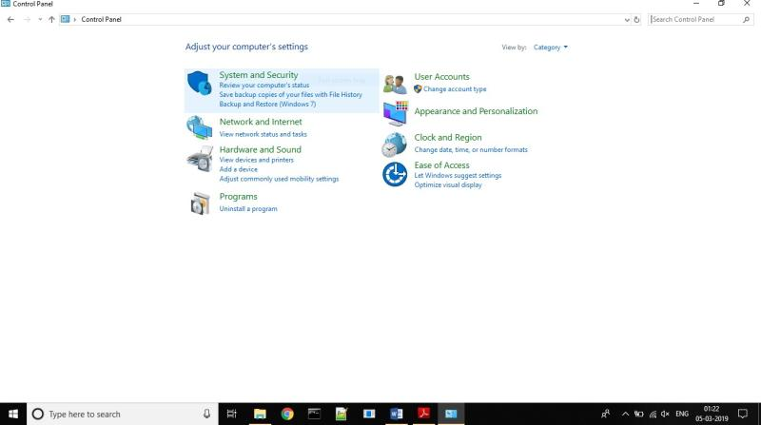

#### Turn Windows features on or off.

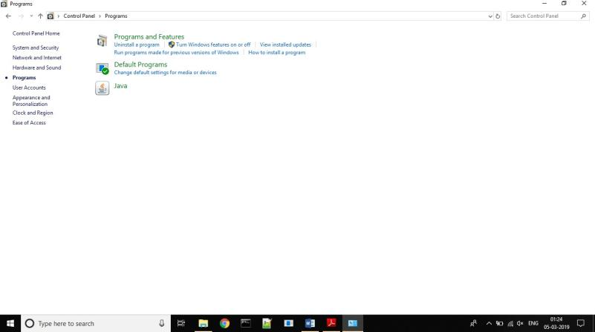

Expand the internet information services and select the following checkbox.

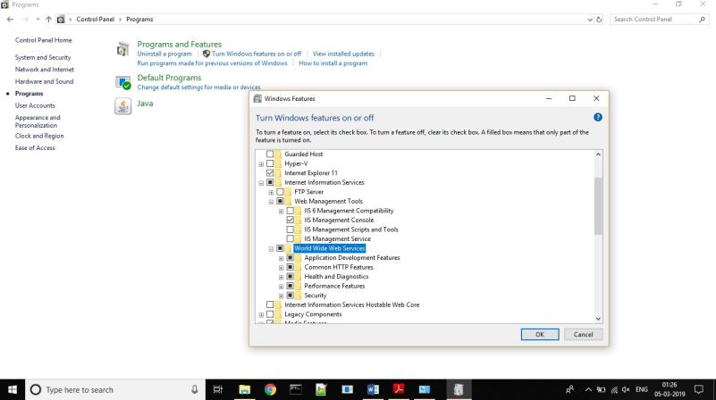

**Step4:**

Now, Start the visual studio 2010 and Go To File->New->Project

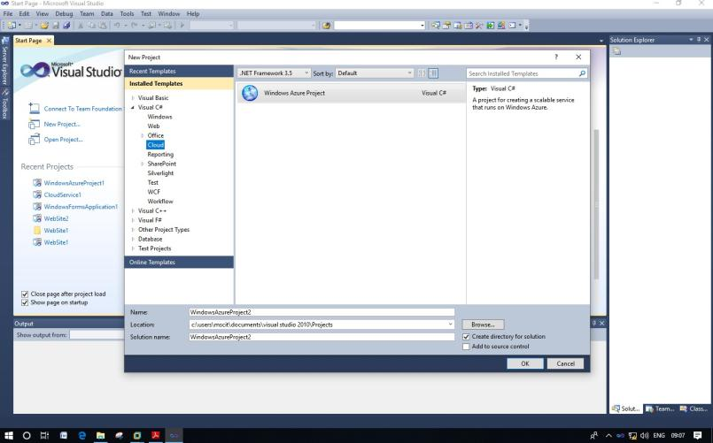

#### Add asp.net roles

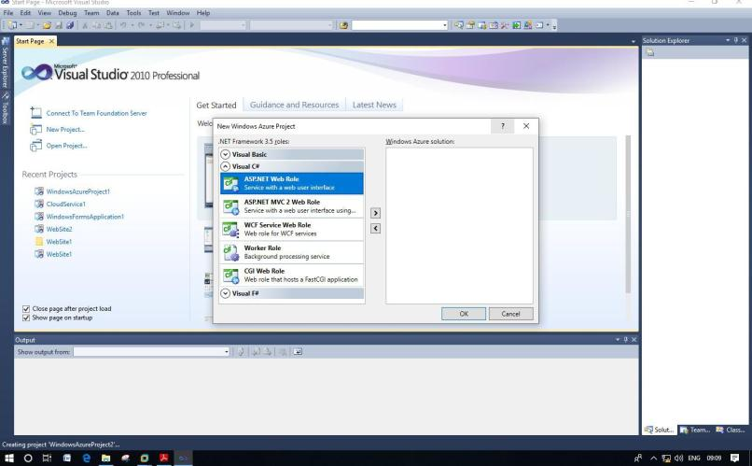

Create a web form

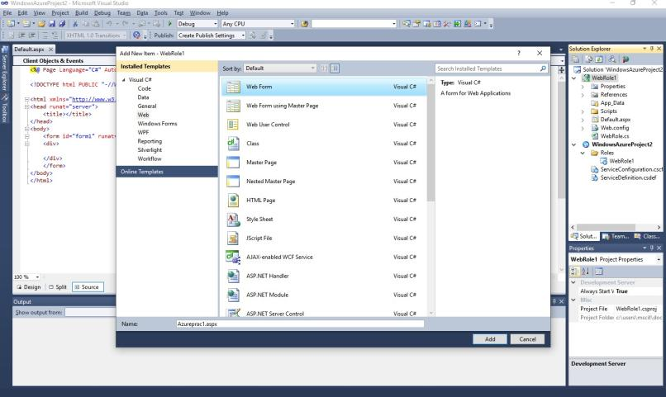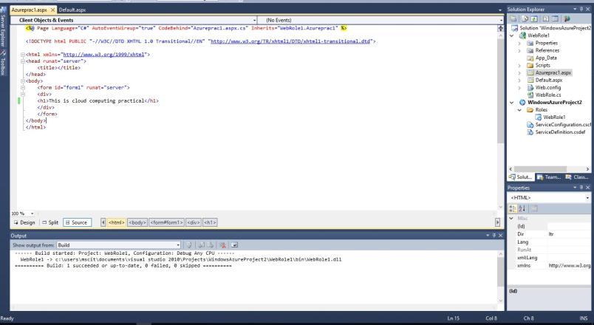

#### Run the website

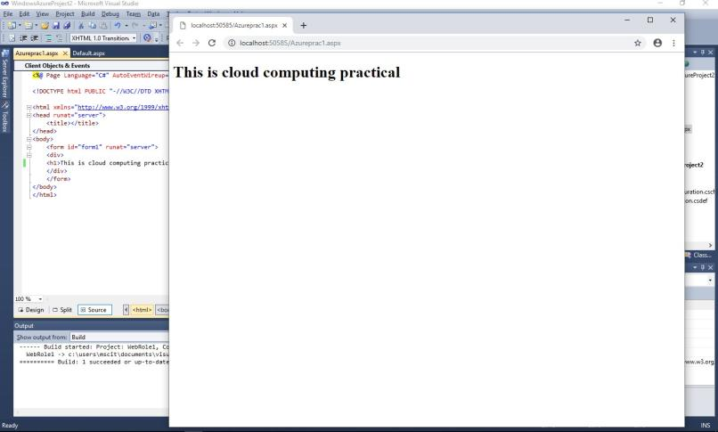

# PRACTICAL: 3

## IMPLEMENTING PRIVATE CLOUD WITH XEN SERVER

#### Open VMware Workstation – And select Create a New Virtual Machine

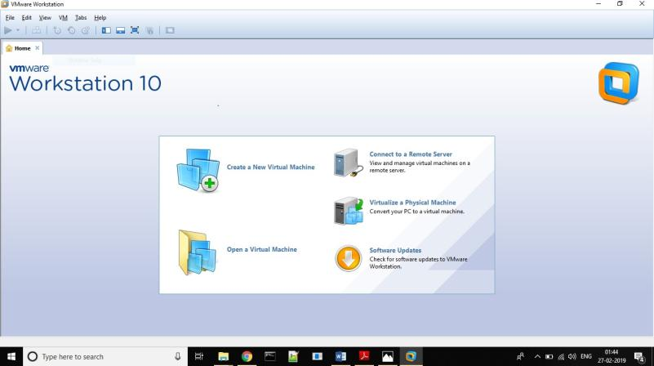

Select Typical and click Next

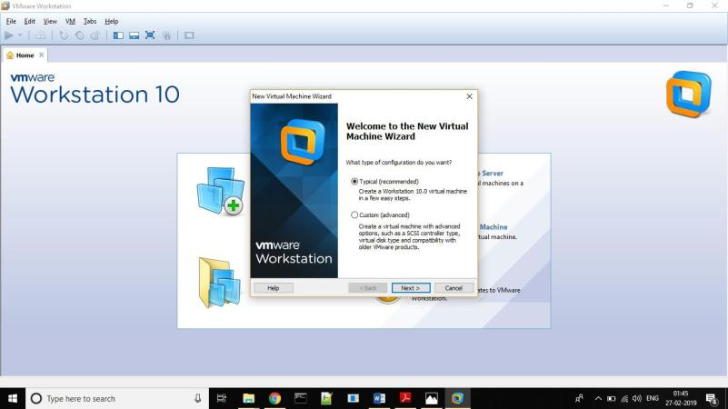

Select Installer disc_image file(ISO). Click Browse - XenServer Iso File – For Example “**D:\ccpraxrj\XenServer-6.2.0-install-cd.iso**”

#### And click on next

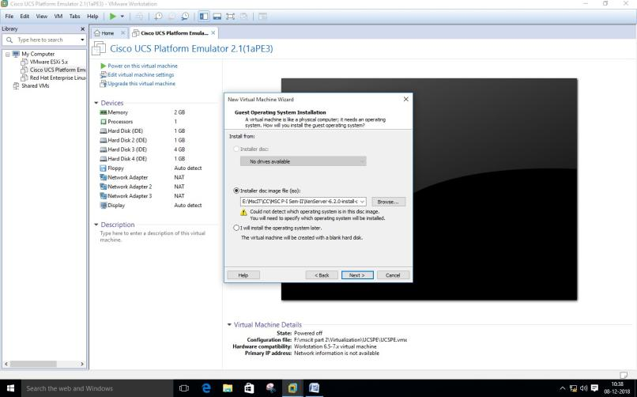

Select Guest Operating system as Linux. Version as Ubuntu. Click Net.

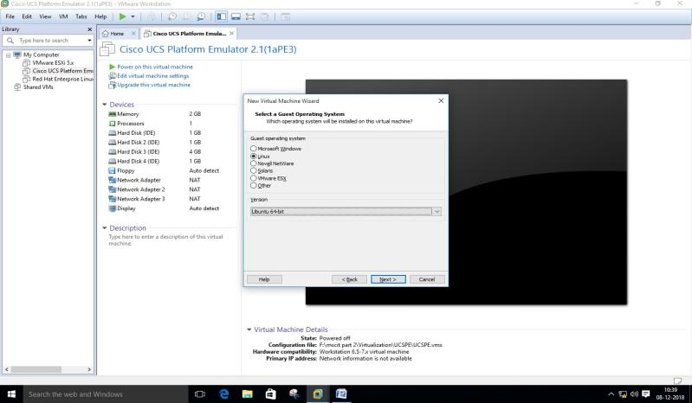

#### Give Virtual name – for Example “XenServerInst” and click on next

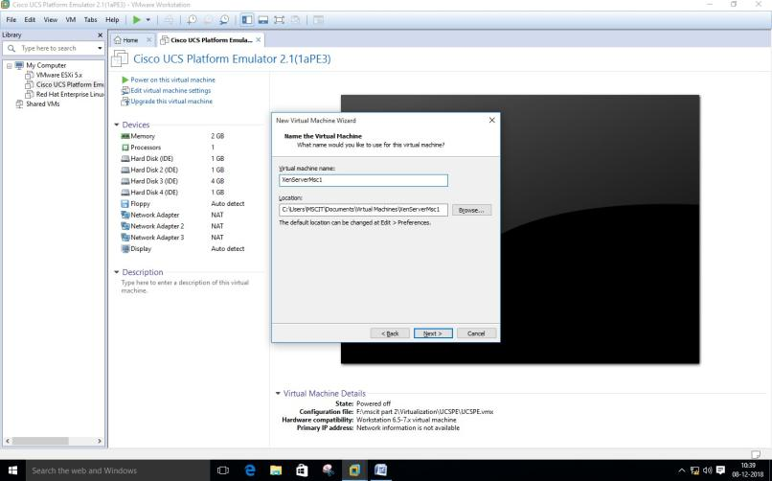

Change maximum disk size to 40 GB and check –Store virtual disk as single file

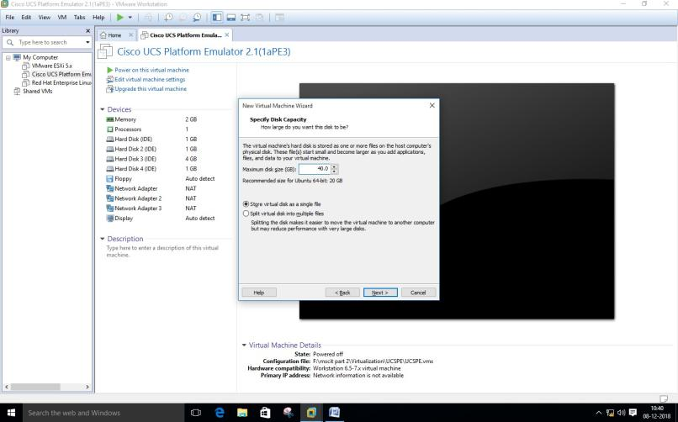

Click on **Customize Hardware option**

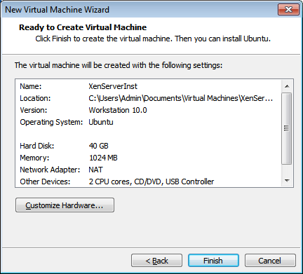

#### Change – Memory for this virtual machine to 2 GB and click on close

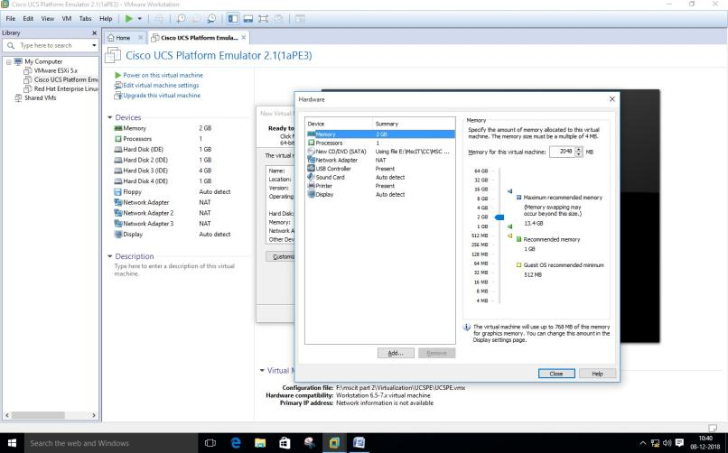

Click on Processer and select virtualize Intel VT

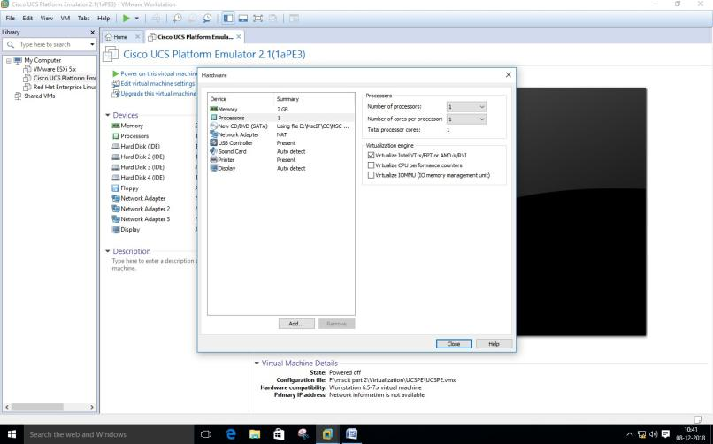

#### Click on Finish –

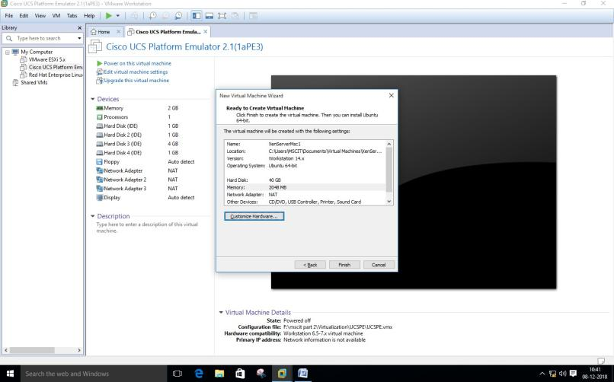

Now Power on newly created Virtual machine –

Now select US and click on OK

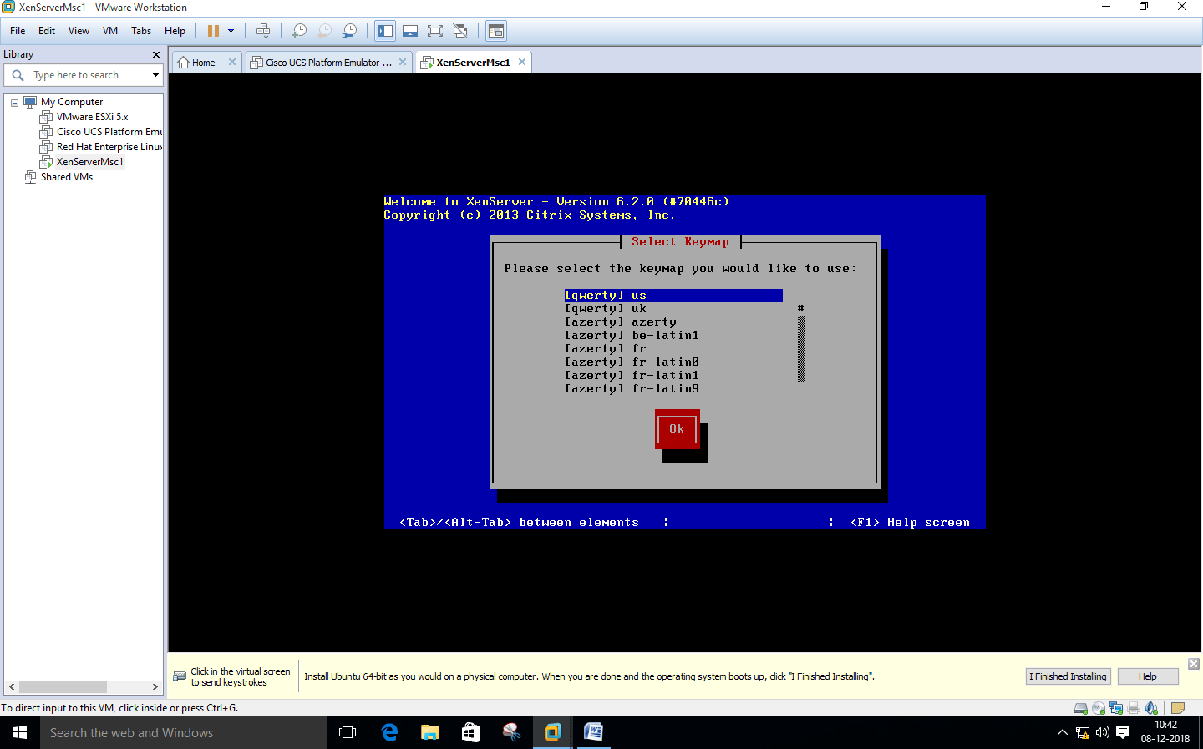

#### Click on OK as seen in below screenshot -



Select **Local media and ok**

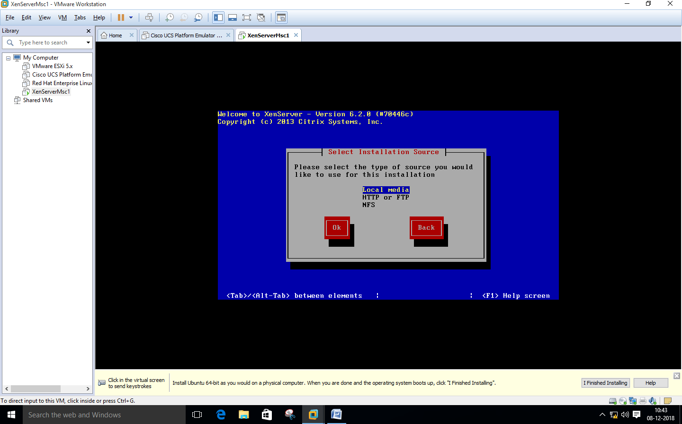

Click **ok**

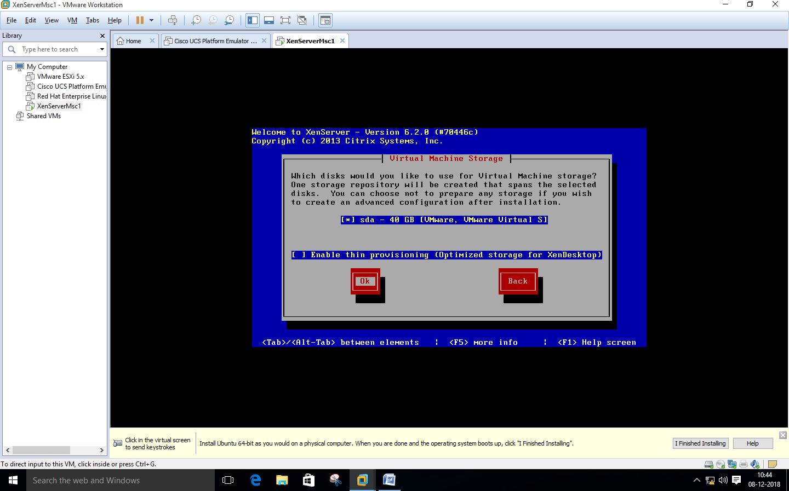

Click **No**

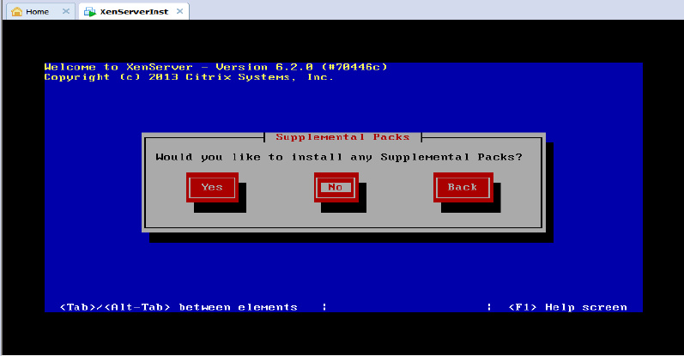

Here click **varify installation**

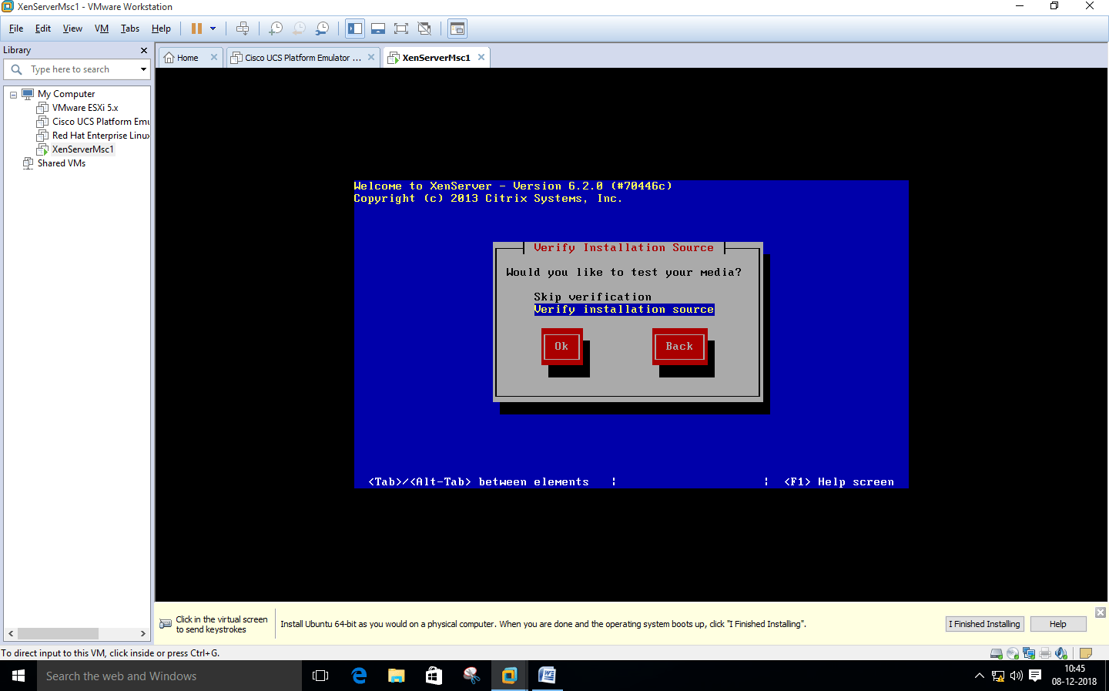

Click **ok**

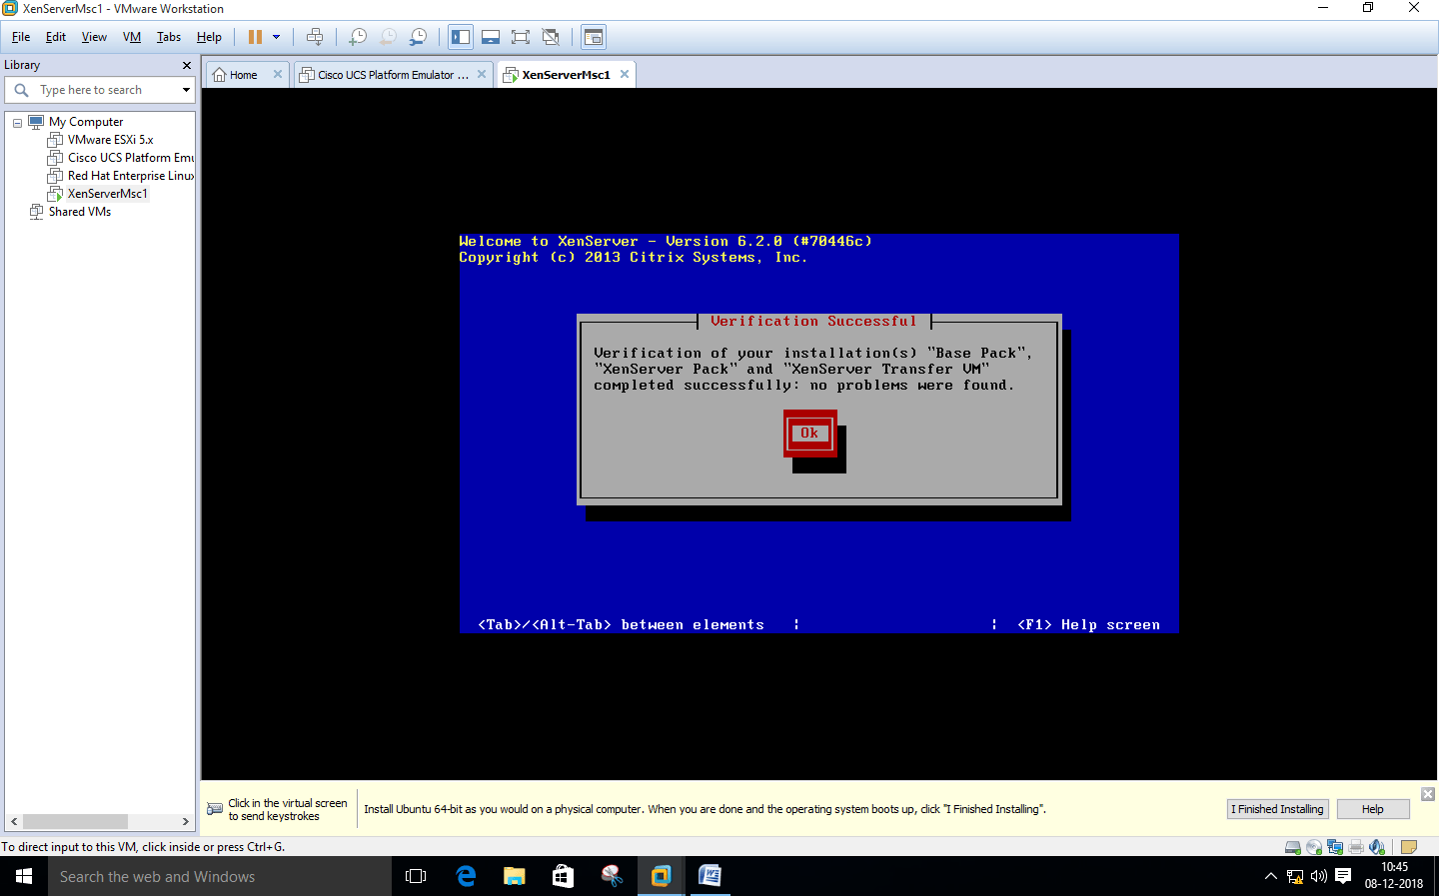

#### Insert password (Remember password entered) and click on Ok –

**Password:root123**

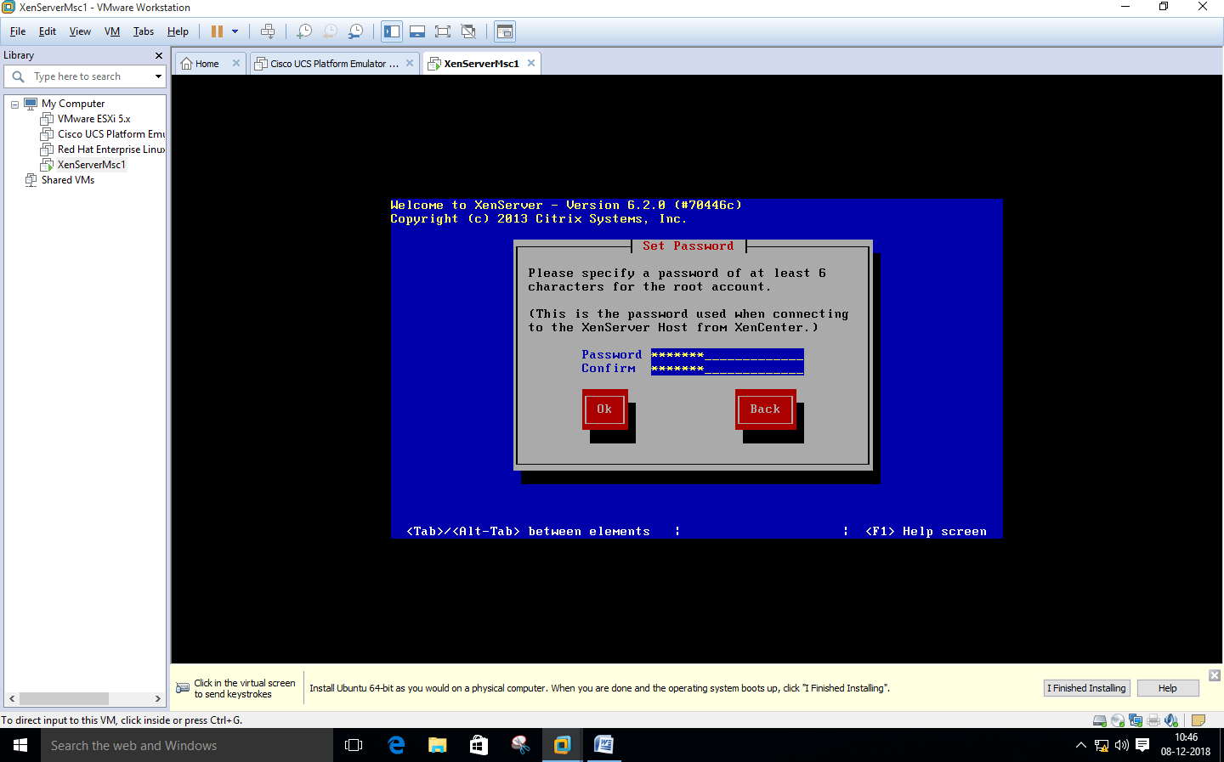

#### Select Automatically set via DHCP and click on OK

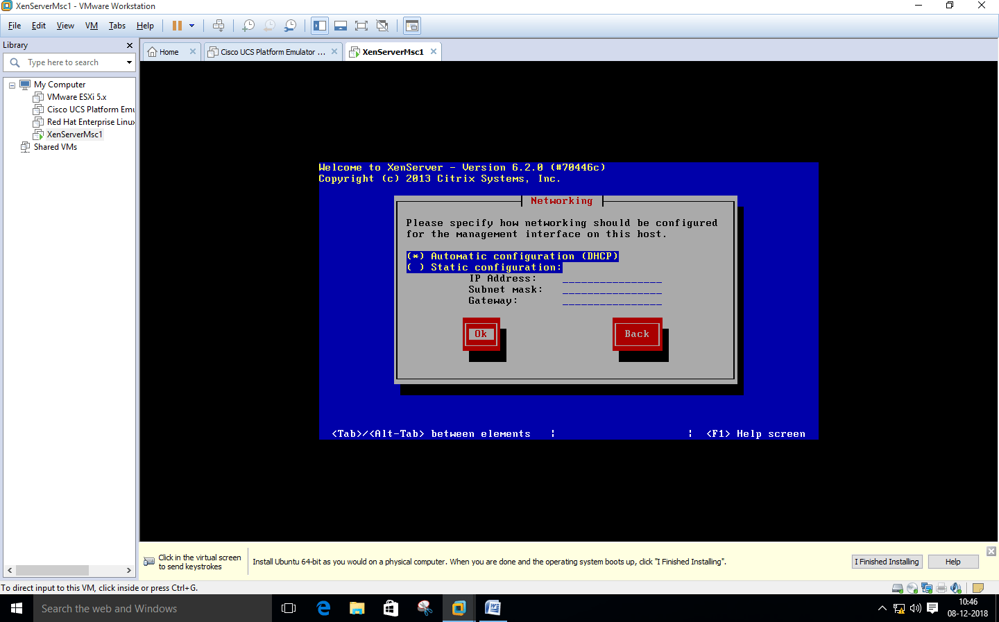

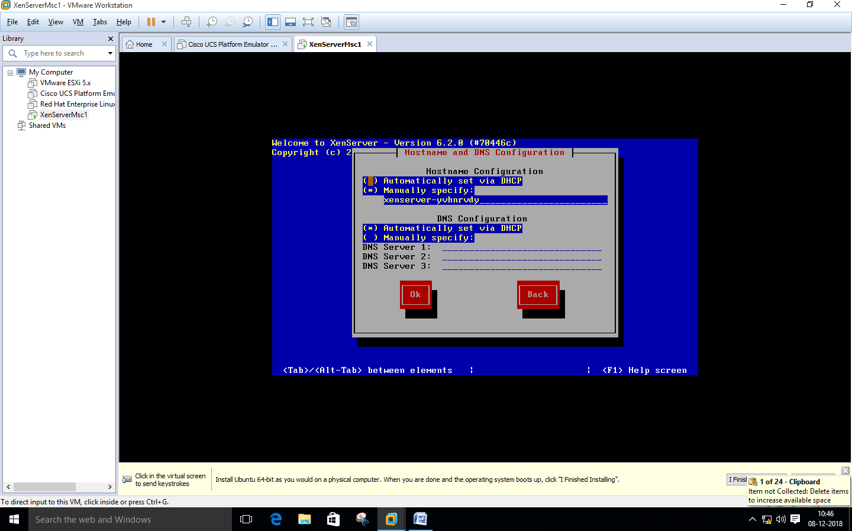

#### Select Asia and click on OK –

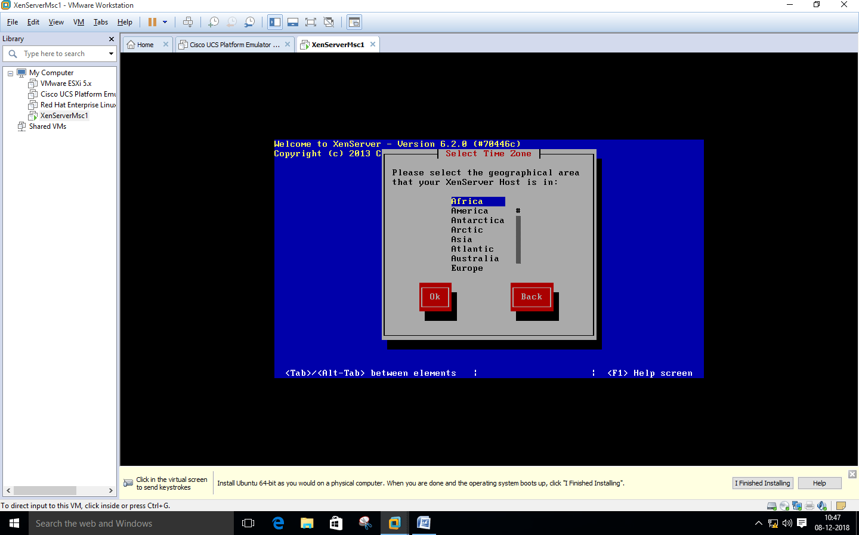

Select **Calcutta**

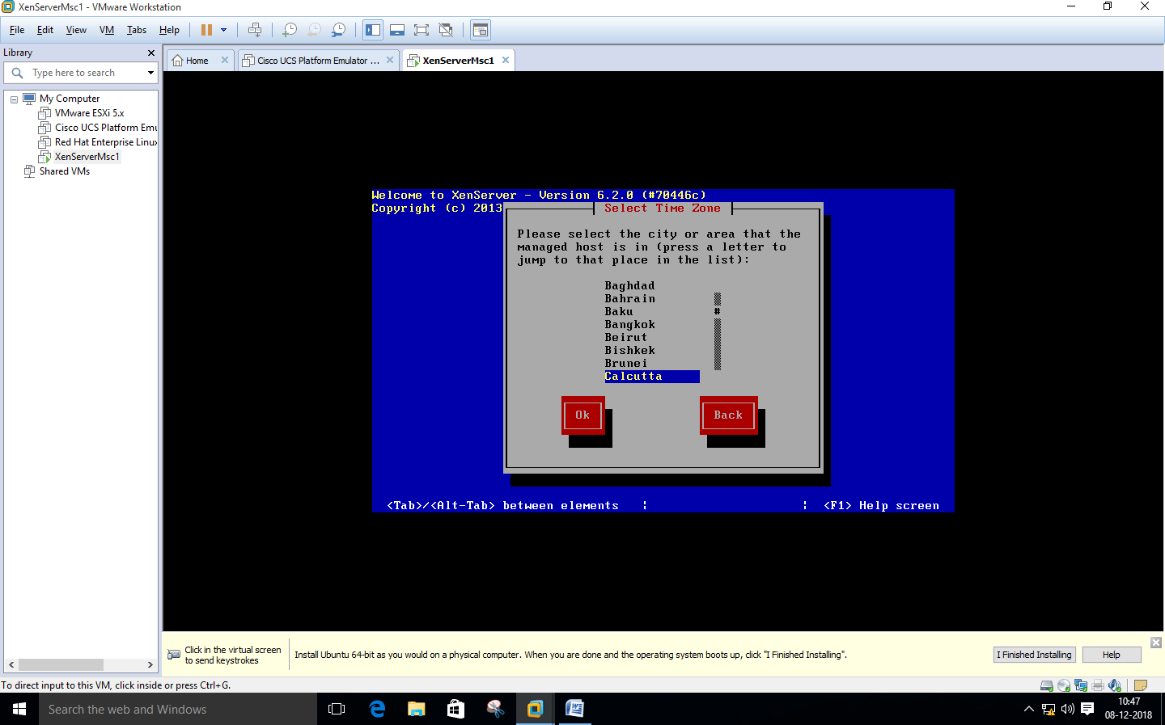

#### Select “Using NTP” and click on OK

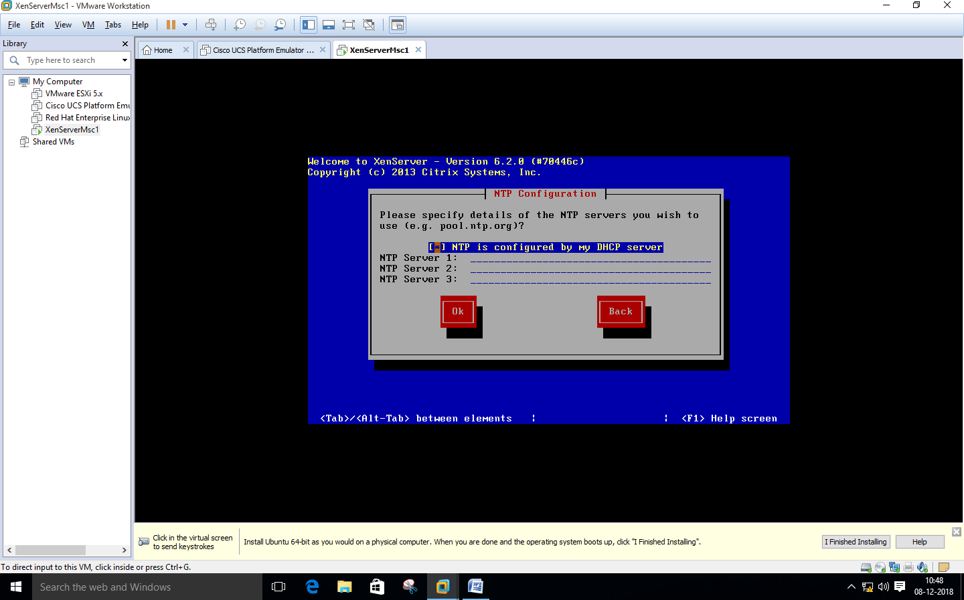

Click **Install Xen server**

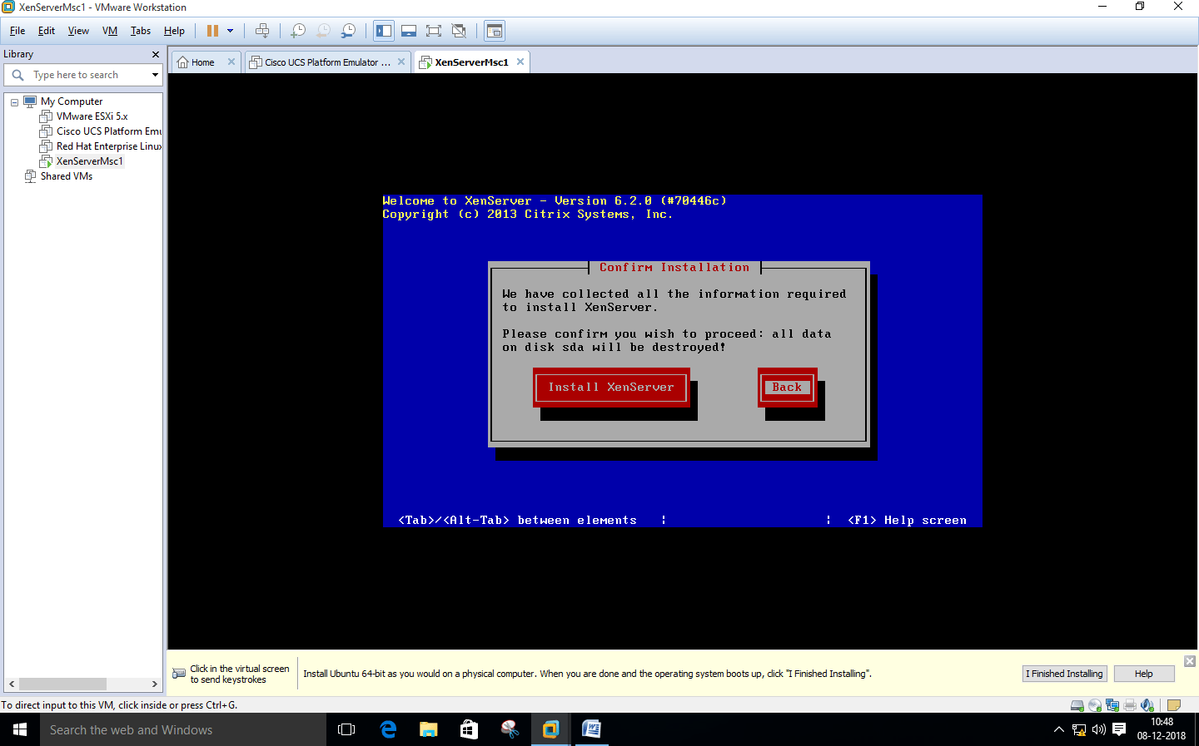

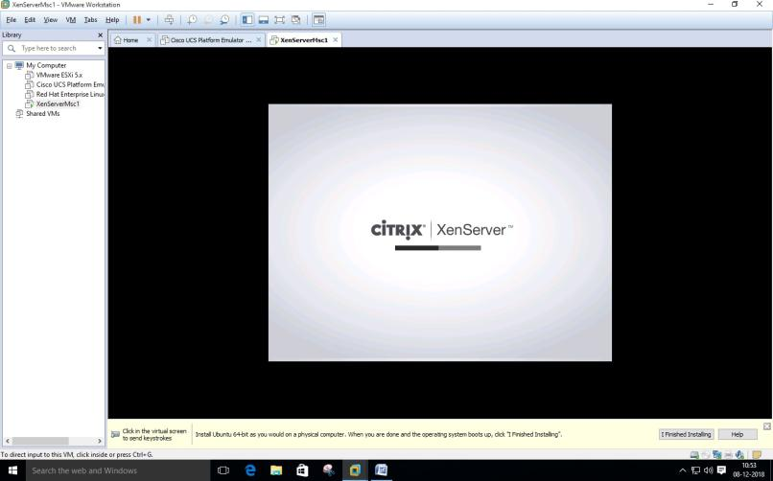

#### Note IP Addres – “ 192.168.283.141” ping it from command prompt

#### Now Install Citrix App if not installed –

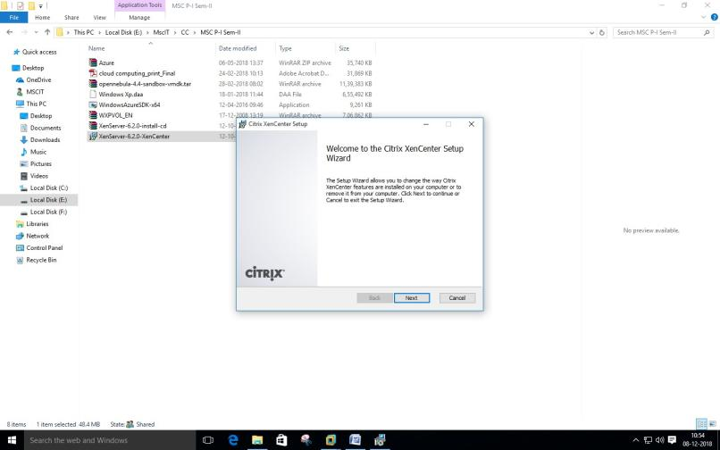

Now Open Citrix XenCenter – and Click and **Add Server**

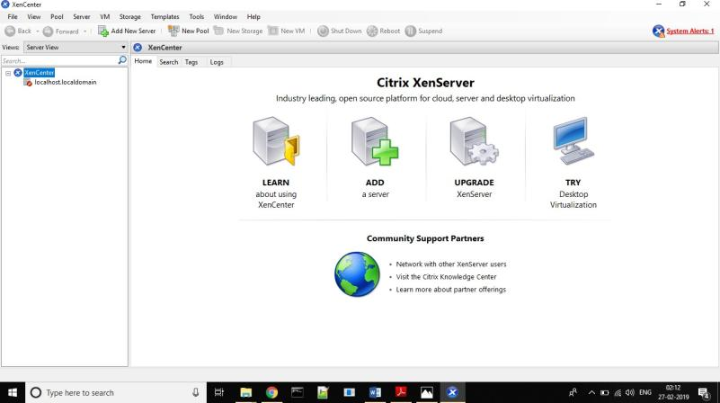

#### Fill IP address copied from Installation and User name as “root” and Password as “root123” which we had given during installation and Click on Add

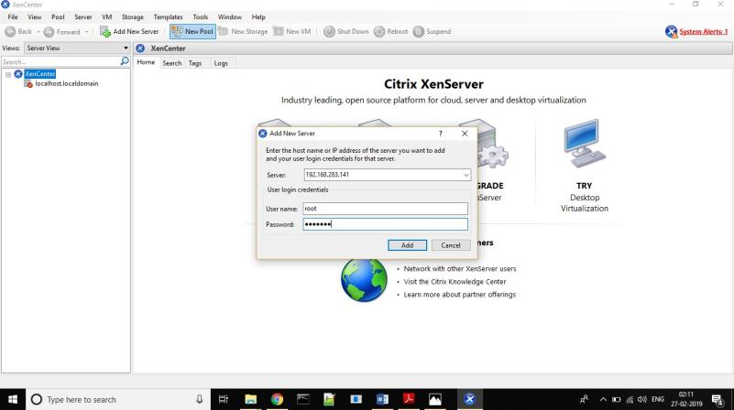

Now Click on New Storage –

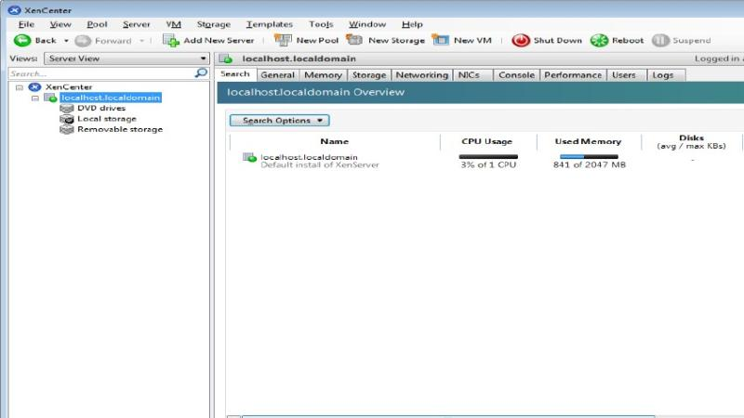

#### Select Window File Sharing (CIFS) and click on next –

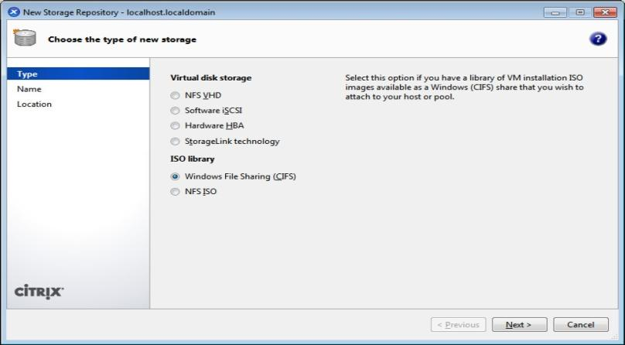

Uncheck Auto generate option Click on Next

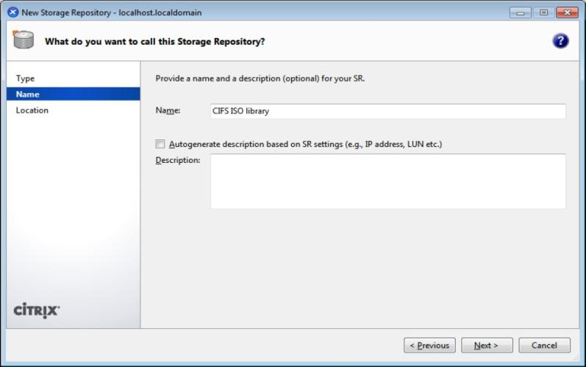

#### Provide the path of shared windows XP image and enter local pc credential ,, click on Finish

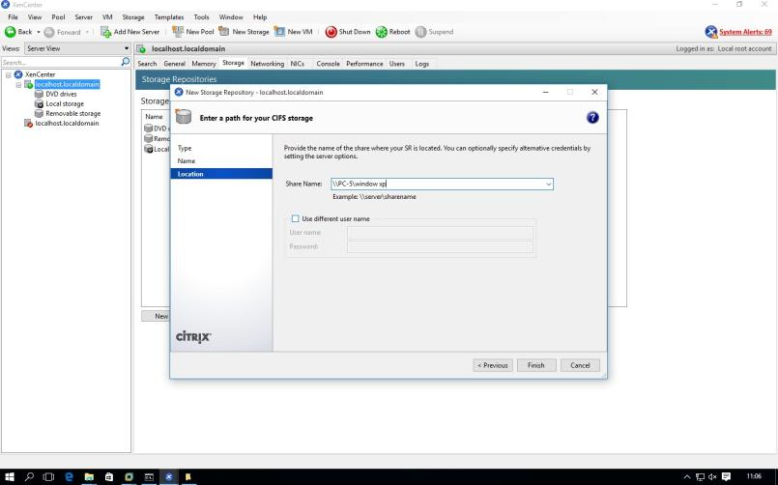

#### Click on New VM – and Windows XP SP3

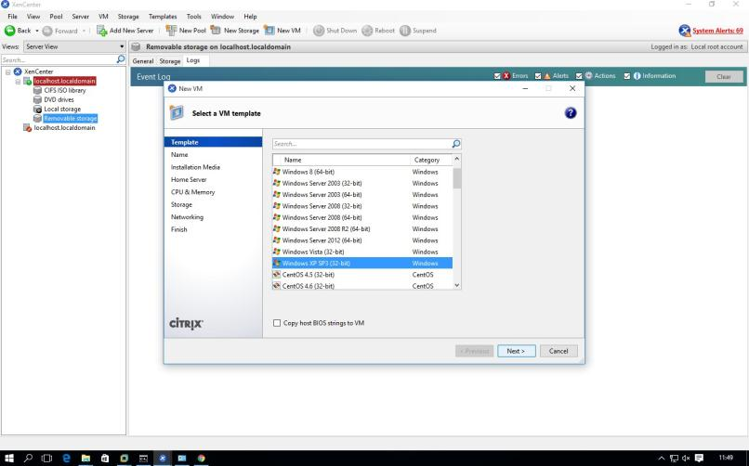

Select ISO file and click on next –

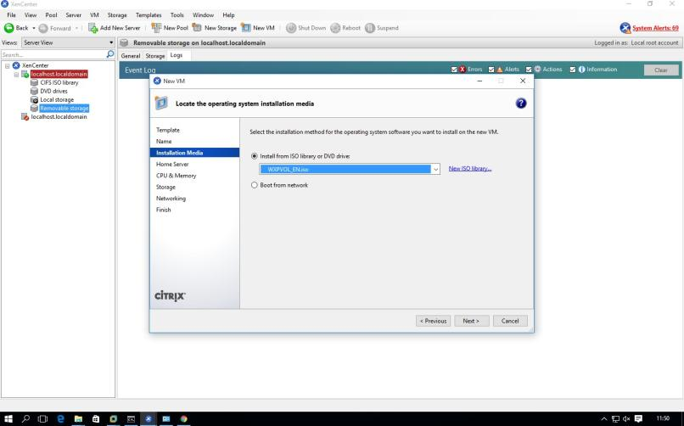

#### Next –

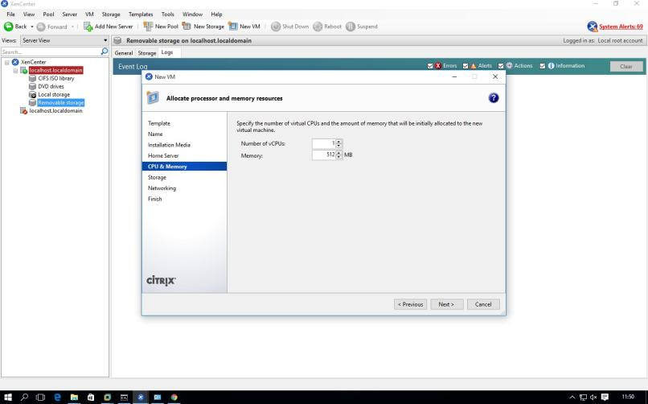

Next-

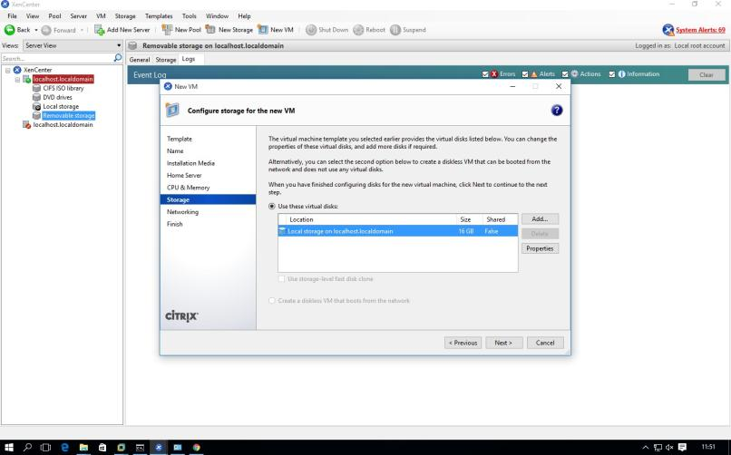

Next-

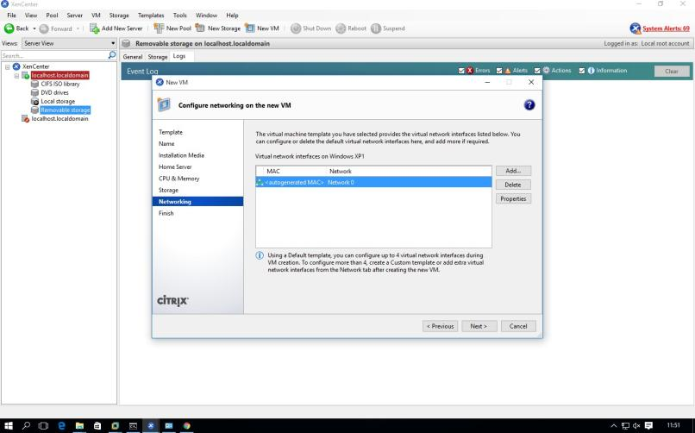

#### Uncheck – Start the new VM and click on create now

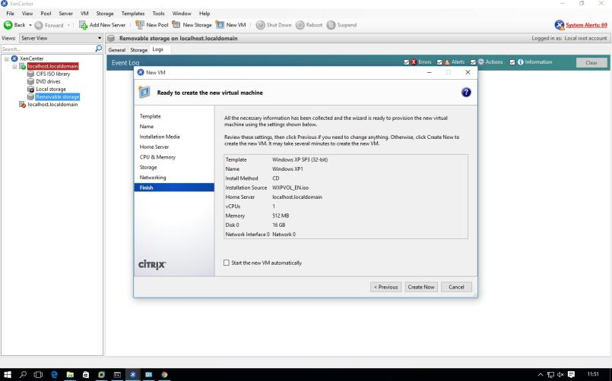

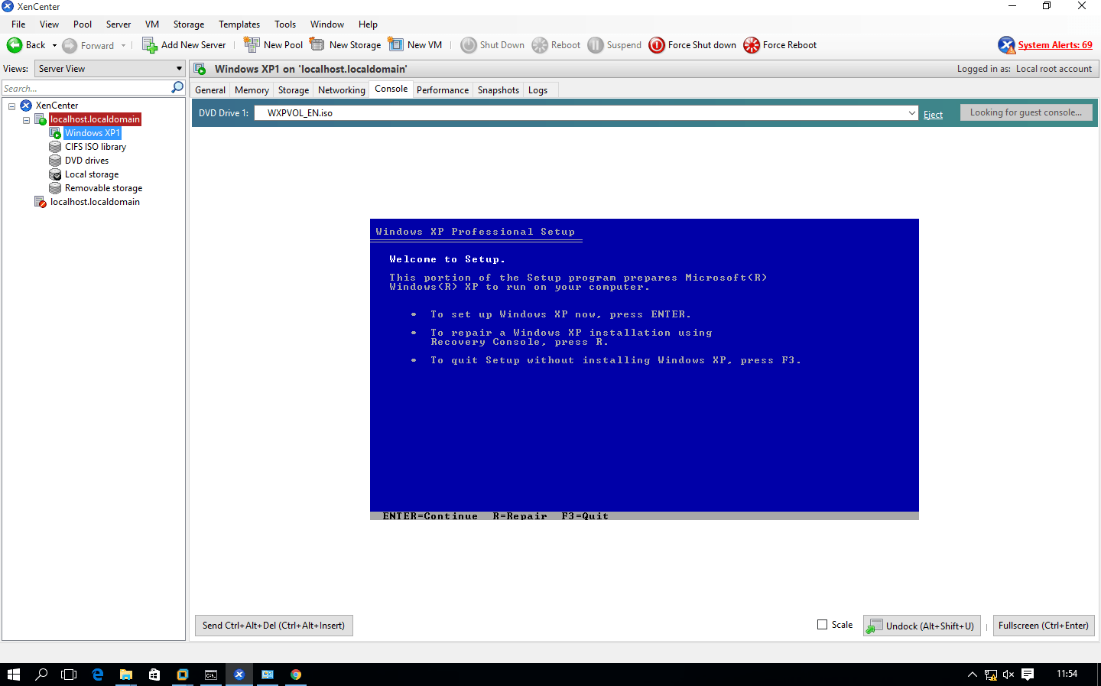

# PRACTICAL: 4

## IMPLEMENT SEARCH ENGINE _ GOOGLE APP ENGINE (GAE)

Open Eclipse Luna. Go to **Help Menu Install New Software…---------**

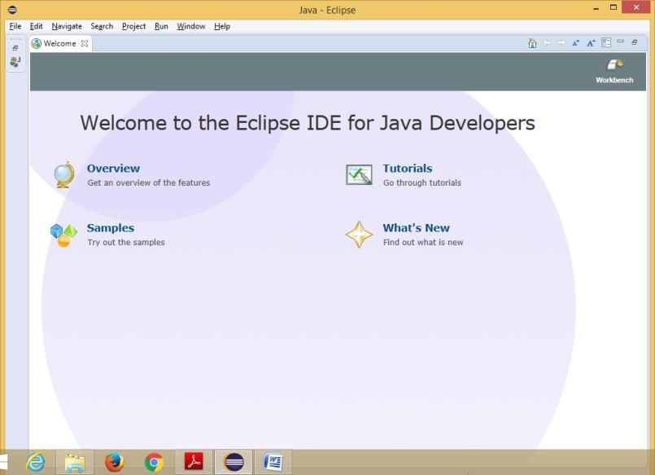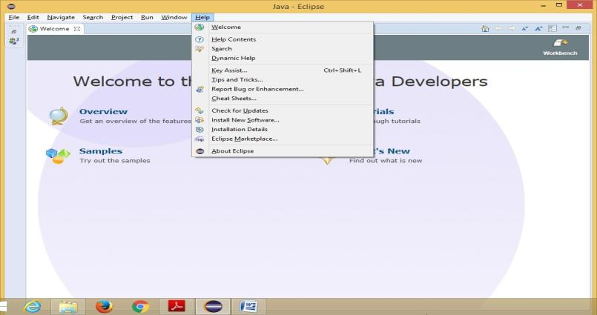

In **Install** window Click on the **“Add”** button besides the **Work with** textbox. **Add Repository**

window appears. Enter the **Location** as **“https://dl.google.com/eclipse/plugin/4.4”**

##### and click

on **“OK”** button**.**

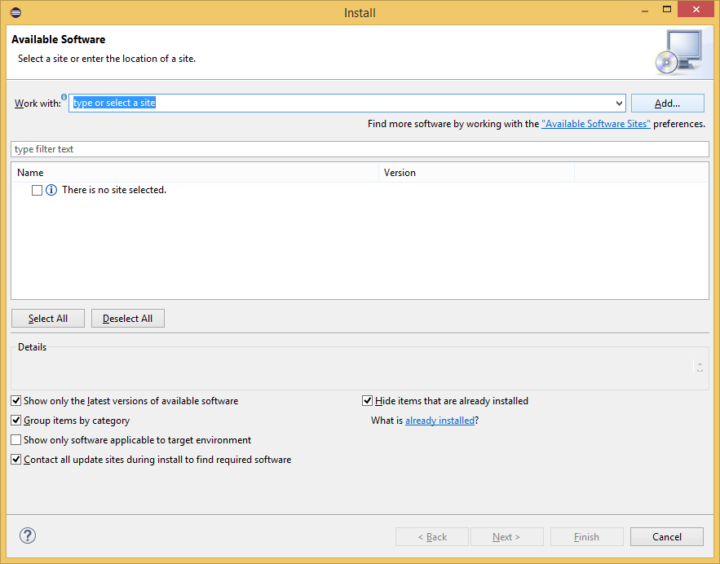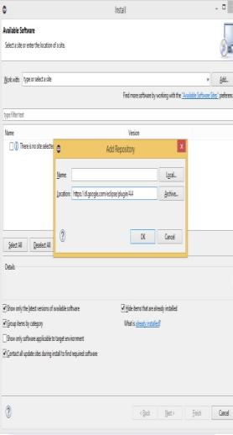

##### From the available software, select the required software and tools as shown in the below image for the **GAE**. Then click on the **“Next”** button.

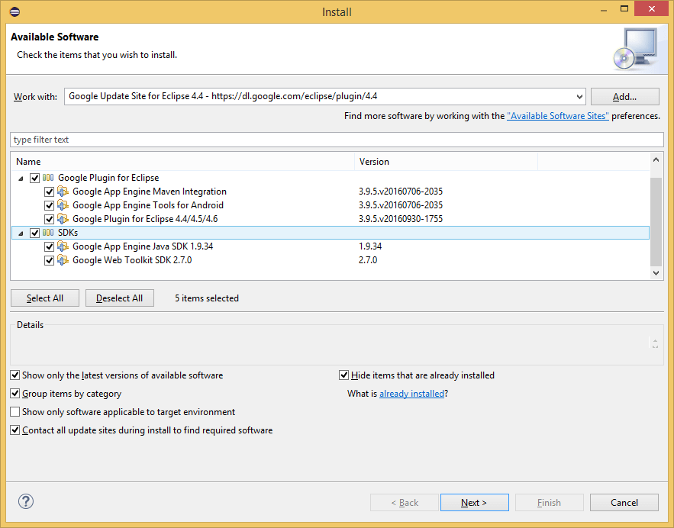

In the **Install Details** window click on **“Next”** button.

##### In the Next Window "Review the Items to be Installed" then click on **“Next”**

In the next window for Review Licenses select the option **“I accept……”** and click on

**“Finish”** button.

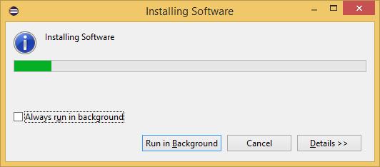

##### The installation is in progress…

After Installation you will get option to **"Restart Eclipse",** click on **Yes.**

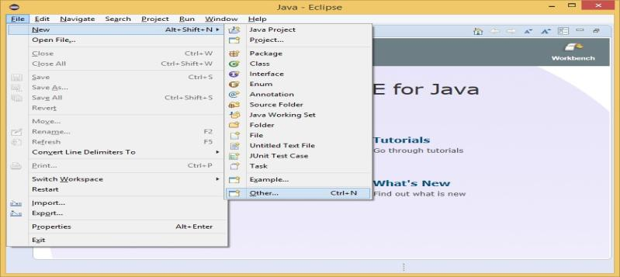So that the software you selected gets updated... Now, go to **FileMenu->New->Other**

In the New window select **Google**_**Web Application Project** and click on **“Next”**

##### button.

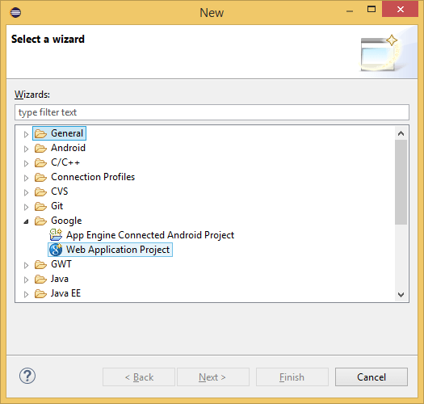

Enter the details for the new Web application project. Deselect the **Use Google Web Toolkit** option under the section **Google SDKs**. Click on the **“Finish”** button.

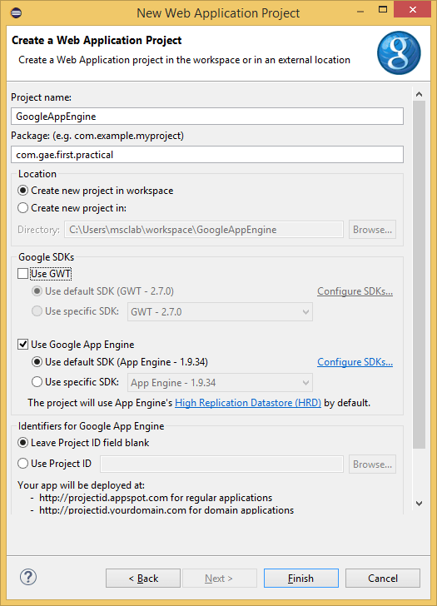

From the **Package Explorer** open the **.java** file (Here it is

**“Google_App_EngineServlet.java”**).

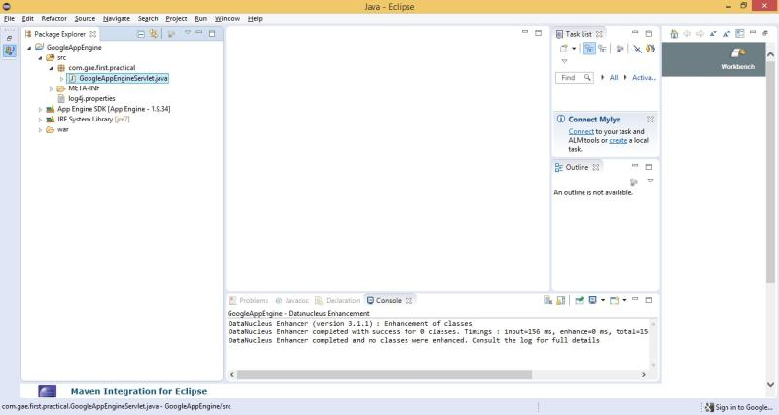

##### Edit the file as required (Unedited file too can be used. Here the editing is done to “what should be displayed” on the browser). **Save** the file. Click on the **Run** option available on the Tools bar.

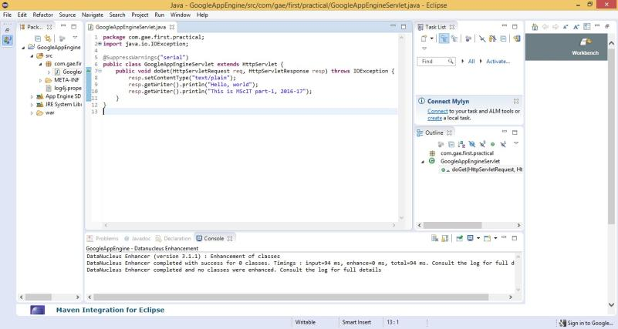

In the browser (Here, Google Chrome) type the address as **“localhost:8888” which is "Default"**.

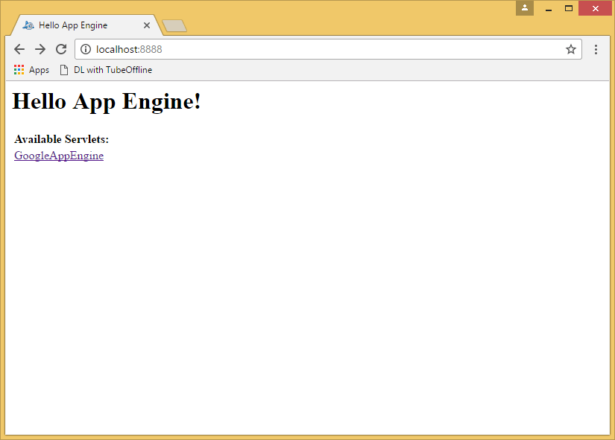

In **localhost:8888** link to the **Google_App_EngineServlet.java** file as **Google_App_Engine** is displayed. Click on this link. It will direct you to **“localhost:8888/Google_App_Engine”**.

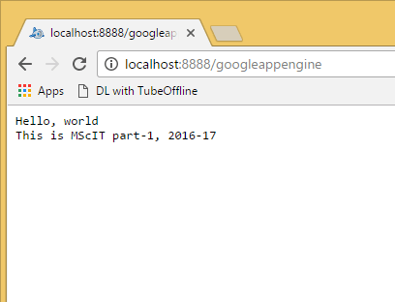

The **output text entered** in the **java** program is **displayed as the output** when clicked the link

##### “Google_App_Engine”.

# PRACTICAL: 5 IMPLEMENT ESXi SERVER

#### **Steps:** Open VMware Workstation – And select Create a New Virtual Machine



Select Typical and click Next



Select Installer disc_image file(ISO). Click Browse -ESXi-5.x-Custom.iso Iso File – For Example “**D:\ccpraxrj\ESXi-5.x-Custom.iso**”

#### And click on next

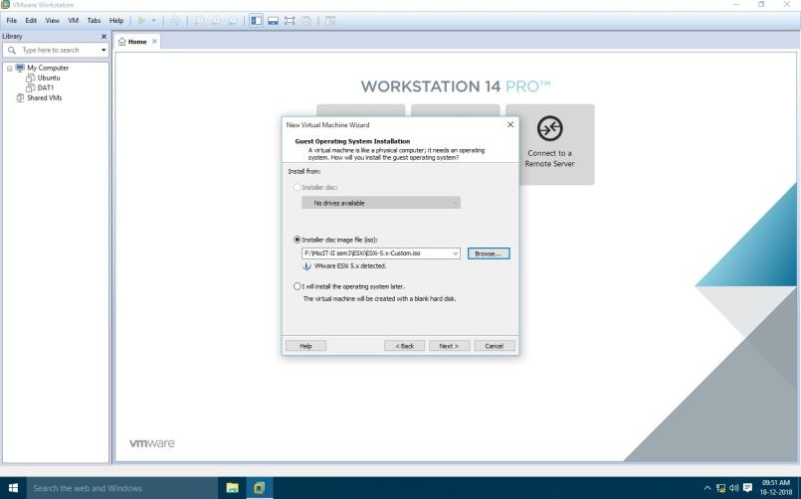

Change maximum disk size to 60 GB and check –Store virtual disk as single file

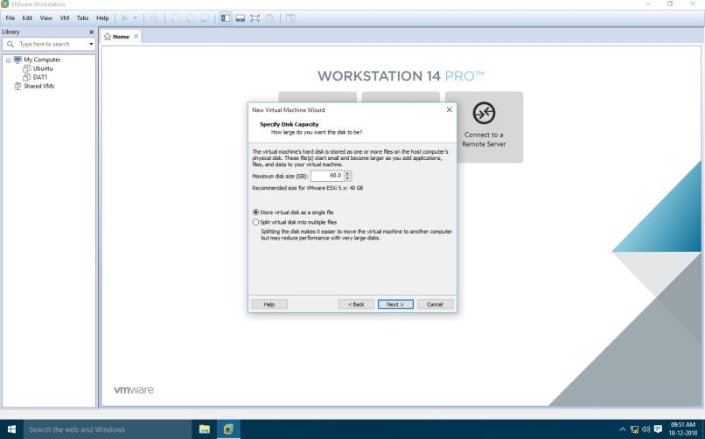

Click on **Customize Hardware option**

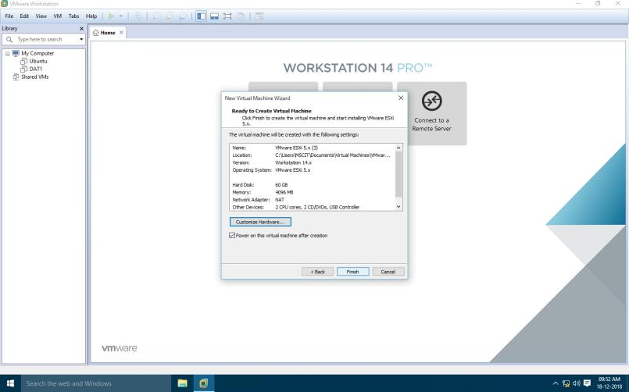

#### Change – Memory for this virtual machine to 4 GB and Click on Close. Click on Processor and select virtualize Intel VT

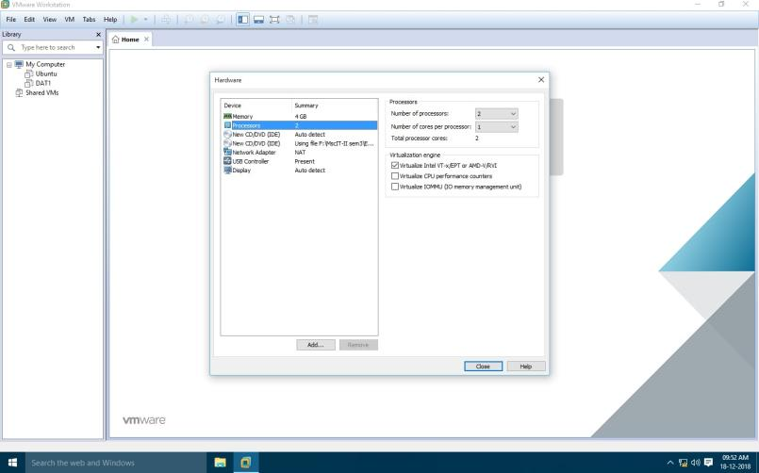

Now Power on newly created Virtual machine –

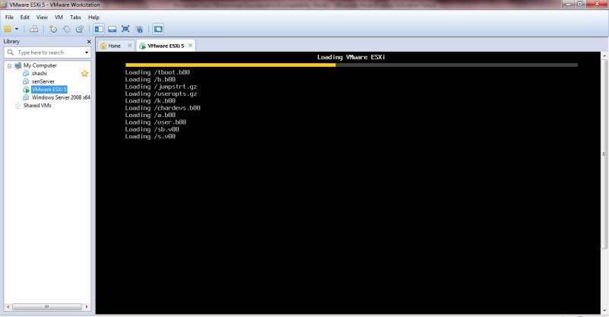

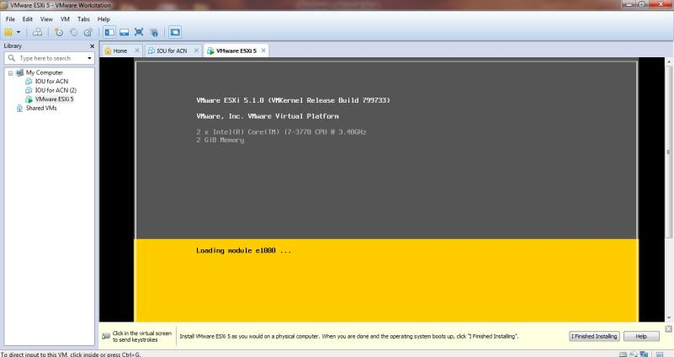

Click on install EXSi server

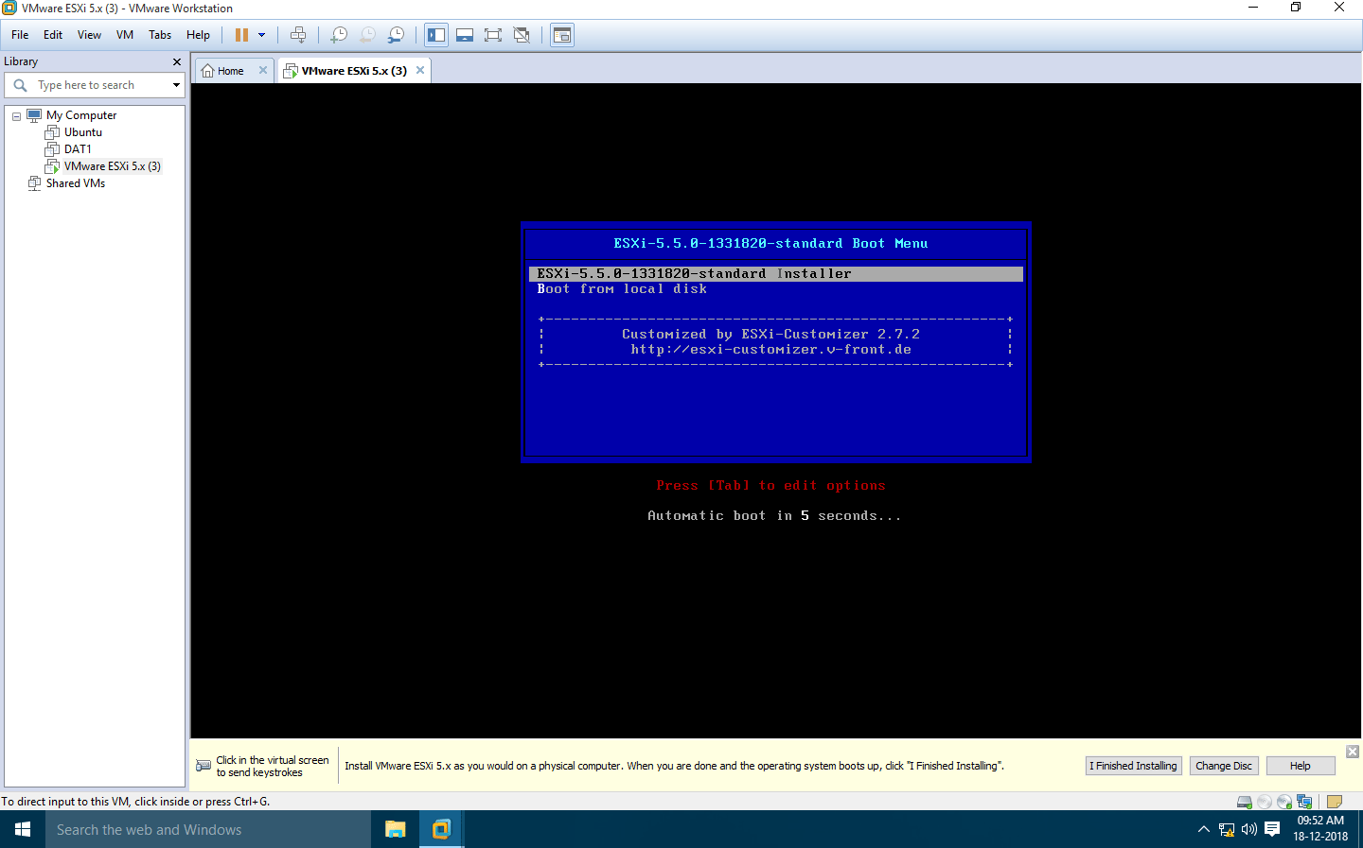

#### Press enter

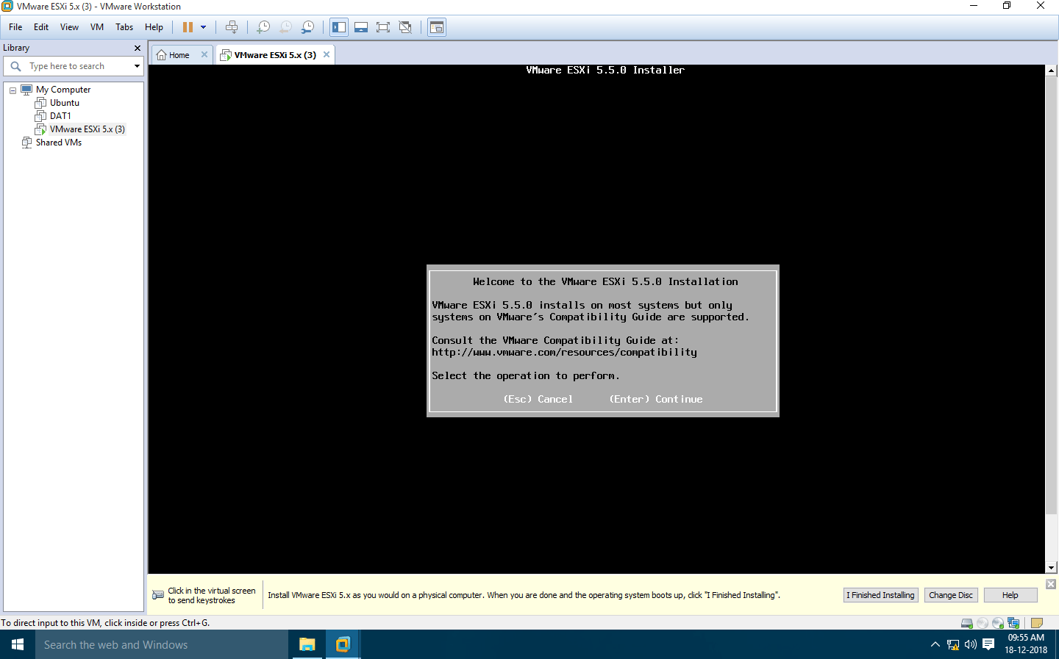

Select us default and click enter

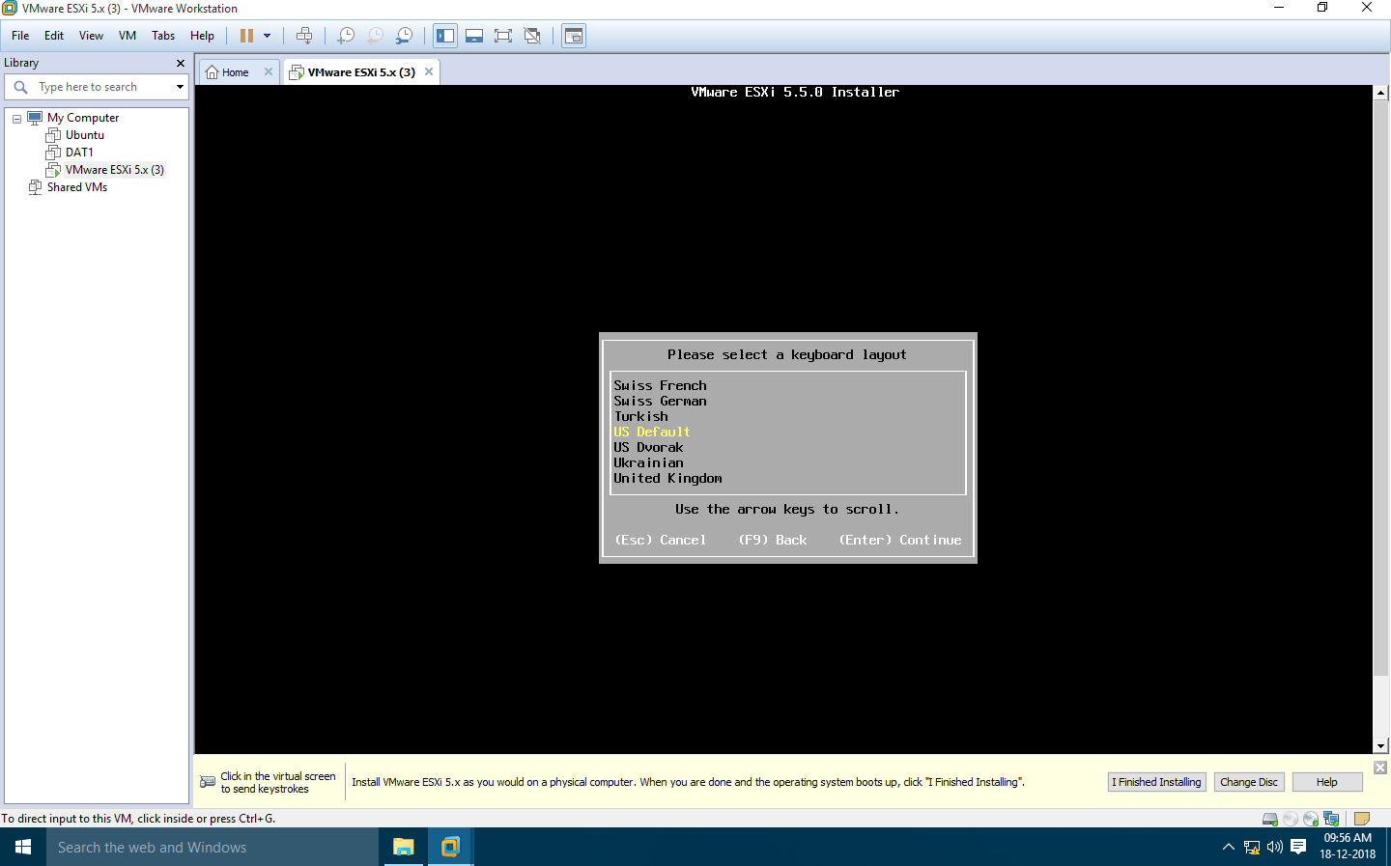

#### Click install

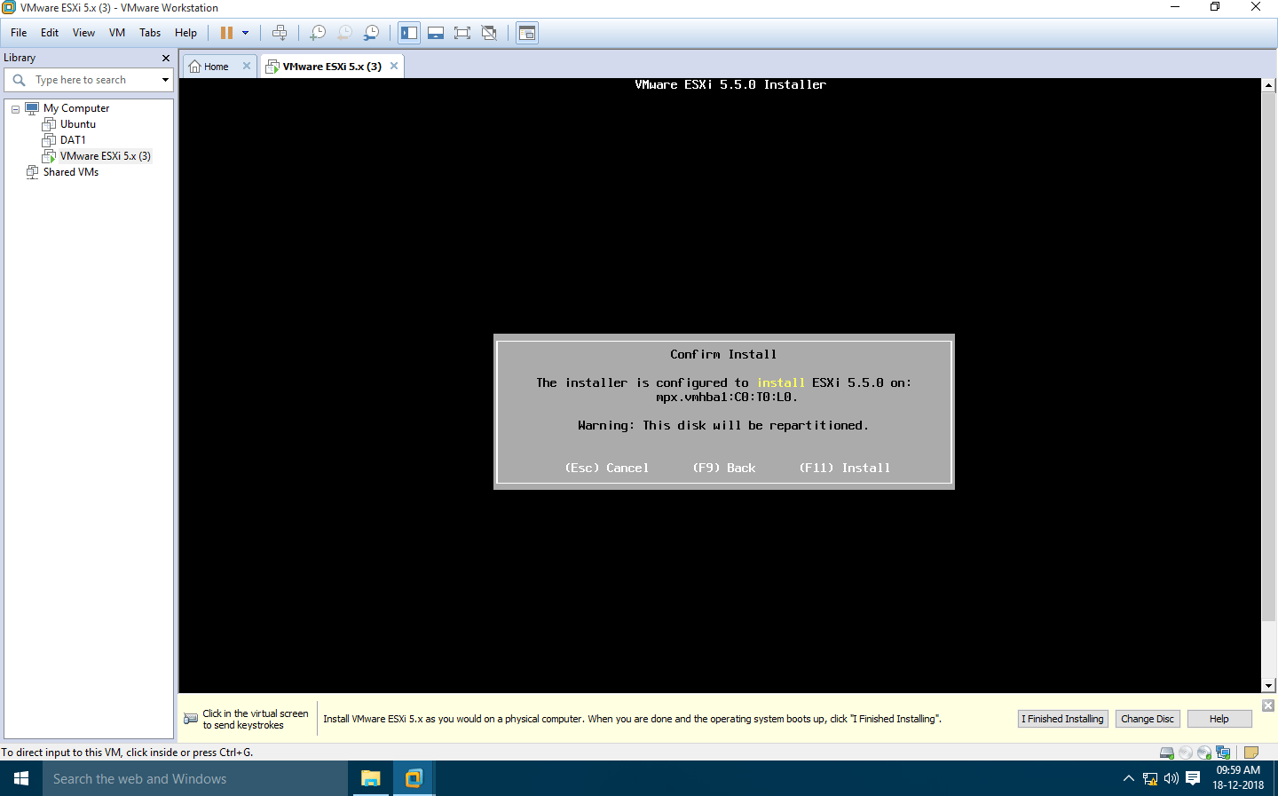

Press enter to reboot the system

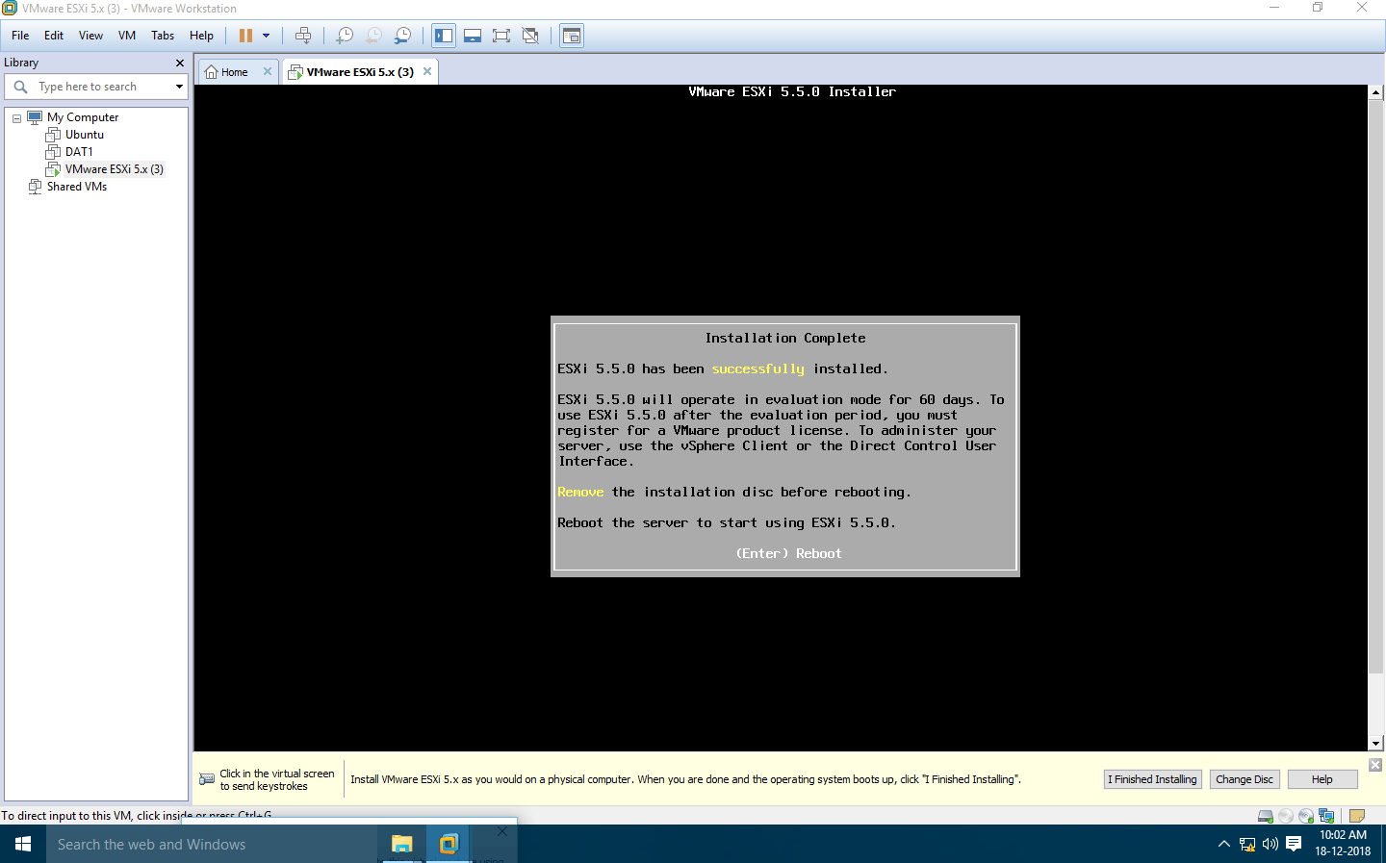

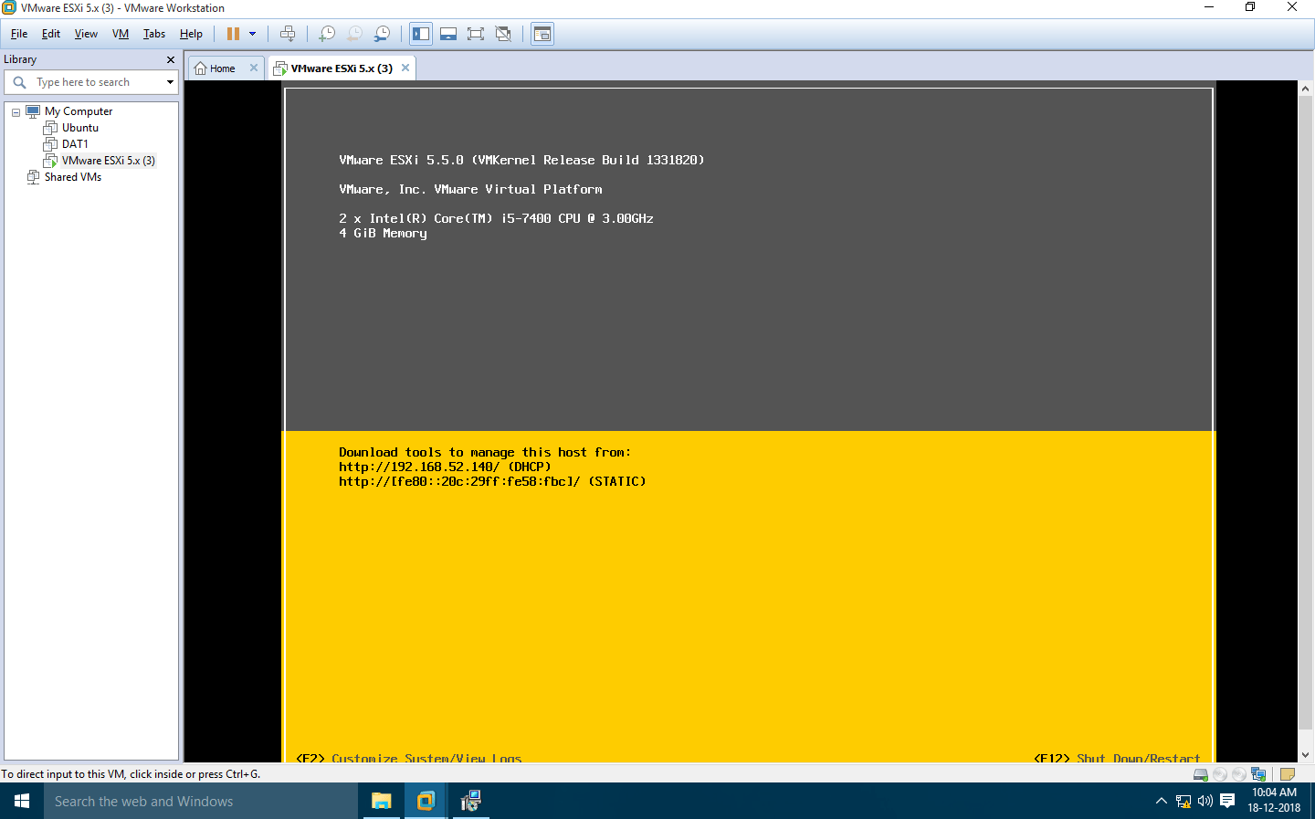

#### Open Browser & type respective IP Address

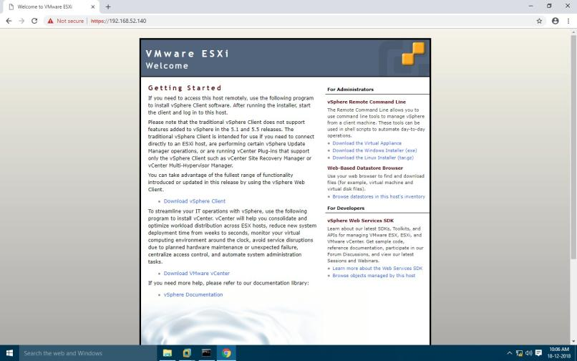

#### (since we already have vsphareclient so we are not going to download it,first install and open vsphareclient)

VMware vSphere Client

* Enter IP address (Which was assigned dynamically)
* Enter Username and Password

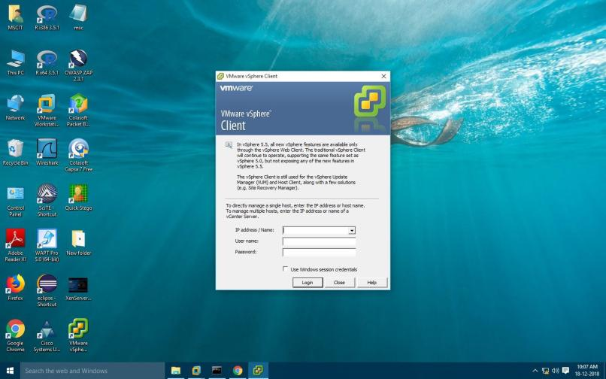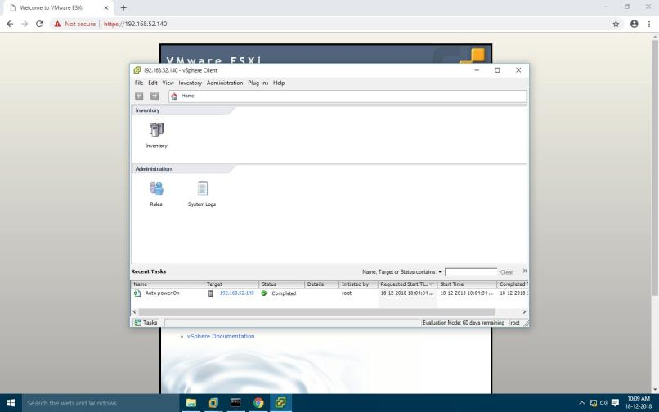

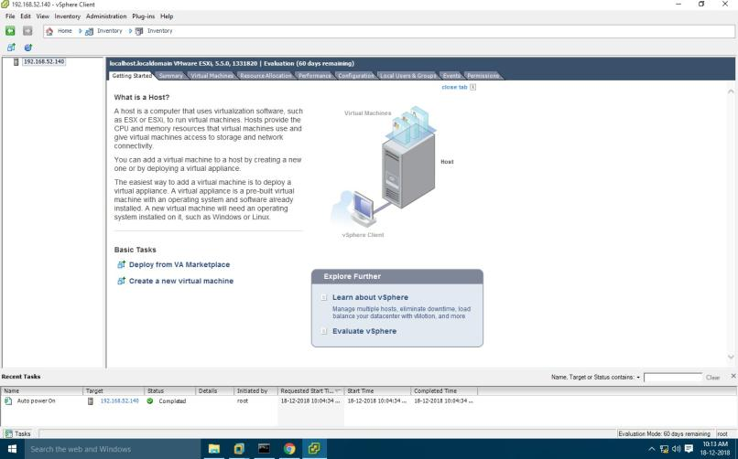

#### Select Summary tab.

* In Storage section, Select on datastore1 and Right-click on Browse Datastore to add iso image of Windows XP in Datastore.

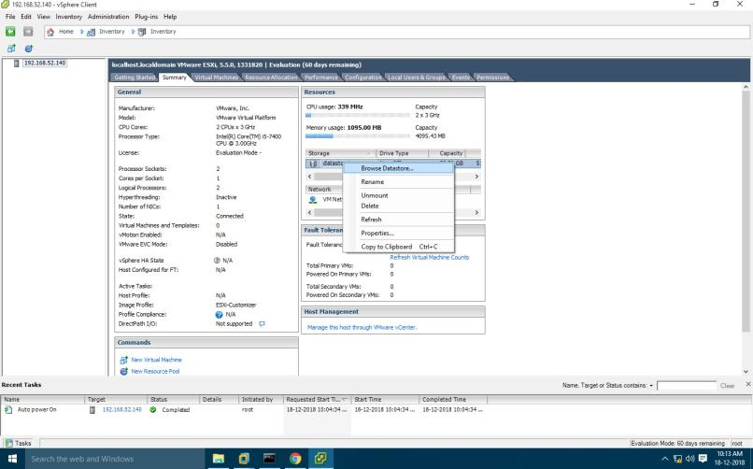

#### Click on Upload Icon and Select Upload File.

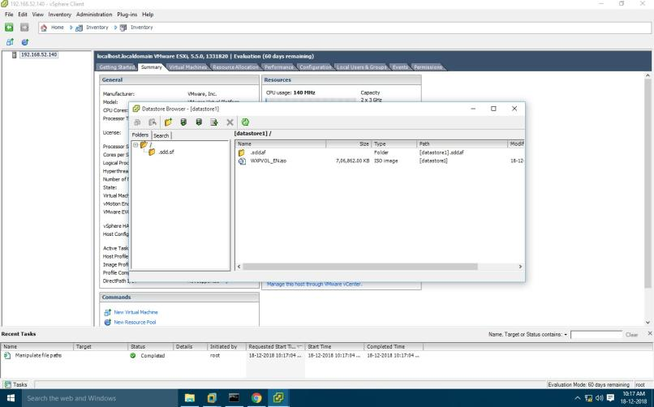

Click on Yes

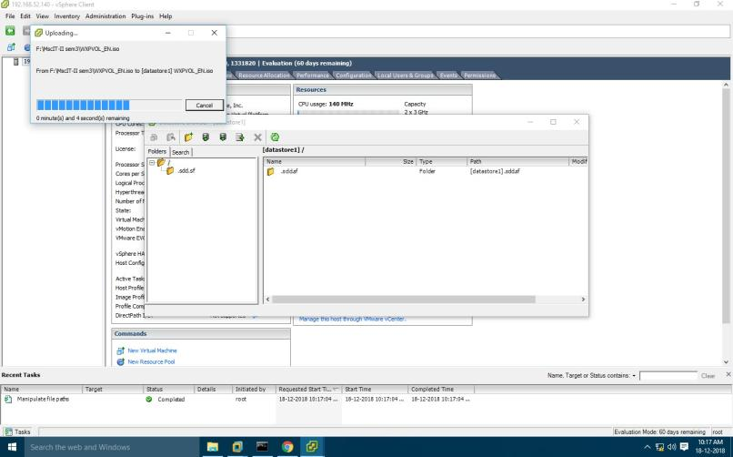

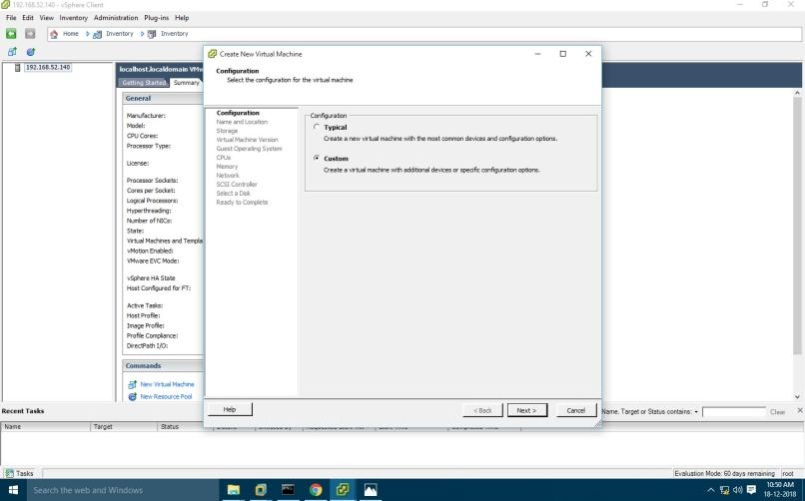Click on **File >> New >> Virtual Machine**. **Configuration :** Select Custom configuration.

**Name and Location:** Give name to a Virtual Machine(Windows XP)

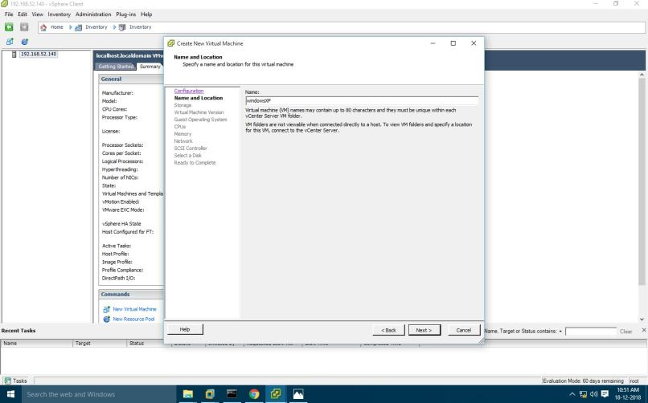

#### **Storage:**Select datastore1 and click Next

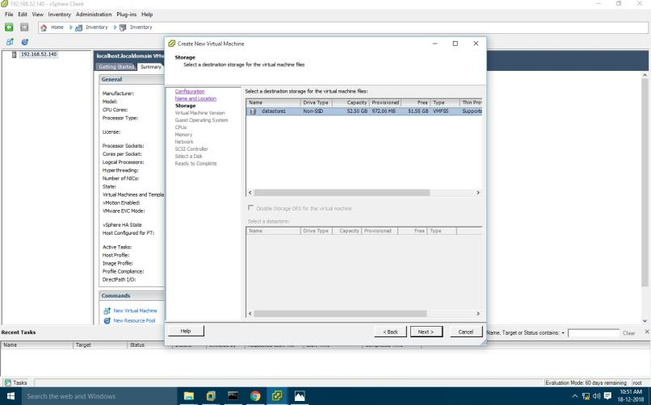

**Virtual Machine version :** Select Virtual Machine version 8

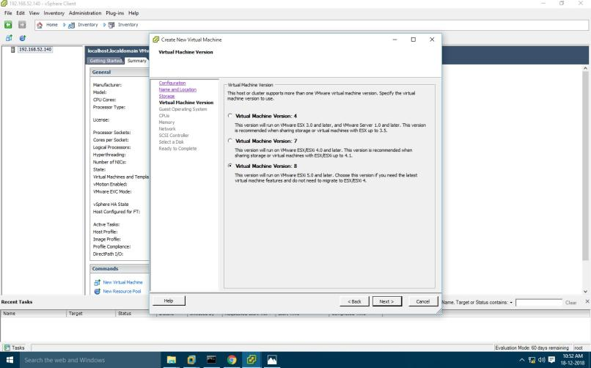

**Guest Operating System:** Windows

#### **Version:** Microsoft windows XP Professional (32-bit)

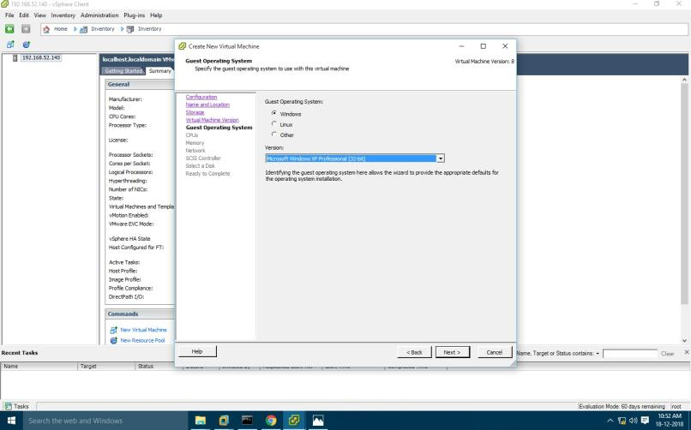

**CPUs :**

#### Number of virtual sockets : 1 Number of cores per virtual socket: 1

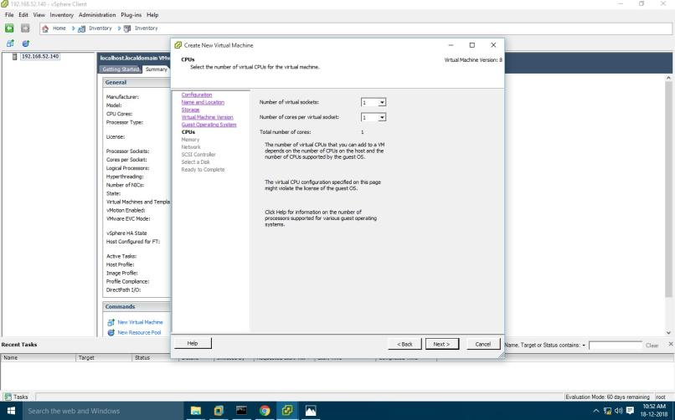

**Memory:** Memory Size : 1 GB

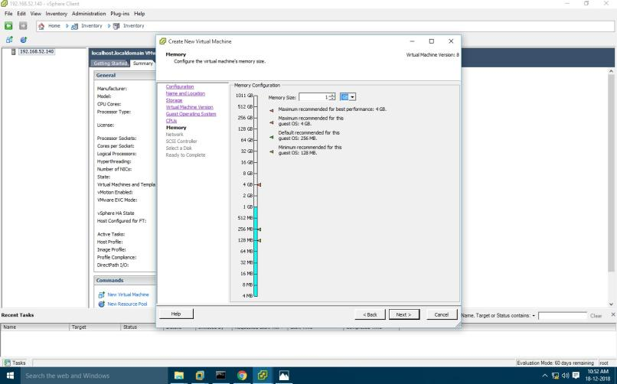

**Network:** Number of NICs : 1

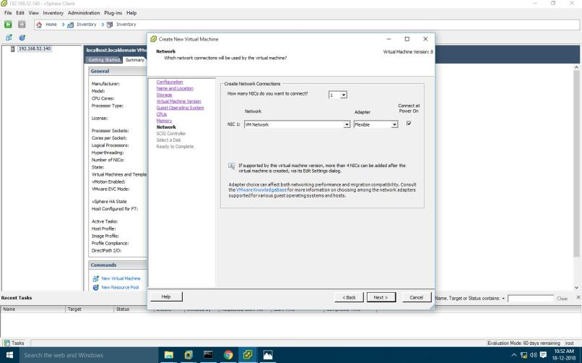

**SCSI Controller :** VMware Paravirtual

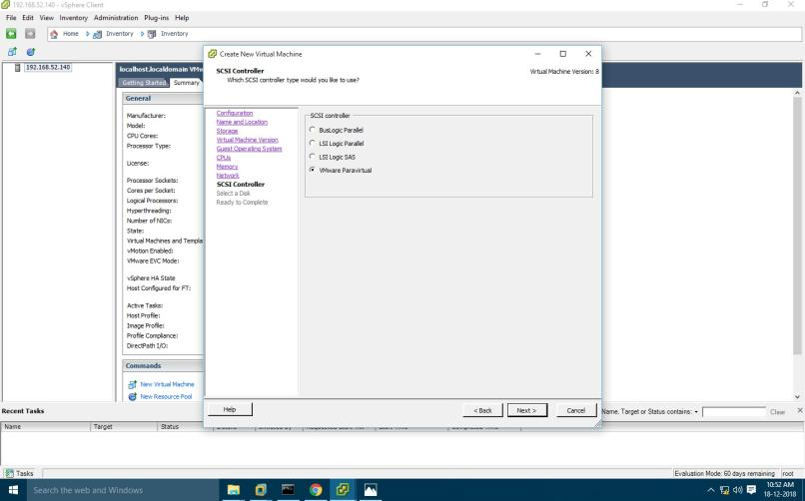

**Select a Disk:** create new virtual disk.

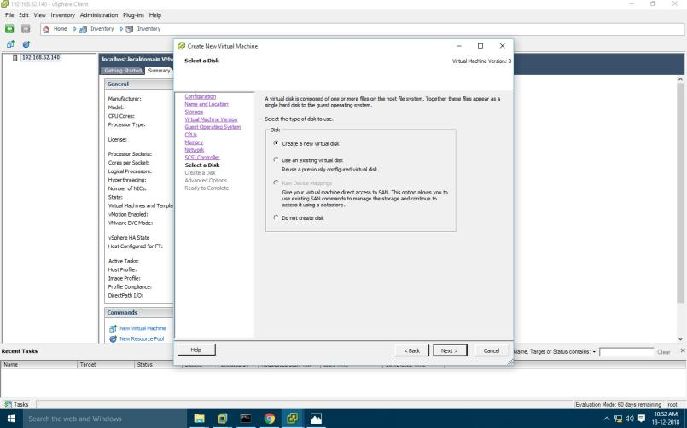

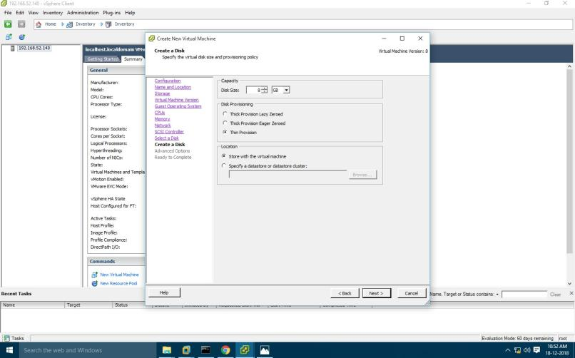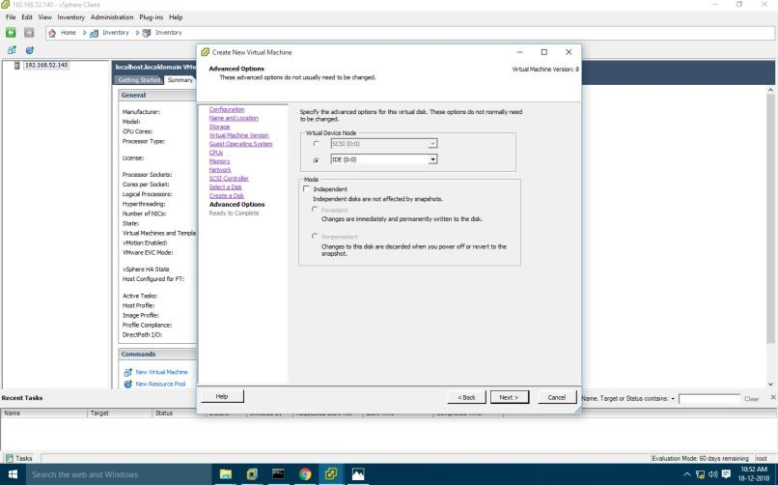

#### Click edit

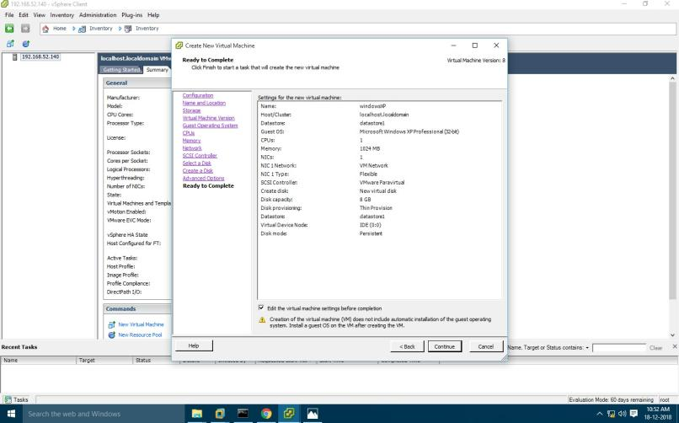

#### Click on datastore

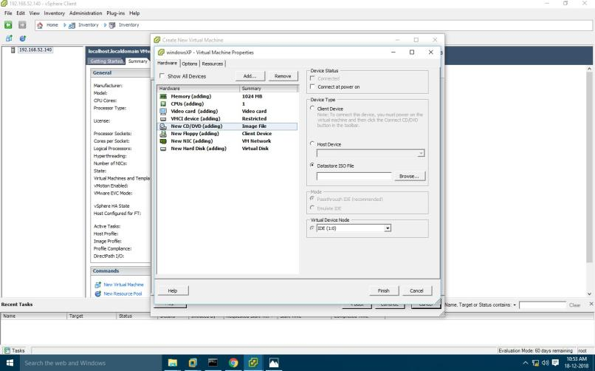

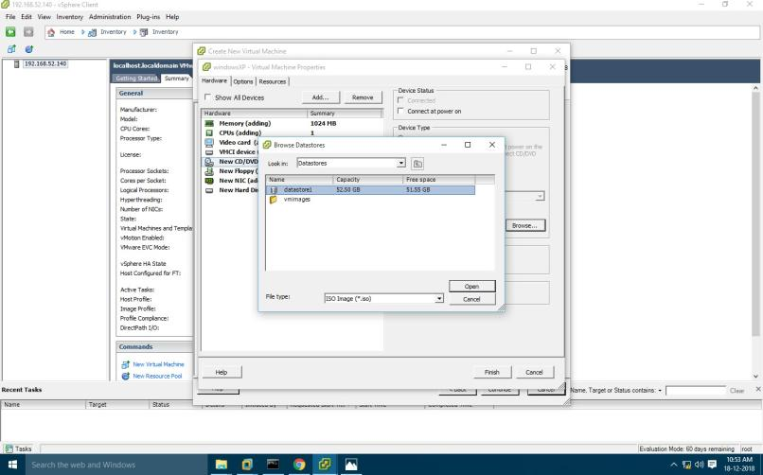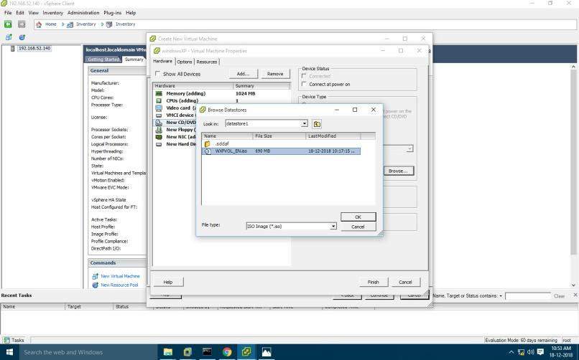

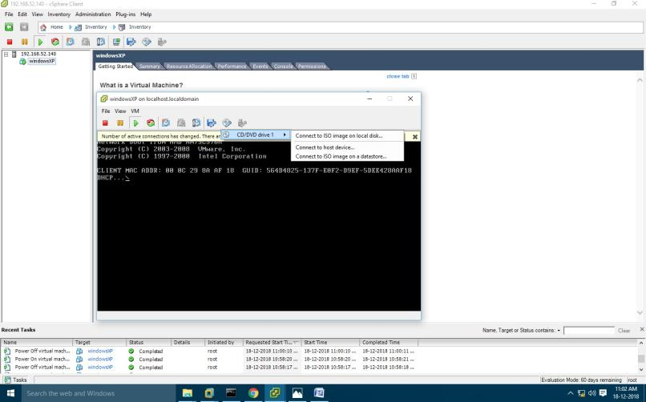

#### Right Click on Windows XP >> Power >> Power On

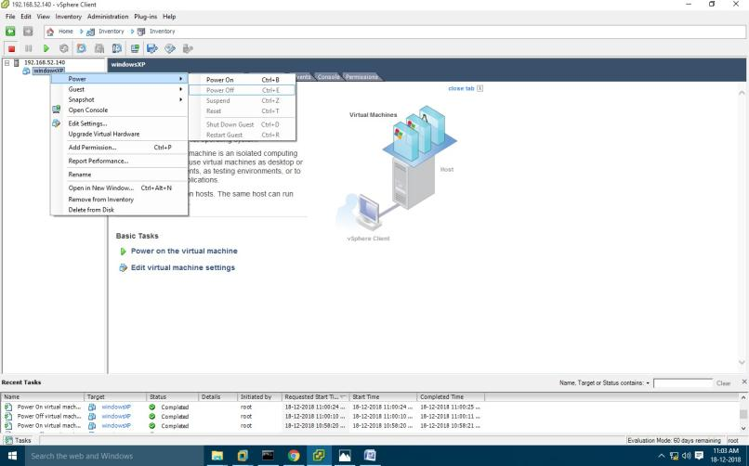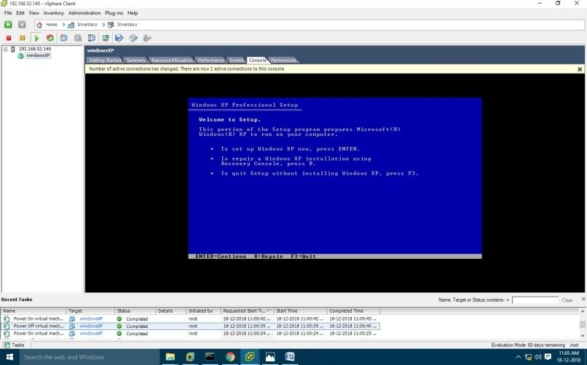

**PRACTICAL: 6**

**NATIVE VIRTUALIZATION USING Hyper-V**

#### First we have to uninstall vmware software if already installed on computer because the VMware Workstation installer does not support running on a Hyper-V virtual machine.

After uninstalling VMware, we can proceed to next step - go to control panel and click on uninstall a program

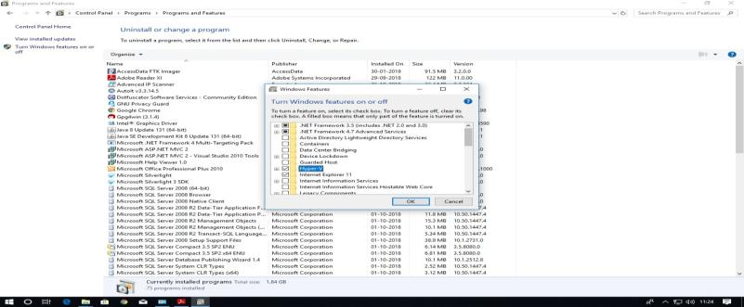

After Restart **Search for hyper-v manager in search box and click on that**

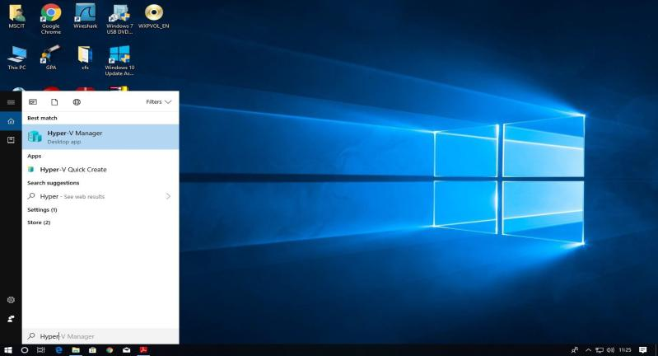

**for creating virtual machine first we have to create virtual switch**

#### click on virtual switch manager option

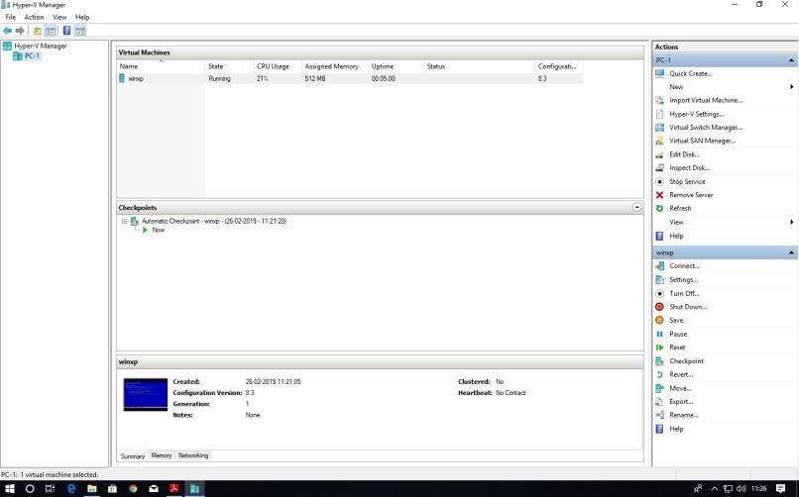

Select External as a connection type and then click on create virtual switch

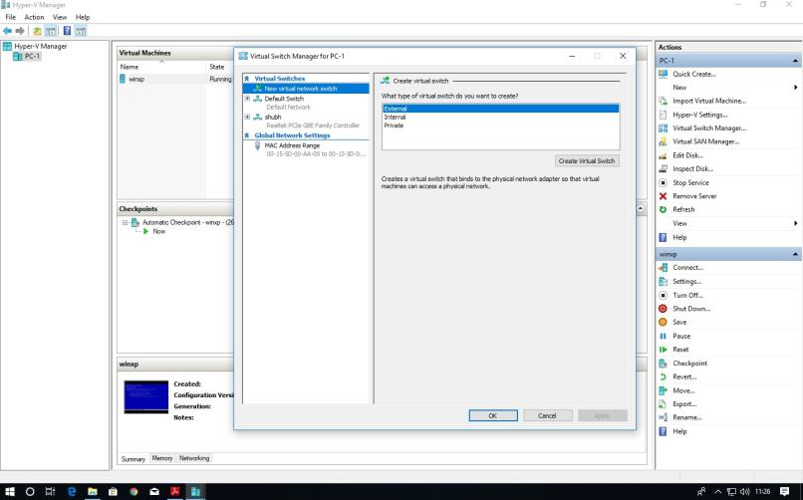

#### Give name to our virtual switch then click on apply button

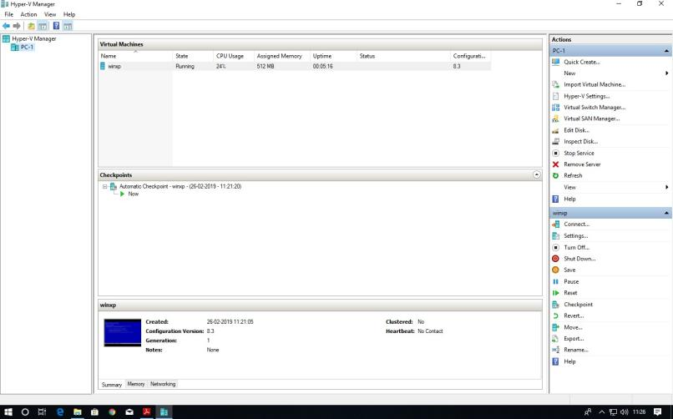

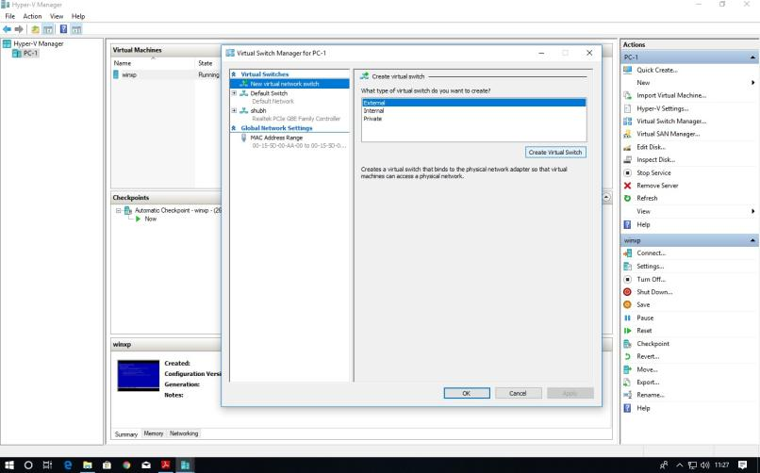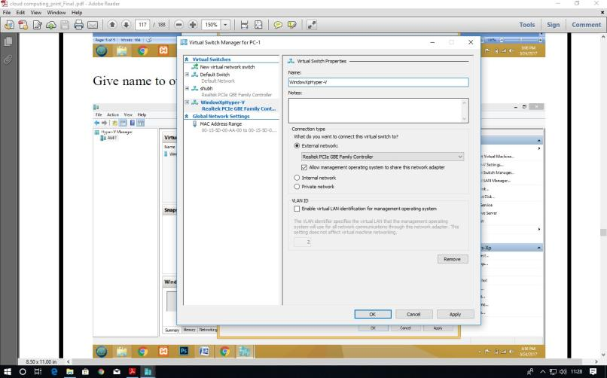

#### after click on Apply button it will show warning about our connection click on yes

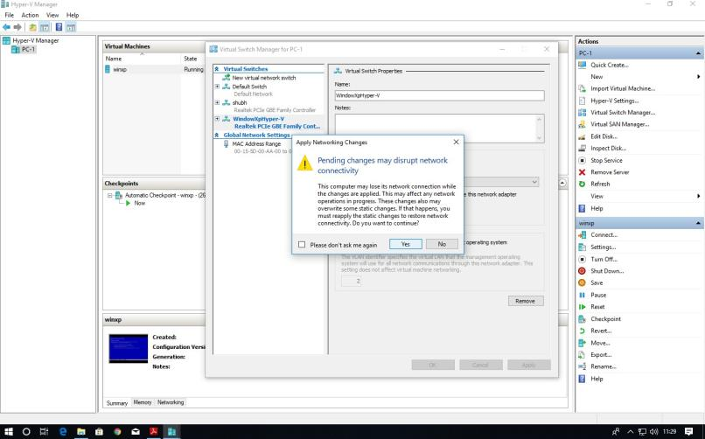

#### Now right click on server and select new virtual machine

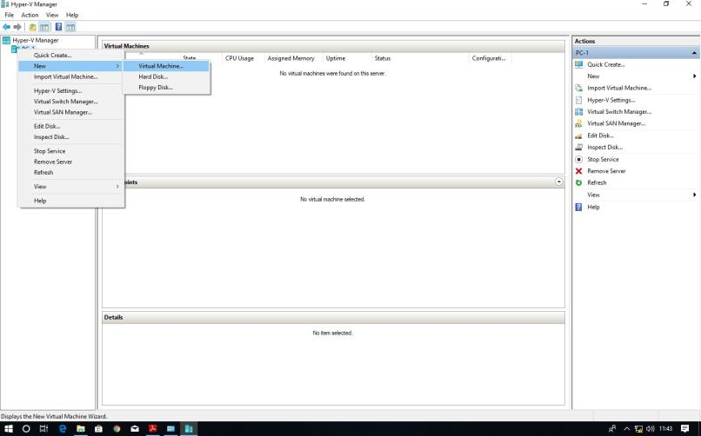

#### click on next button

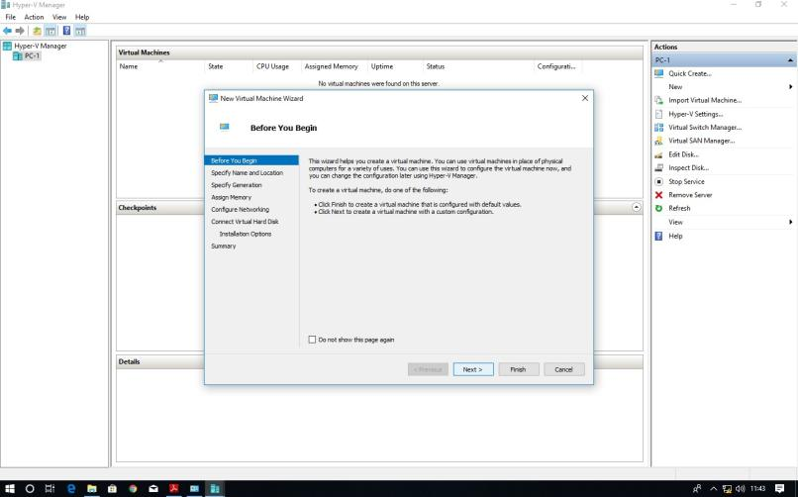

Provide name to virtual machine then click on Next button

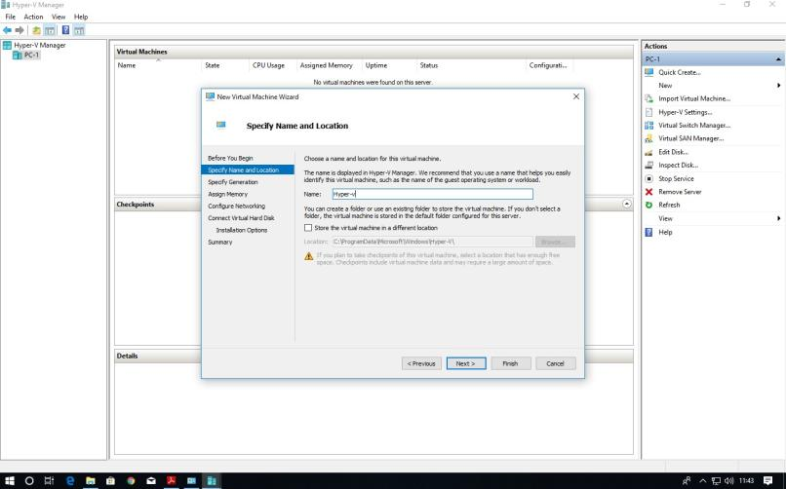

Specify generation : generation 1

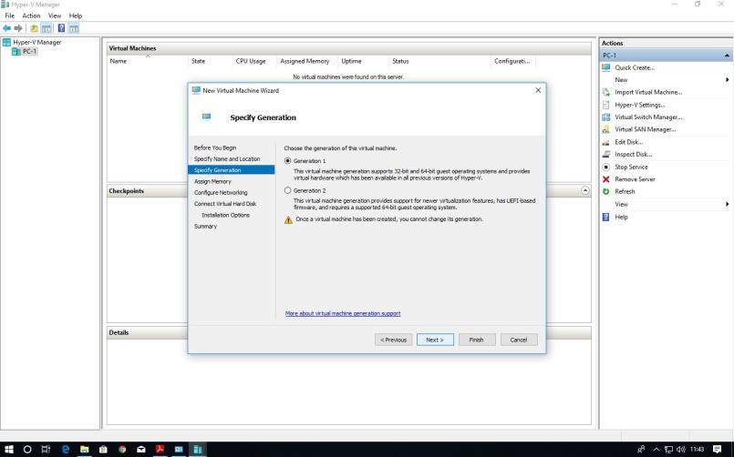

tick on use **dynamic memory for this virtual machine**

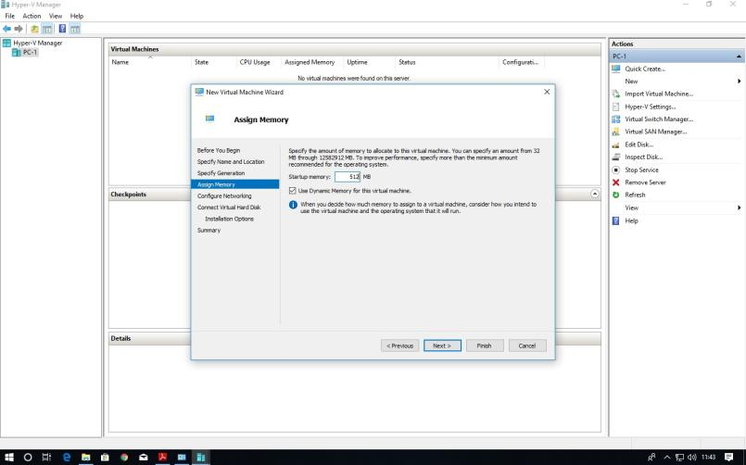

#### Select switch which we created earlier for our virtual machine from drop-down list and then click on next

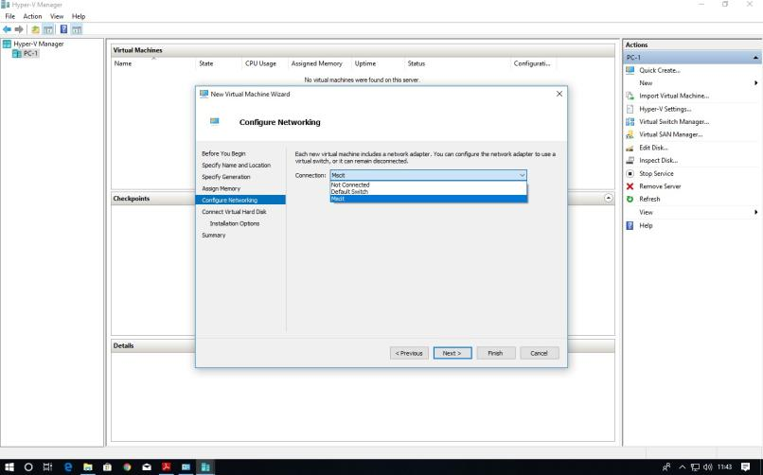

#### Description of virtual machine and location where it will store virtual machine related files and size require for this machine click on next

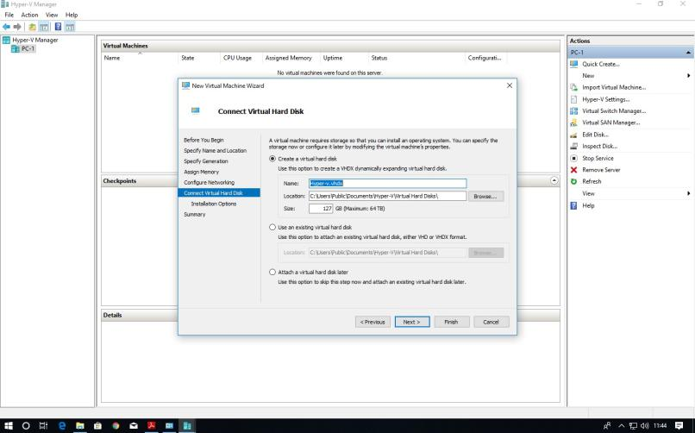

New virtual machine wizard panel will appear, where we will choose operating system which we want to install on virtual machine

select install an operating system from boot CD/DVD-ROM and then select Image file(.iso) and browse our OS iso file then click on next button

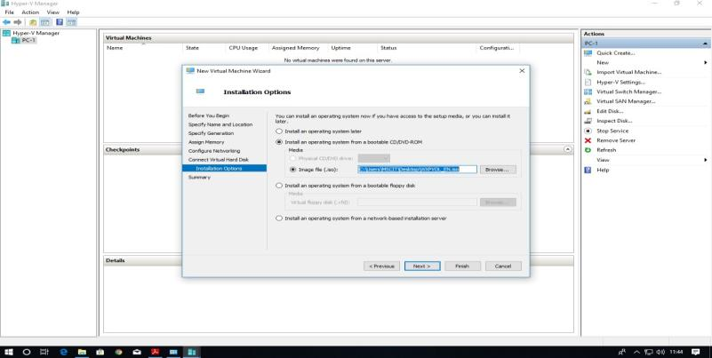

#### Summary report will be generated about virtual machine then click on Finish button

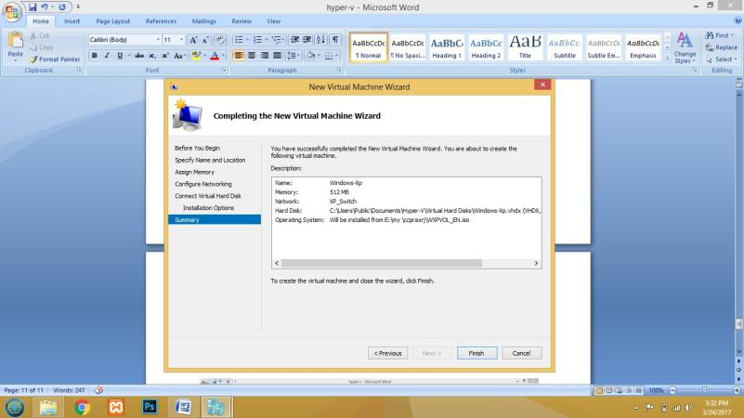

In virtual machine panel our virtual machine will appear which has off state

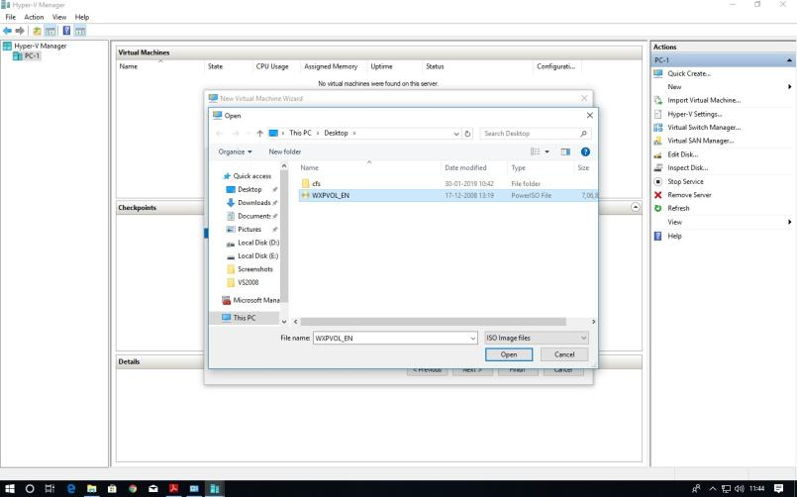

Click finish

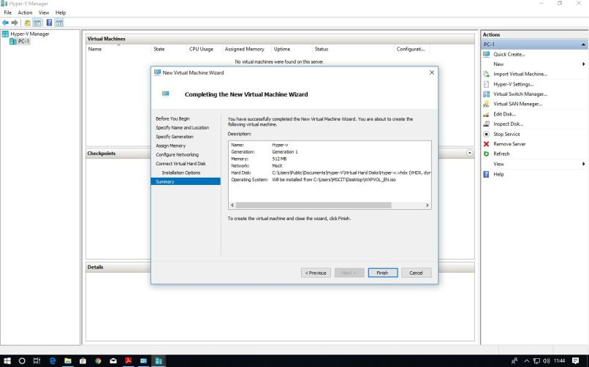

#### Right click on virtual machine and click on connect option

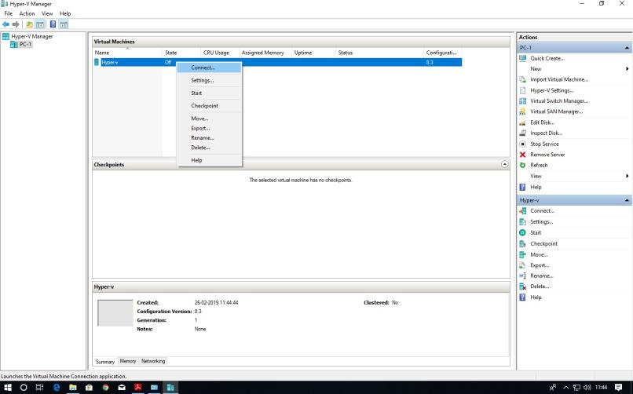

#### Now turn on virtual machine on

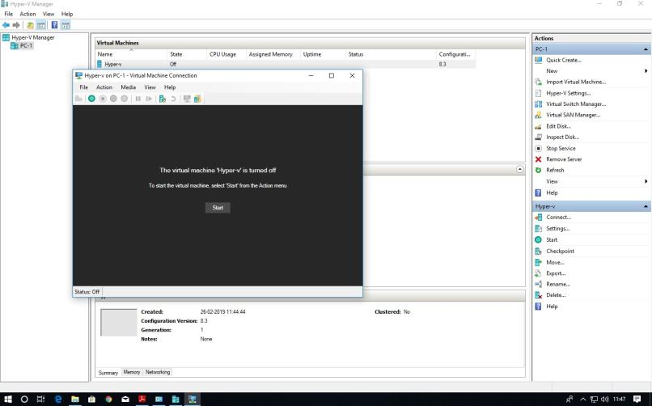

Virtual machine will start with below screen

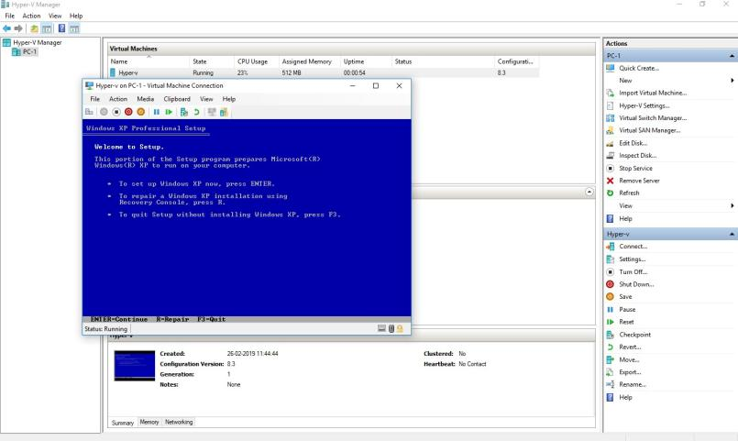

# PRACTICAL: 7

## IMPLEMENT OPENNEBULA

**Client configuration** software needed (Download Opennebula sandbox software from open nebula.org)

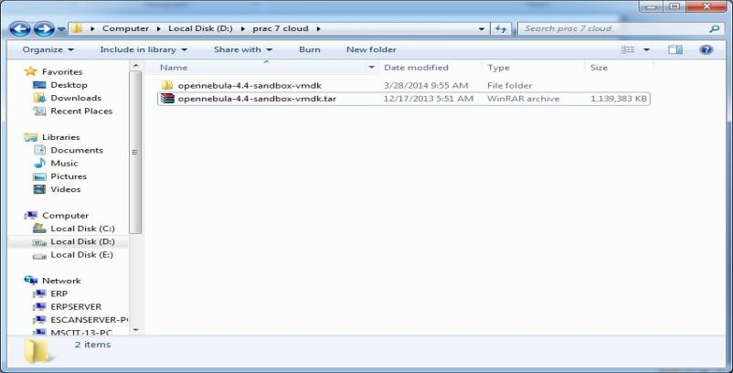

#### Start vSphere Client.

* Enter Static IP address
* Enter Username and Password. Click Login.

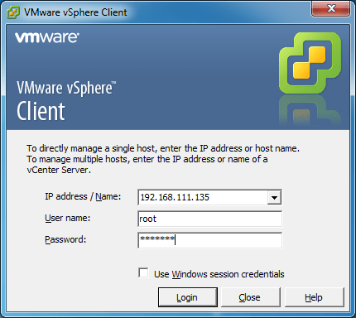

#### Click on ignore

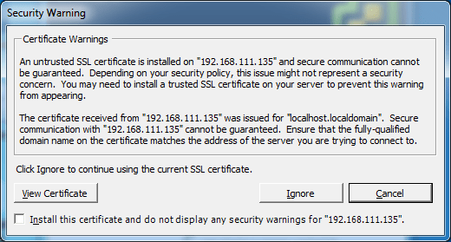

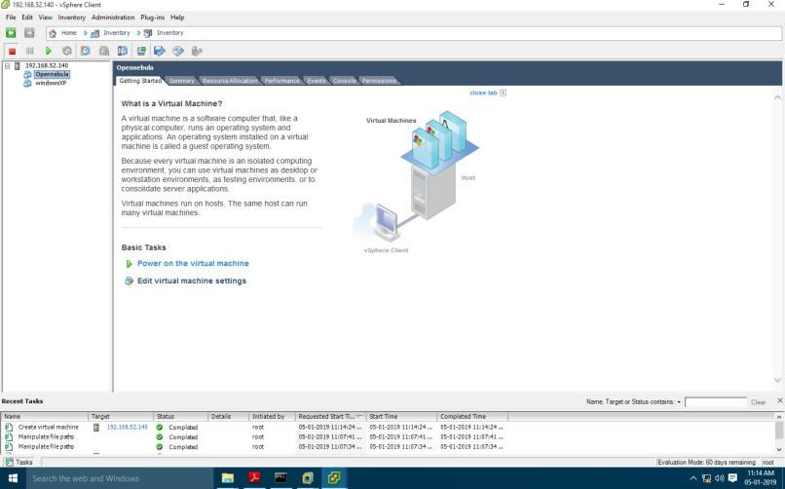

Go to Configuration tab select storage and right click on data store1 and select Browse Datastore.

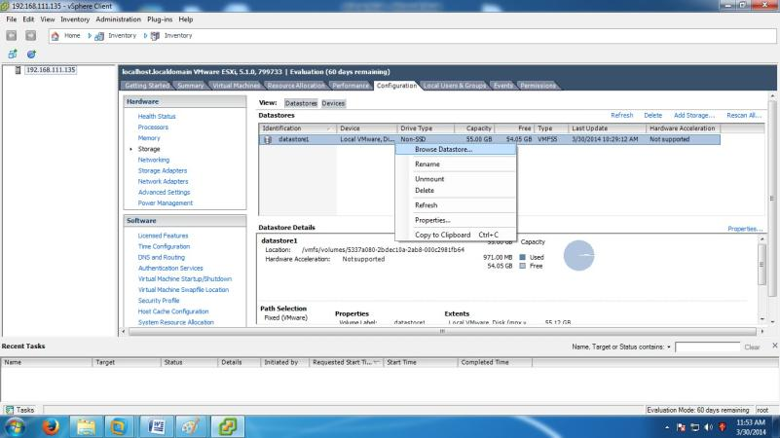

#### Go in this particular folder opennebula-4.4-sandbox-vmdk and select **disk-flat**

file.

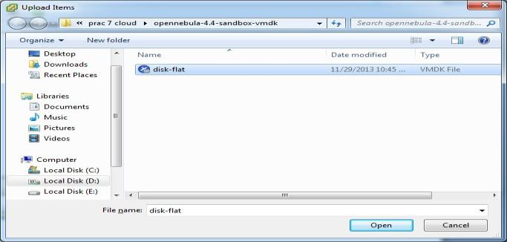

Create a new virtual machine.

* On the VI client click on the (new virtual machine) icon

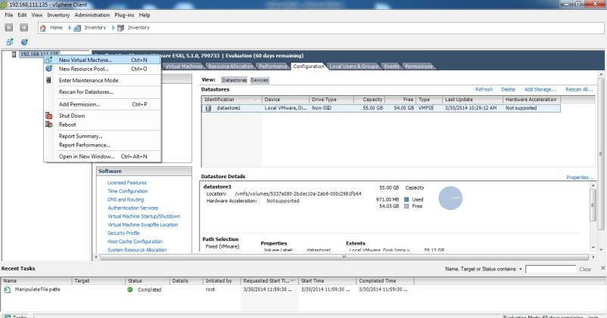

#### Select custom virtual machine and click on next.

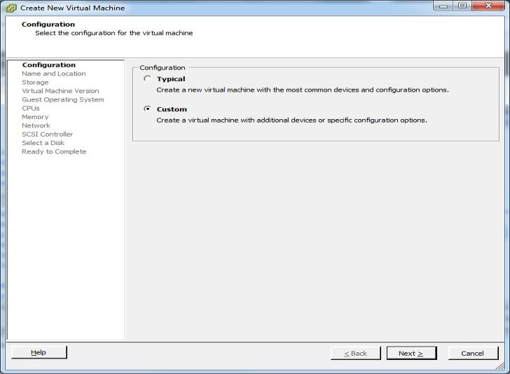

#### Name : Opennebula-sandbox and click on next.

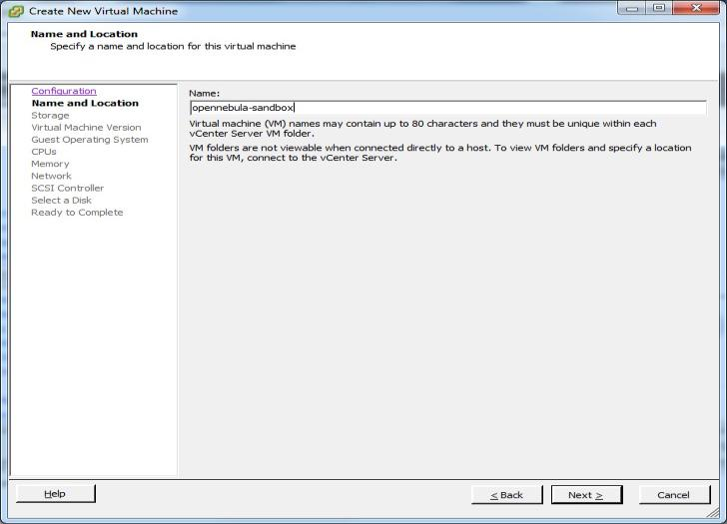

Select the same data store as in the screen and click on next.

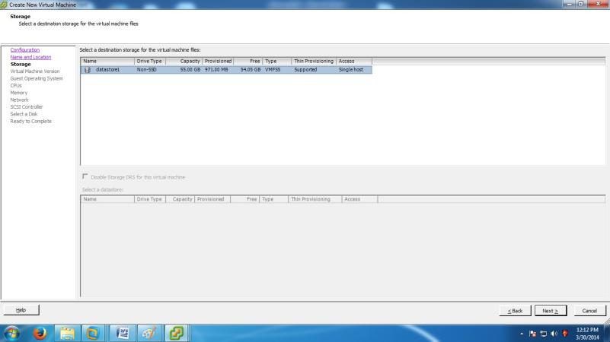

#### Select virtual machine version 8 and click on next.

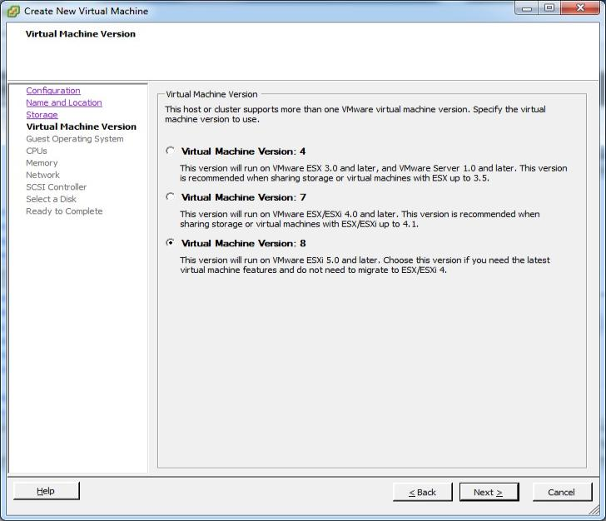

Select linux option-->and then select CentOS 4/5/6(64-bit) and click on next.

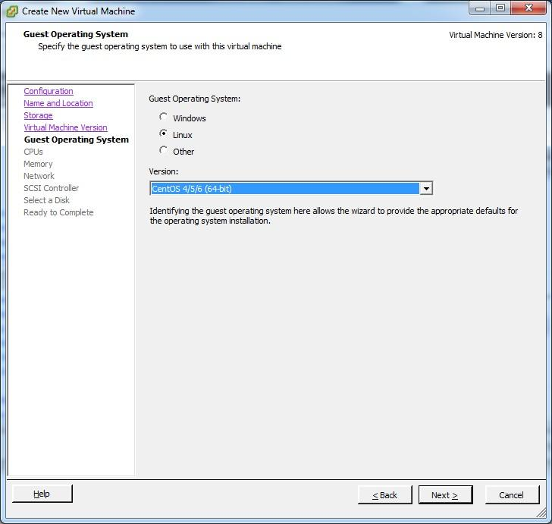

#### CPUs: Accept the defaults and click next.

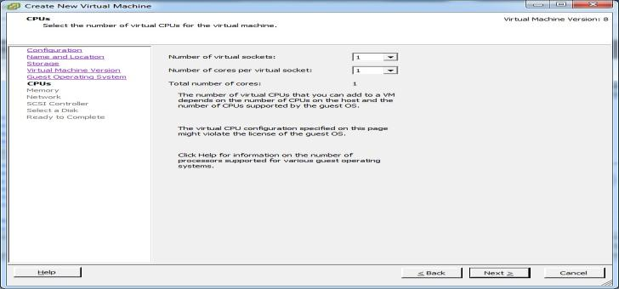

#### Select memory as 1 GB and click next

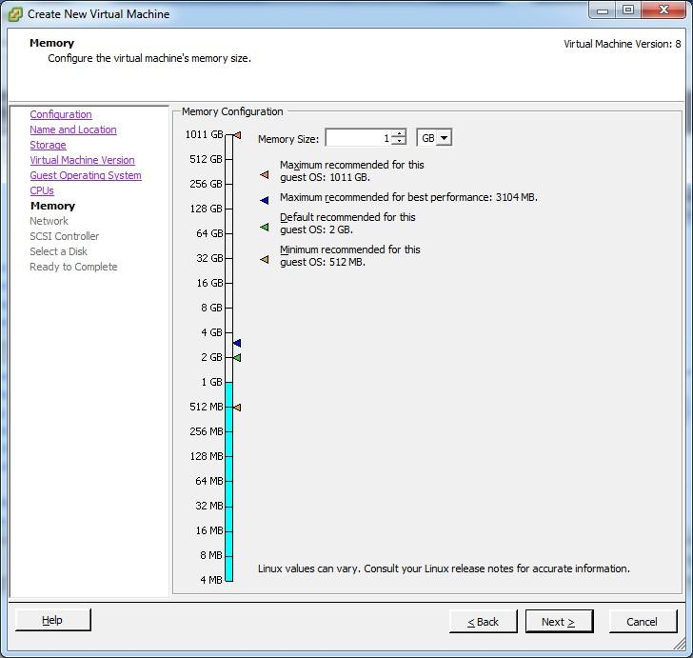

Select it as default and click next

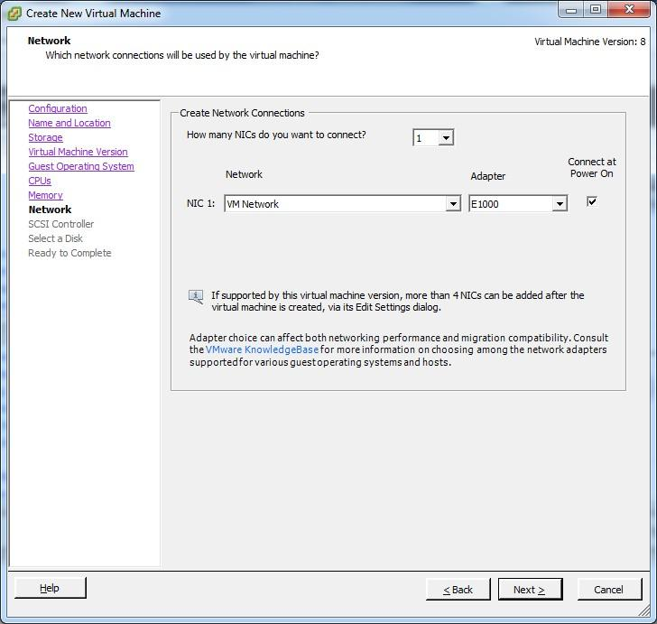

#### In the SCSI controller select as VMware Paravirtual and click next.

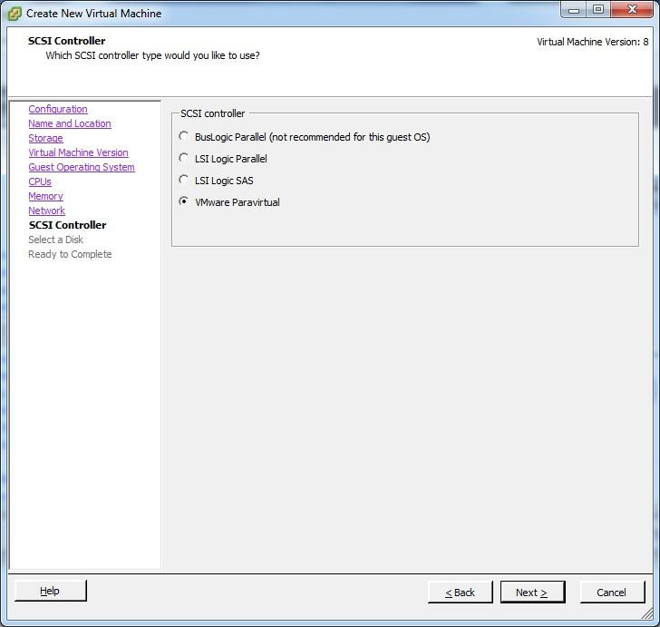

#### Select disk --> use an existing virtual disk and click next.

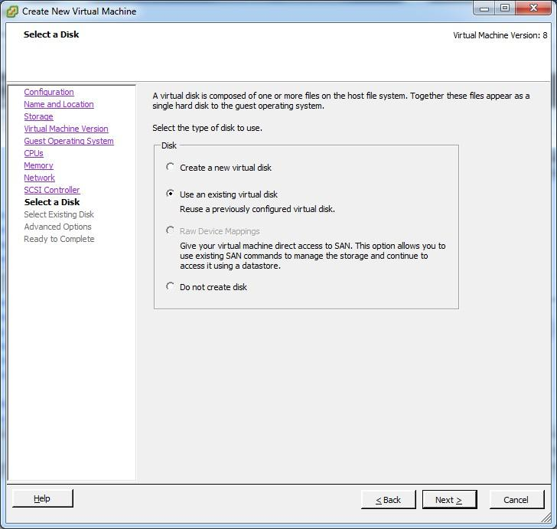

#### Click on browse and select data store1

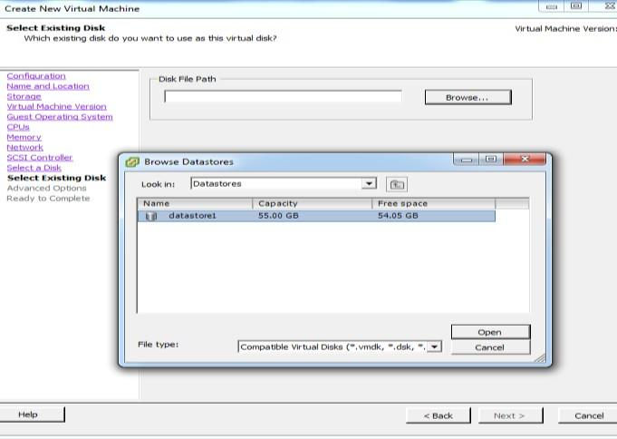

#### Double click on datastore1 --

You will get disk.vmdk file & click on OK

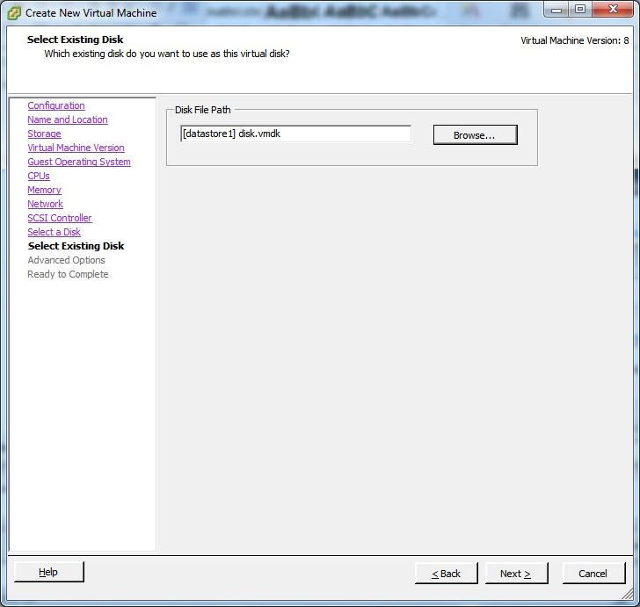

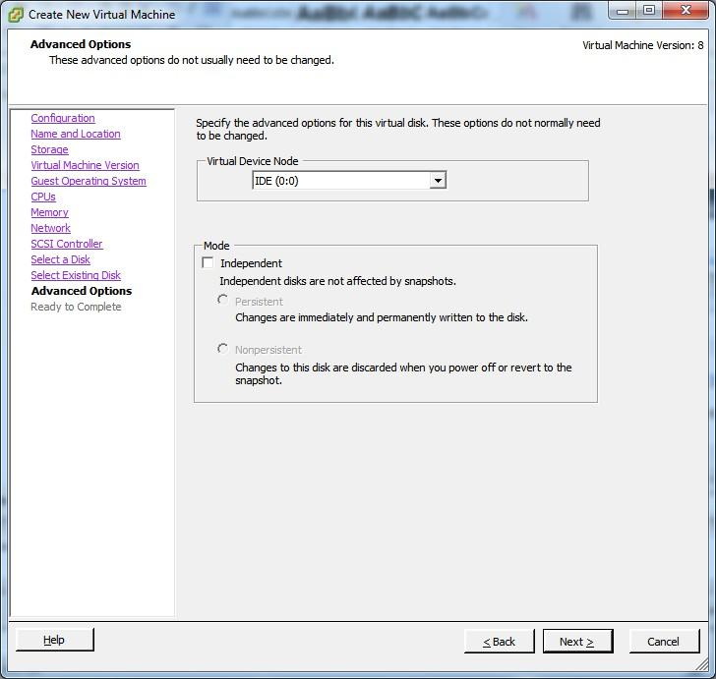

#### Click on next

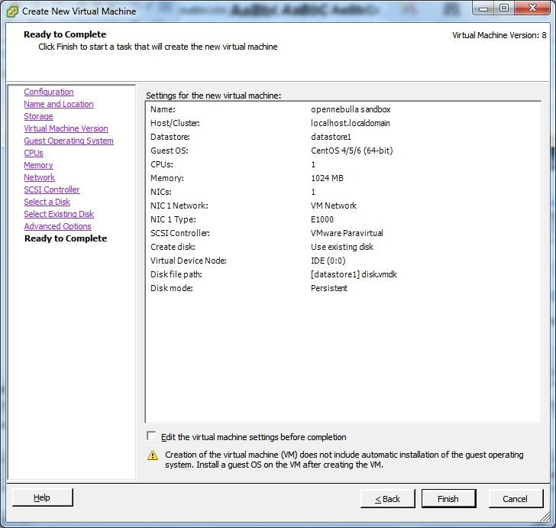

#### Click on finish

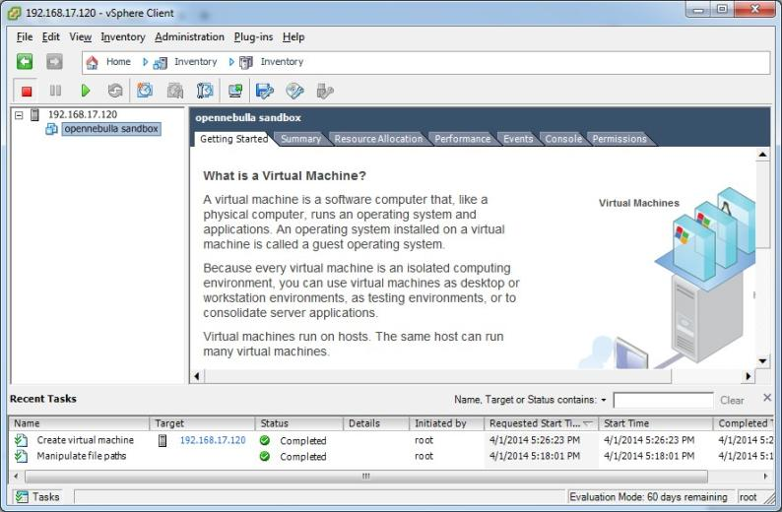

#### Power on the virtual machine

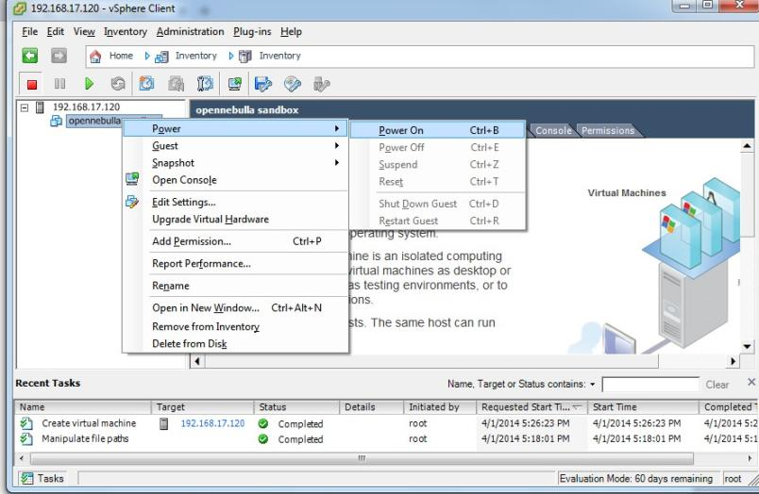

Click on console tab

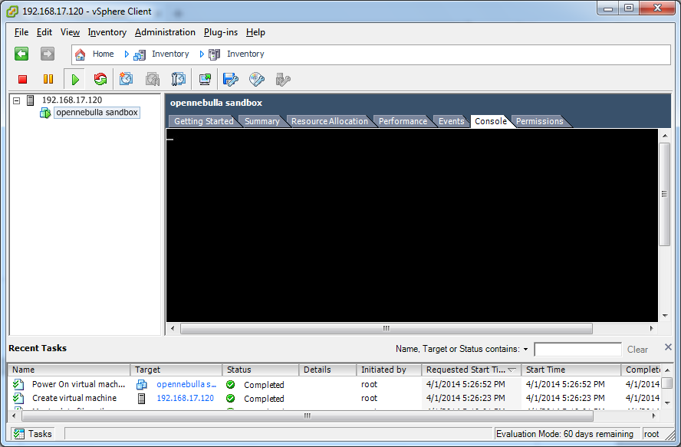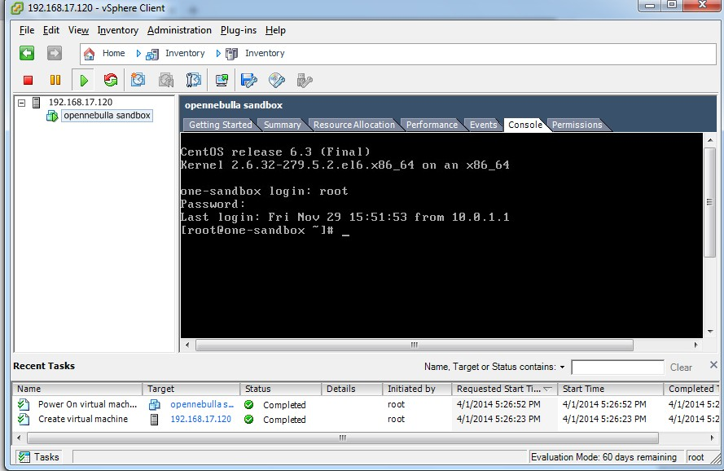

#### Type ifconfig eth0 command to check ip address of linux centos machine

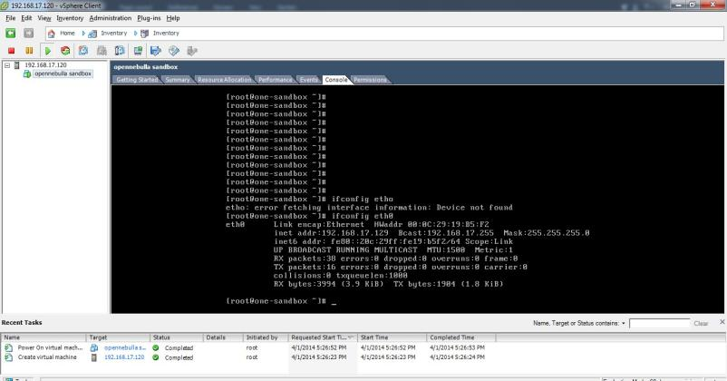

#### Since ip address of openebulla is 192.168.17.129

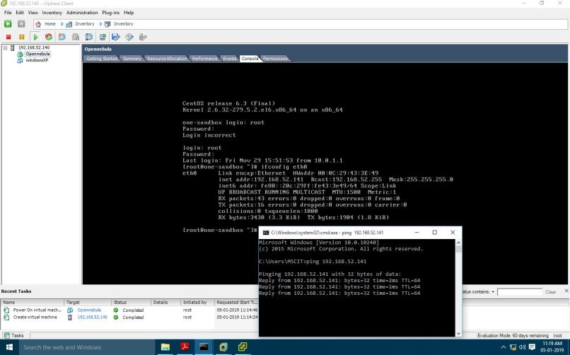Now try to ping 192.168.17.129 openebulla on host OS

Go to Browser copy the http path and paste it.

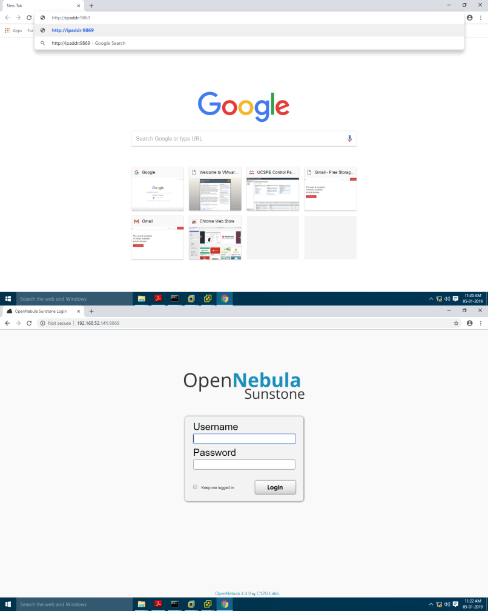

#### type username : oneadmin password : Opennebula

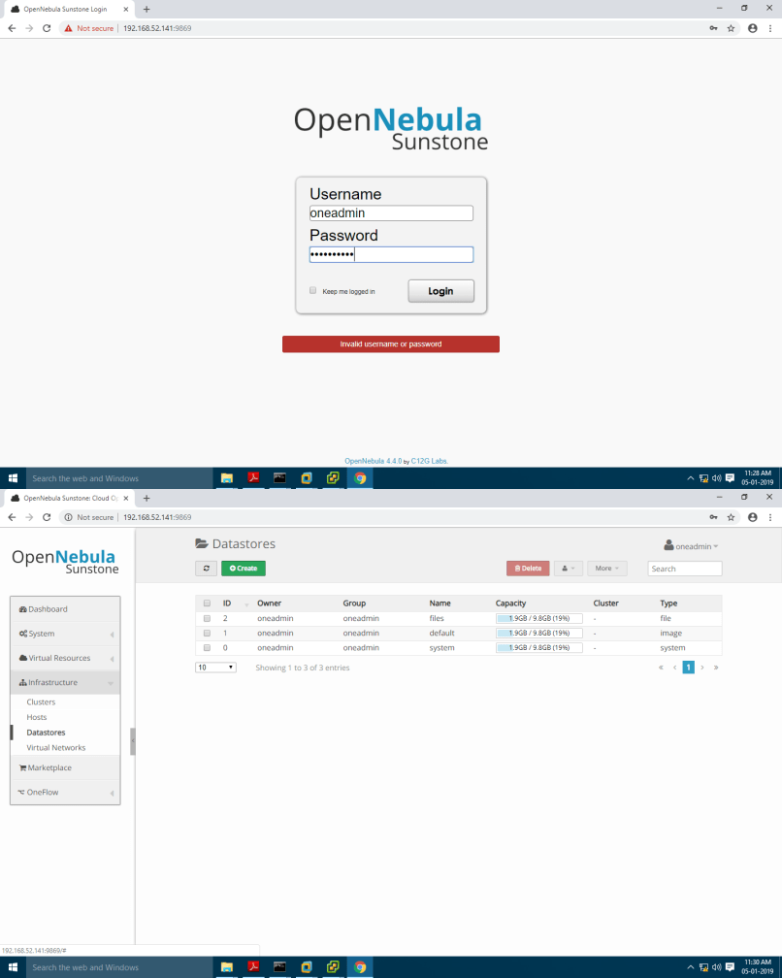

#### click on "create"

type name test-12 and click on "create"

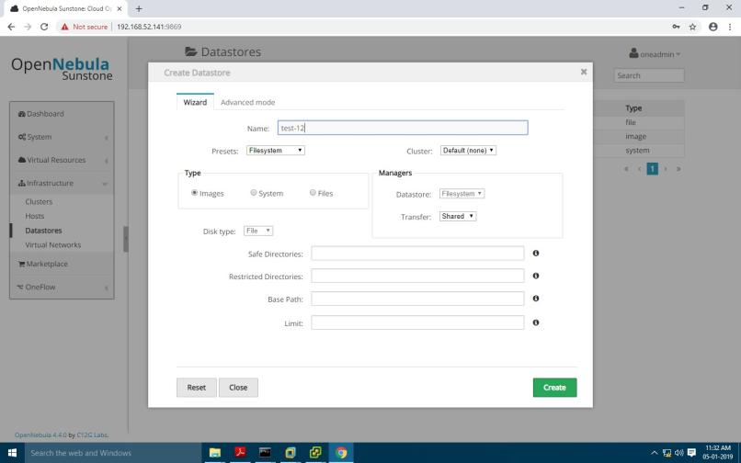

#### DATASTORE is created

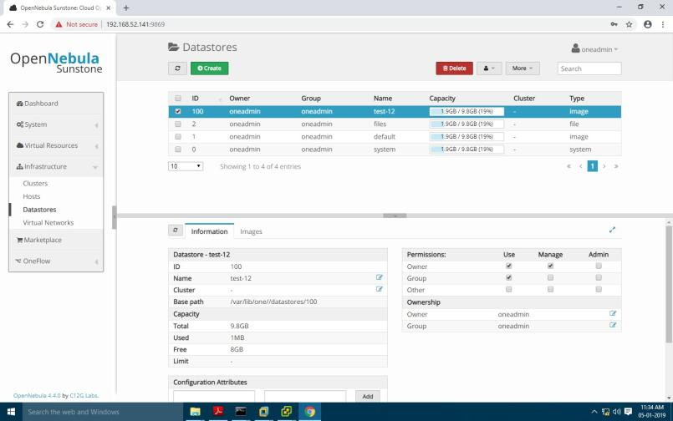

now we will create "Virtual Network"

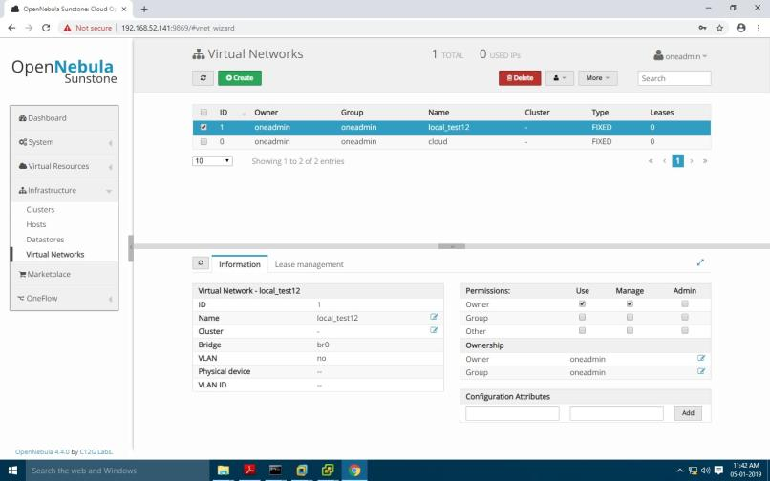

#### click on "Create"

provide name as "local_test12" click on Fixed Network

provied ip address in range "192.168.1.100" to "192.168.1.106" and also provide Bridge name :"br0"

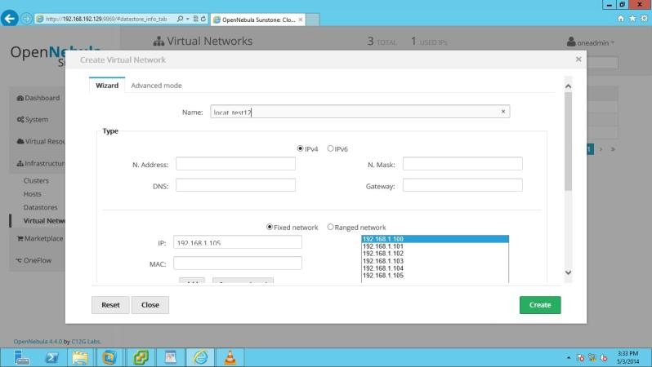

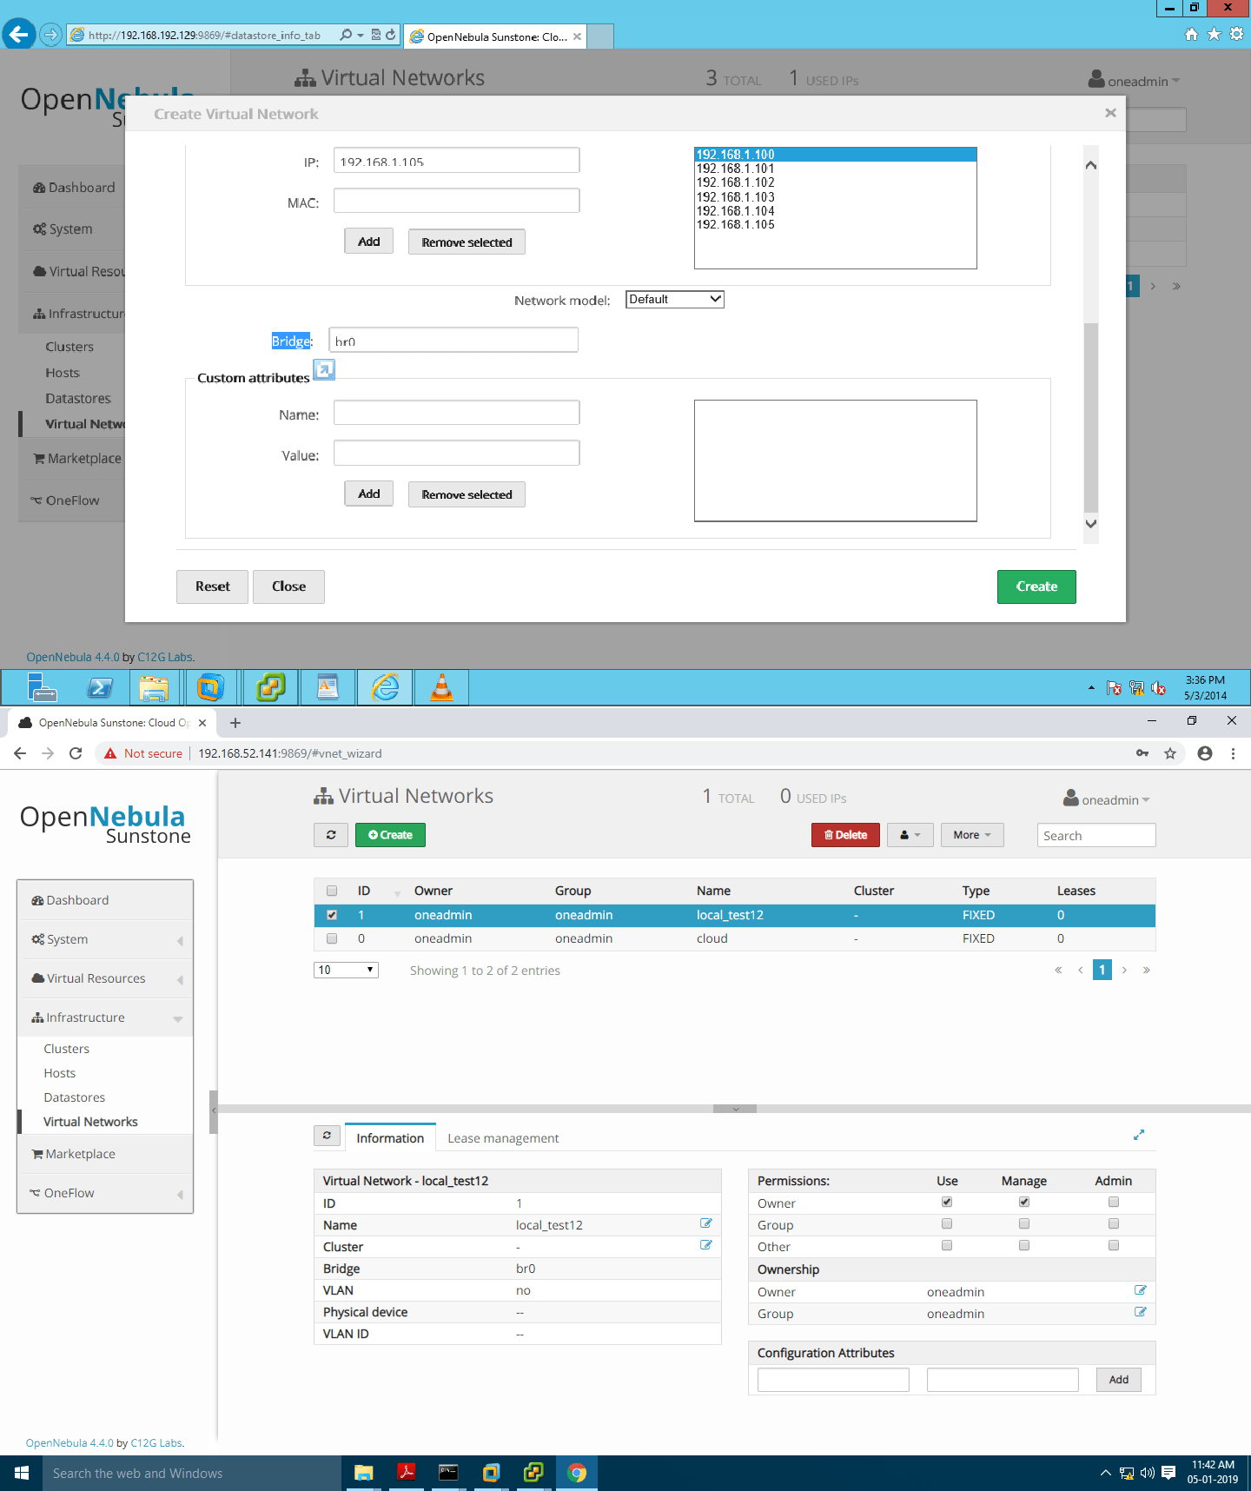

#### create new user name :root

password : opnenebula

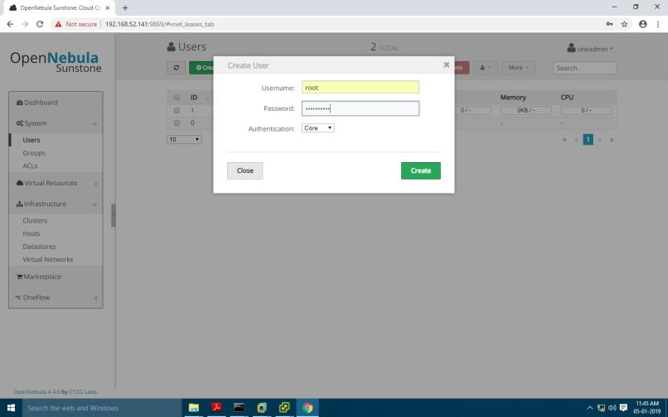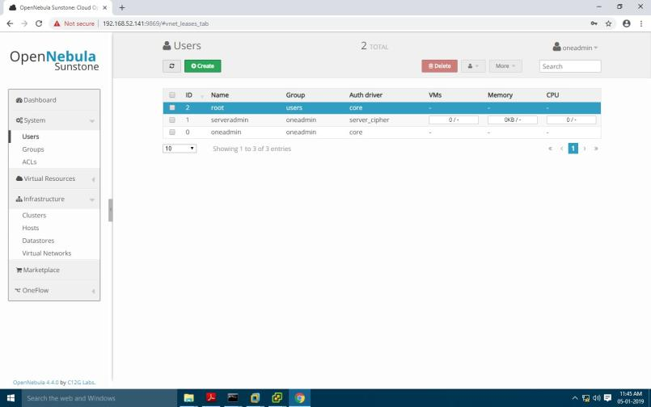

#### now login again as username : root password : Opennebula

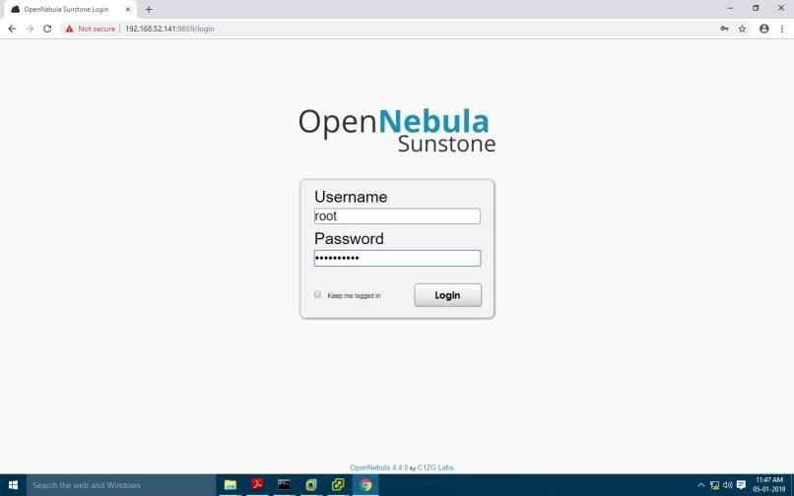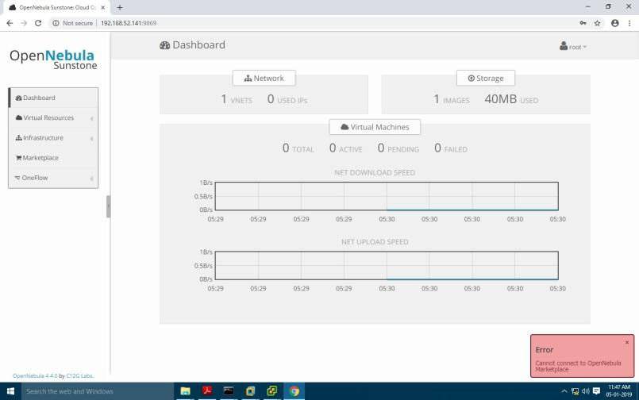

#### click on "Virtual Resources" and images

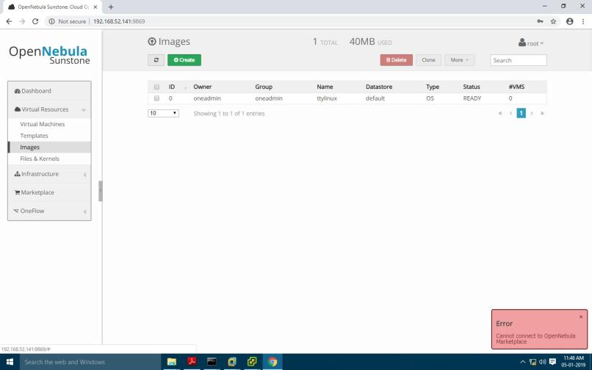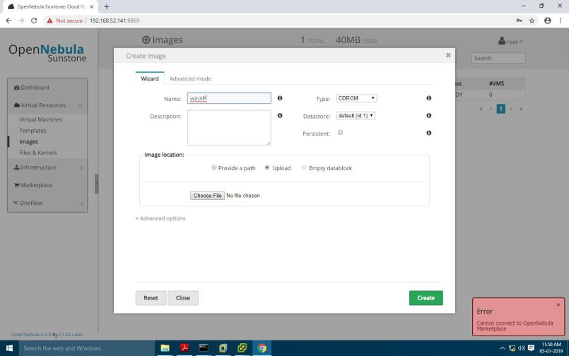

#### now register blank img

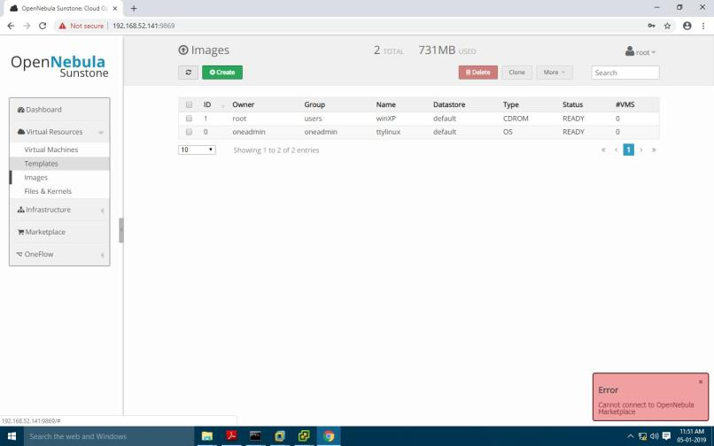

#### click on template

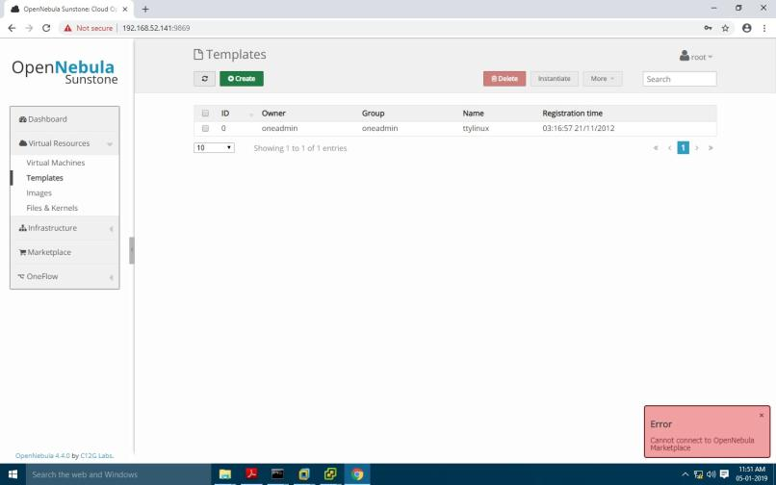

click on storage

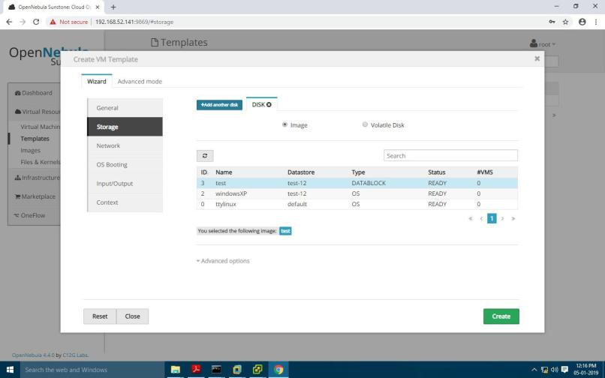

#### click on add another disk



click on "Network" and select network we have created

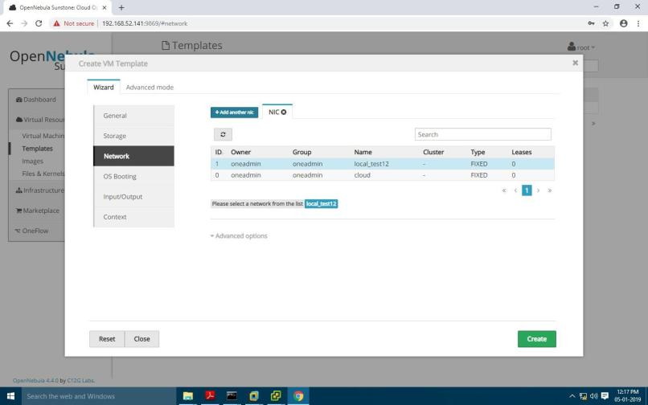

#### click on "INPUT/OUTPUT " SELECT "VNC"

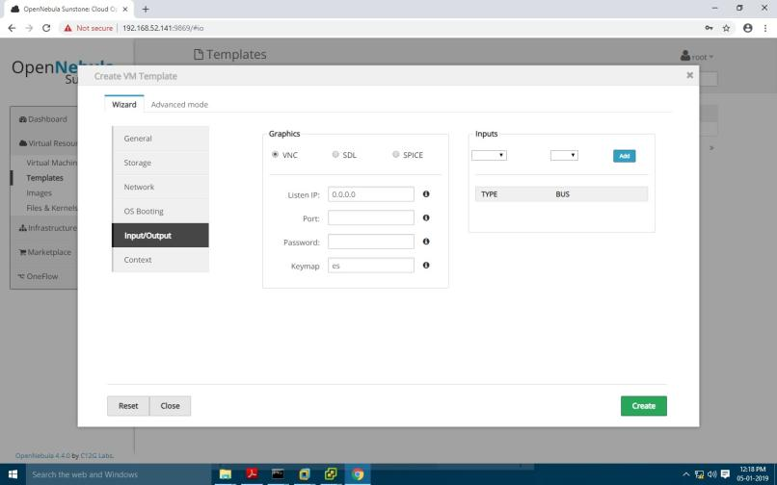

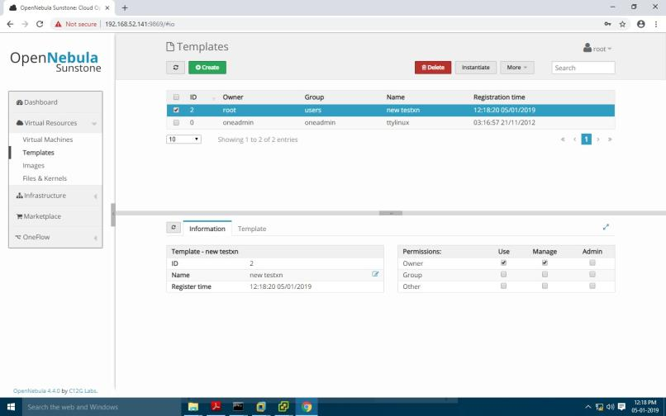

#### NOW click on INSTANTIATE

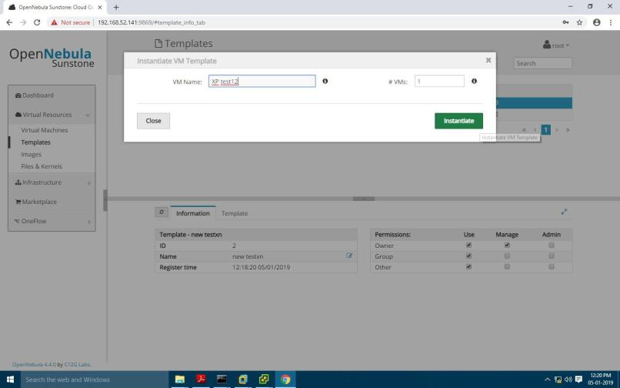

CLICK ON "VIRTUAL MACHINES"

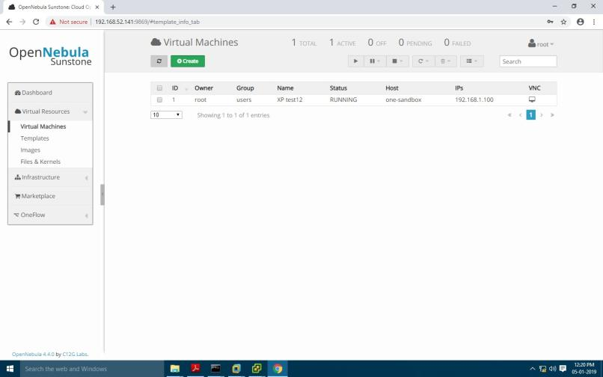

#### CLICK ON REFRESH ICON



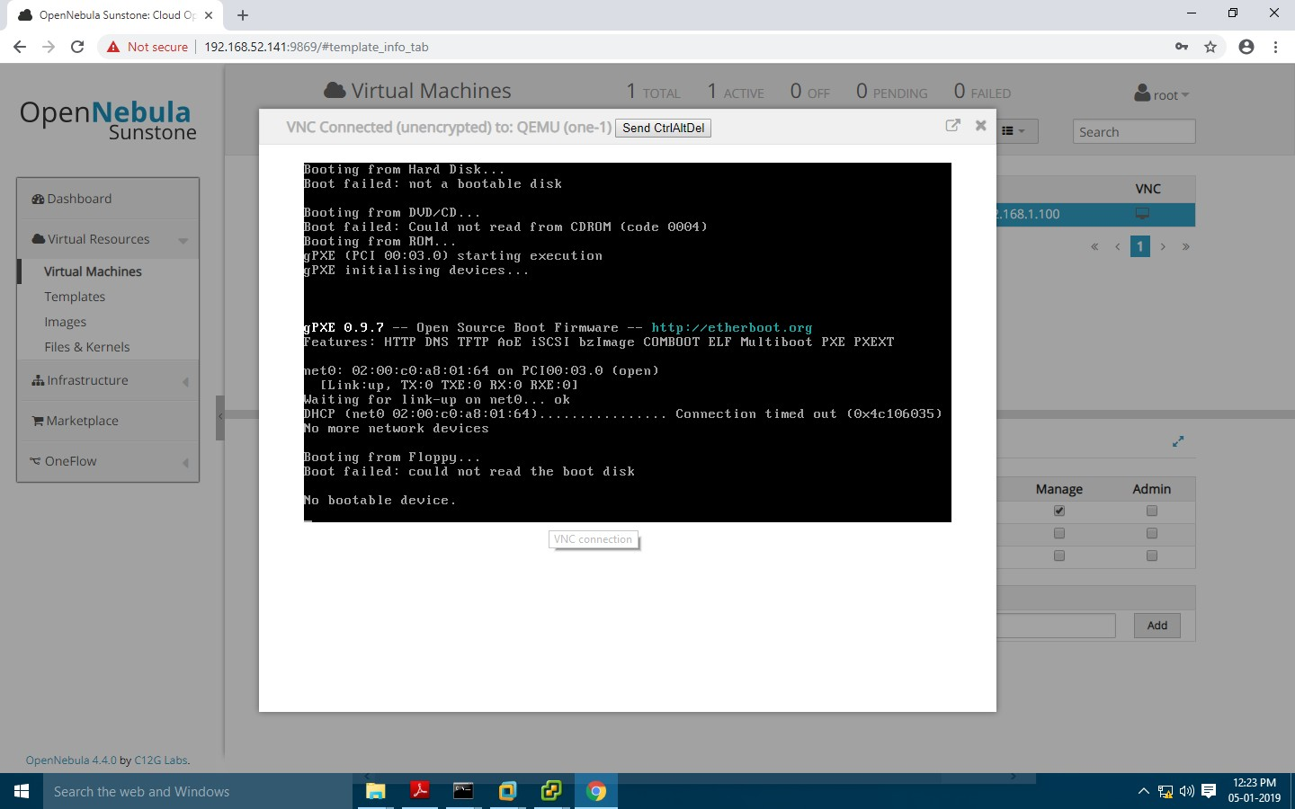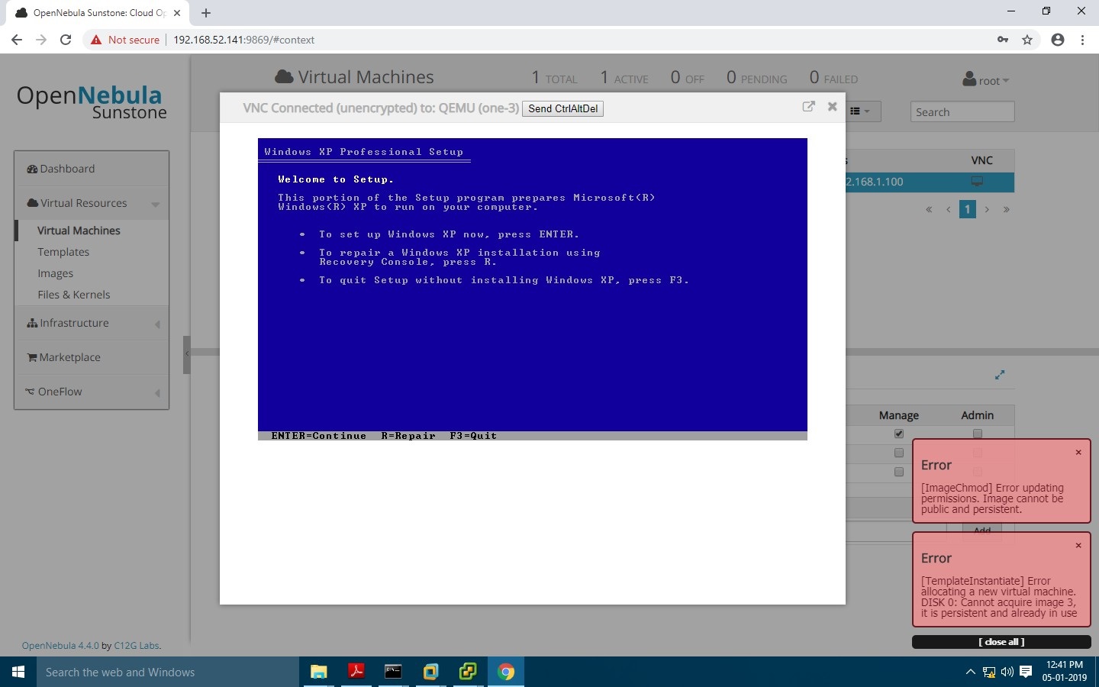

## Steps:

**PRACTICAL: 8 IMPLEMENT IAAS USING EUCALYPTUS**

##### Open Vmware Workstation 10 Go on →File →New Virtual machine .

Select Type of Configuration “**Typical**”

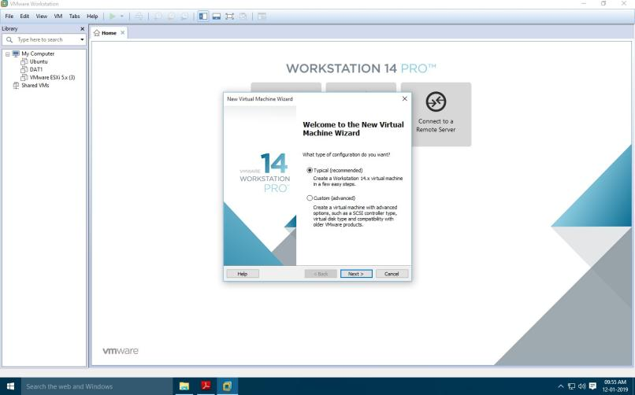

Select **IOS** image file browse the path of .iso file → Next

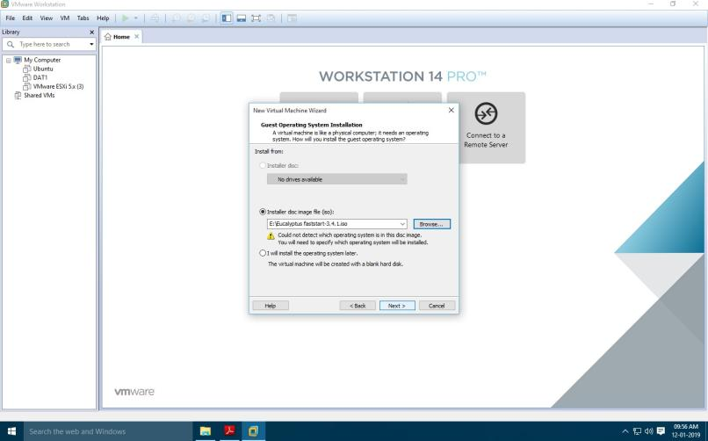

Select Grant Operating System “**Linux**” and version “**CentOS 64-Bit**”

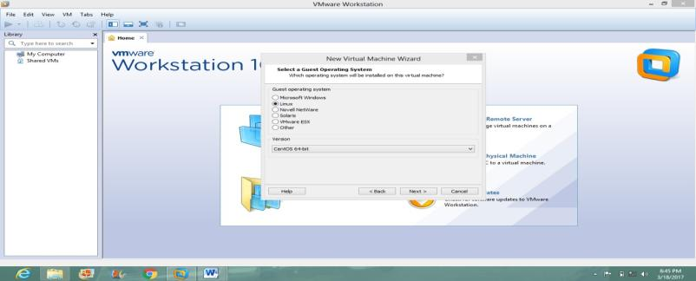

##### Given the Virtual Machine Name → Next

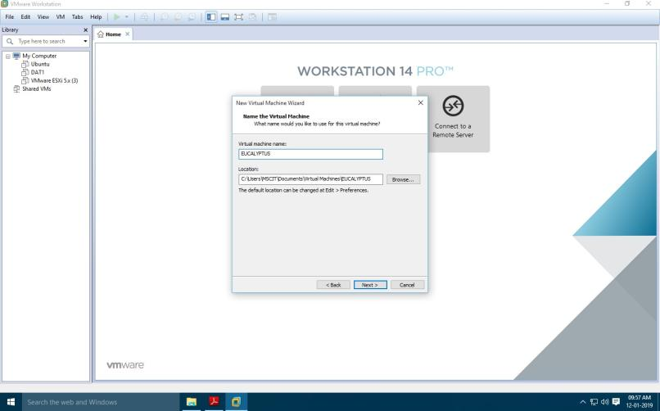

##### Set Memory disk size : 70 GB & Select Store virtual disk as a single file →Next.

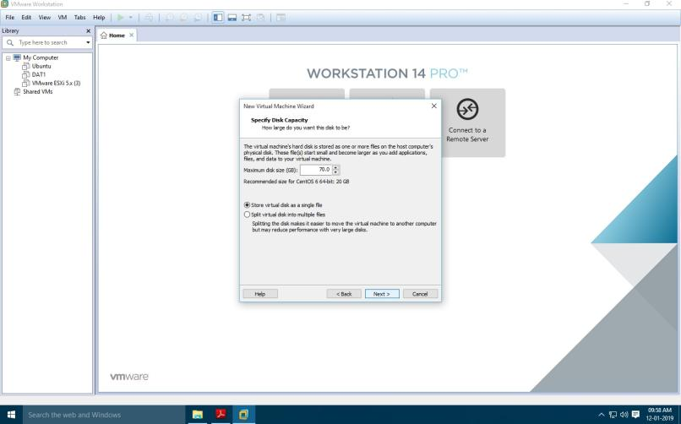

**Set below configuration setting**

##### RAM: 4 to 6 gb

Processors : 2

No of core processors : 2

Select Virtualize Intel VT Click on Ok

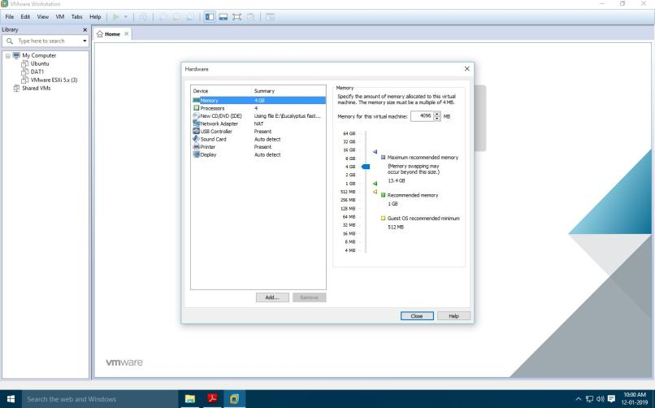

Power on virtual Machine.

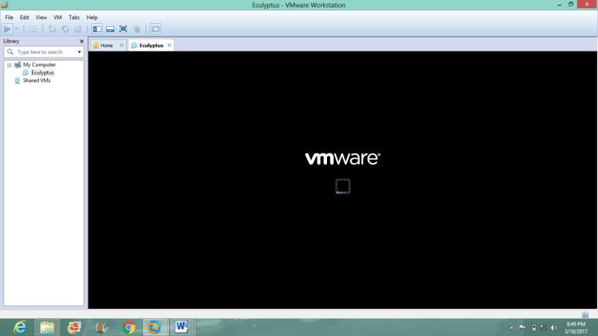

Select “**Install CentOS 6 with Eucalyptus Cloud-in-a-box**” → Enter

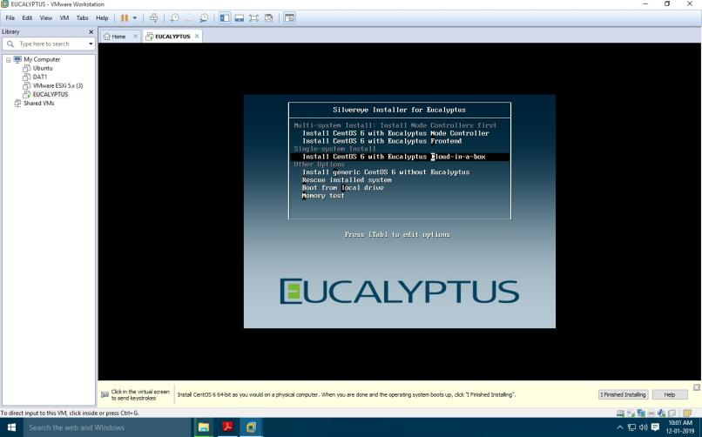

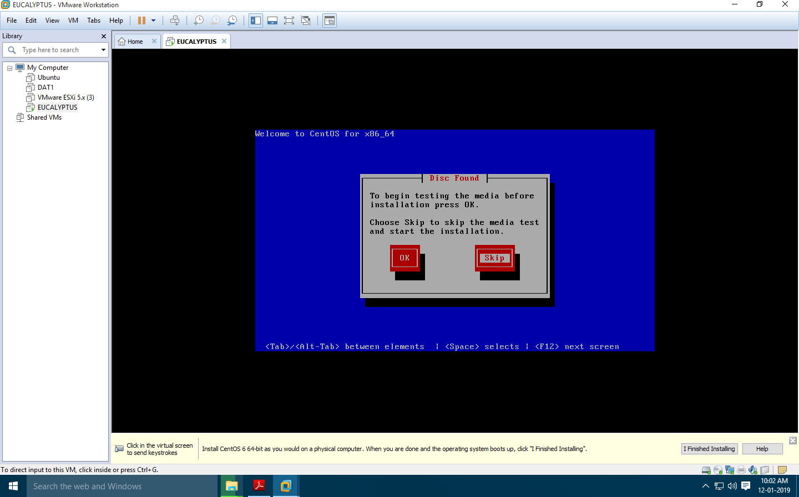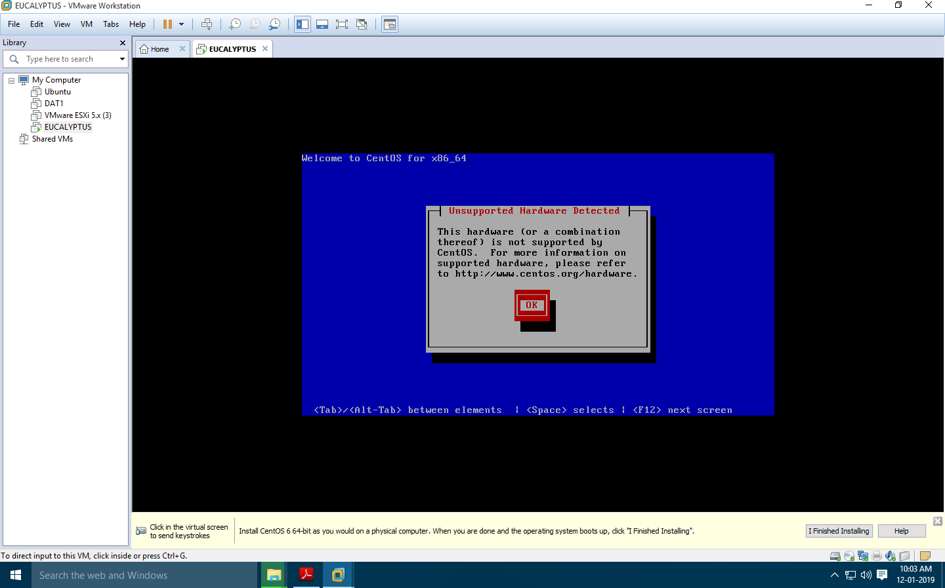

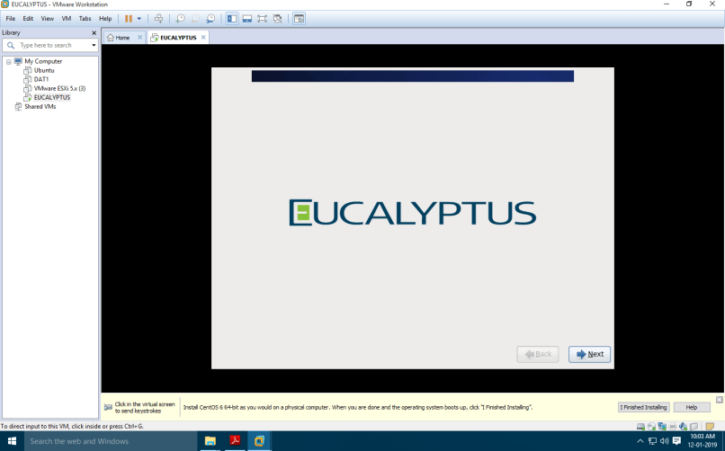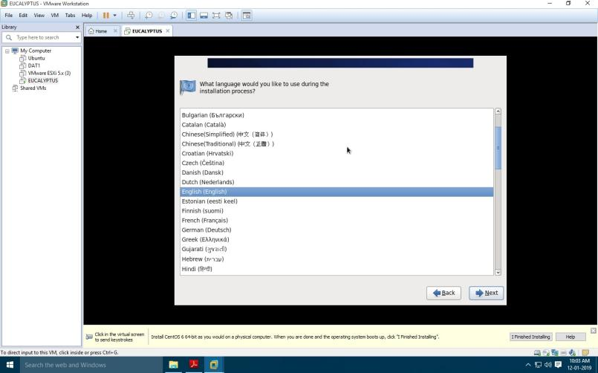

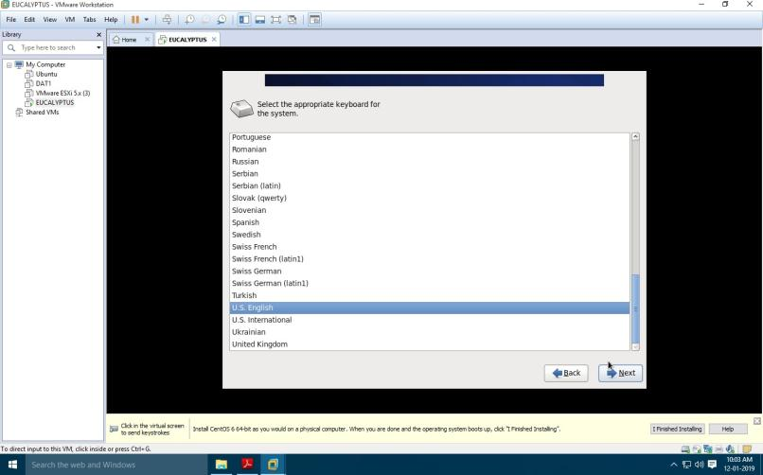

##### Configure the Network Settings with your System's IPV4 address

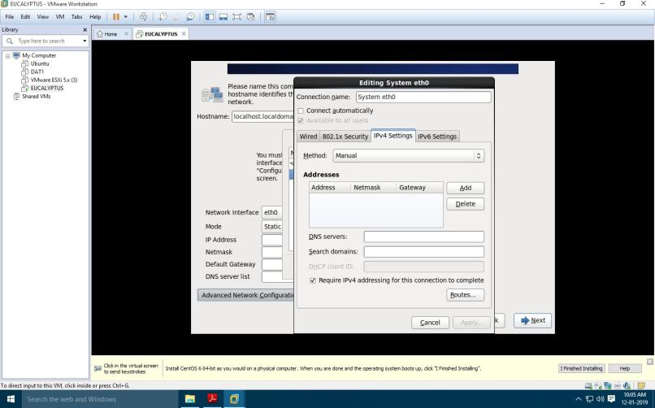

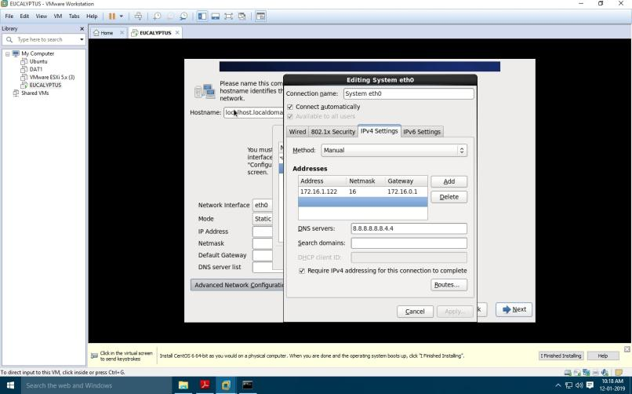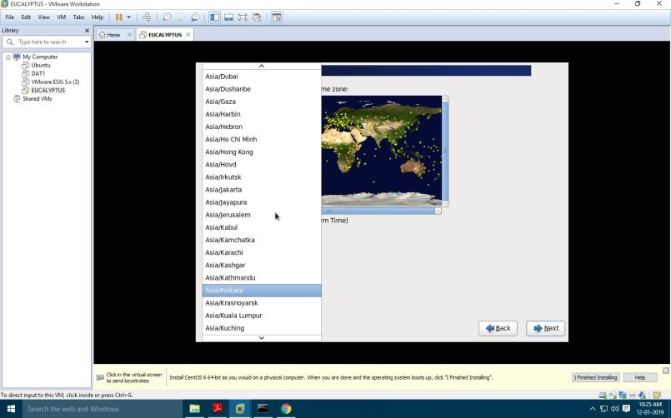

Enter the user name:root Password:root123

